
Bahria University Library Islamabad
Source: Business Recorder, Saturday Feb 11, 2023



Bahria University Library Islamabad
Source: Frontier Post, Saturday Feb 11, 2023


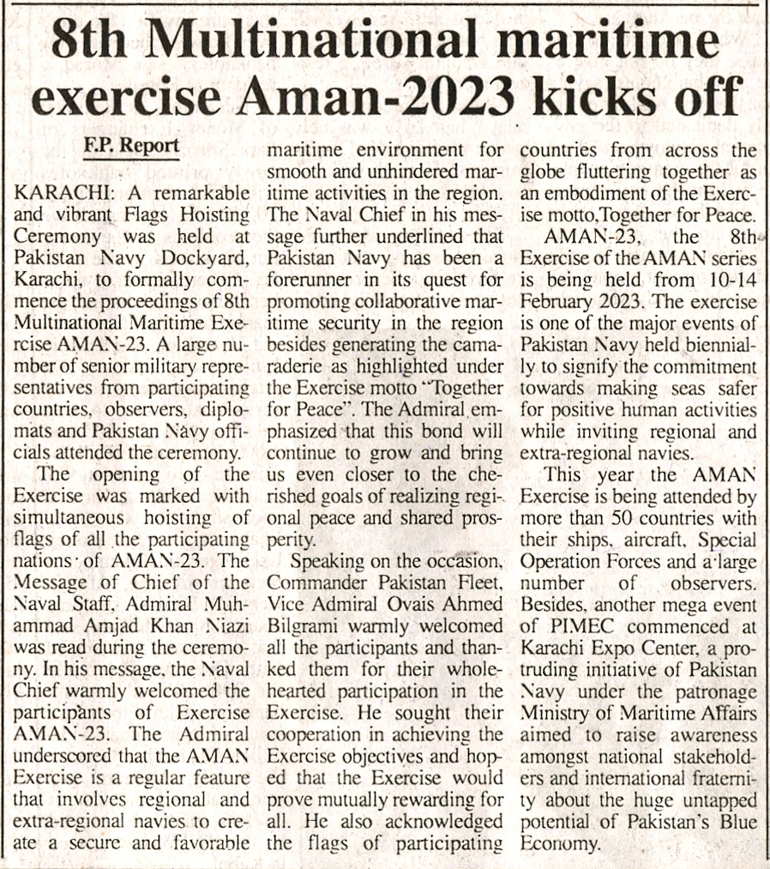

Bahria University Library Islamabad
Source: The Nation, Saturday Feb 11, 2023

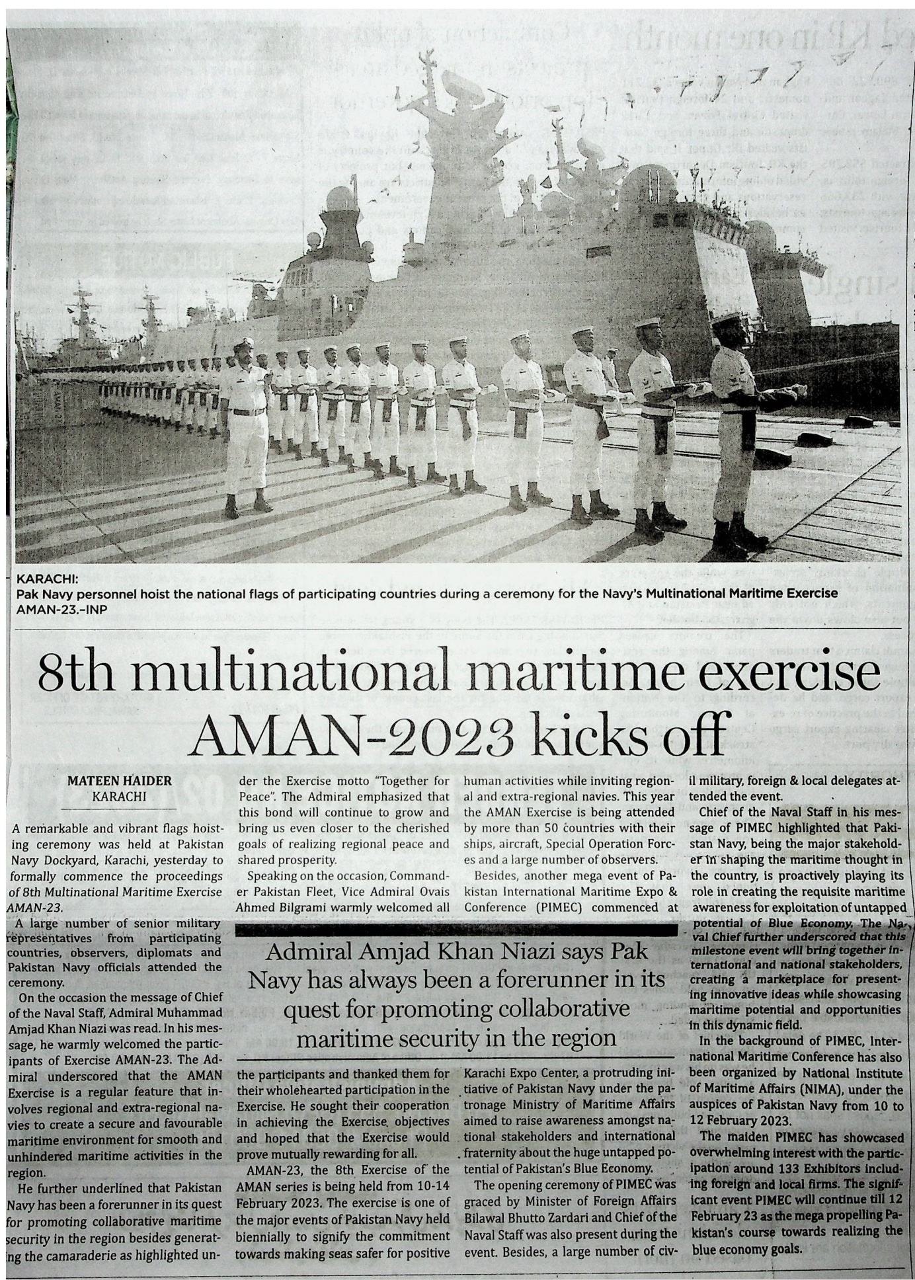

Bahria University Library Islamabad
Source: Daily Times, Saturday Feb 11, 2023



Bahria University Library Islamabad
Source: Dunya, Saturday Feb 11, 2023


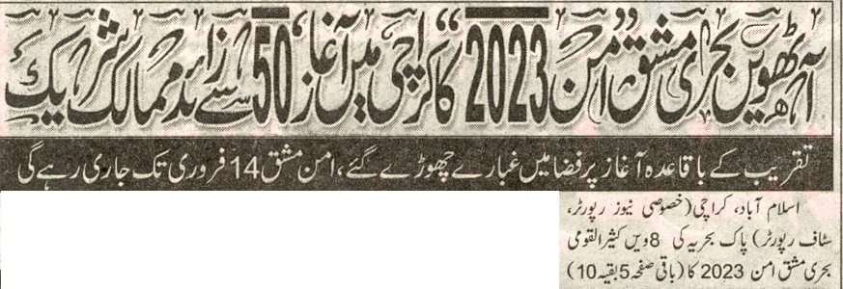
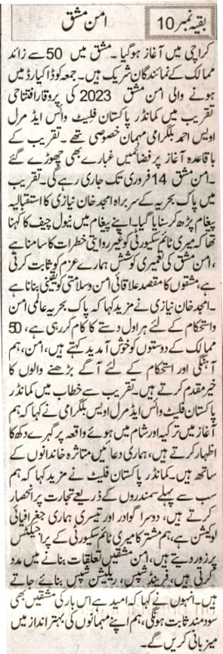

Bahria University Library Islamabad
Source: Express, Saturday Feb 11, 2023


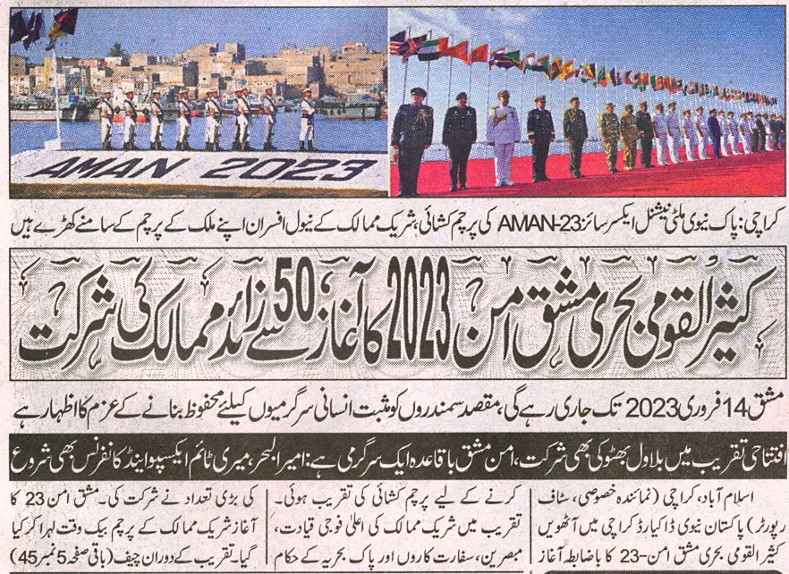
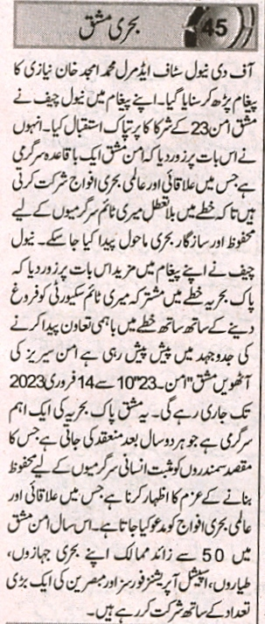

Bahria University Library Islamabad
Source: Nawa-i-Waqt, Saturday Feb 11, 2023

