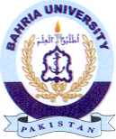
Bahria University Library Islamabad
Source: Dawn Sunday Jan 29, 2023

