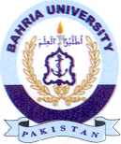
Bahria University Library Islamabad
Source: The News & Jang Sunday Jan 29, 2023

