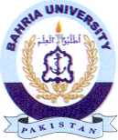
Bahria University Library Islamabad
Source: Dawn Tuesday Jan 25, 2023

