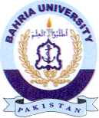
Bahria University Library Islamabad
Source: Dawn & Jang Sunday Jan 22, 2023

