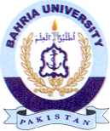
Bahria University Library Islamabad
Source: Express, Sunday Jan 22, 2023

