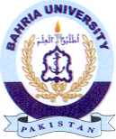
Bahria University Library Islamabad
Source: The Nation, Saturday Jan 21, 2023

