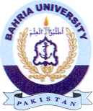
Bahria University Library Islamabad
Source: The News & Express Thursday Dec 22, 2022

