
Bahria University Library Islamabad
Source: Nawa-i-Waqt, Wednesday Dec 21, 2022

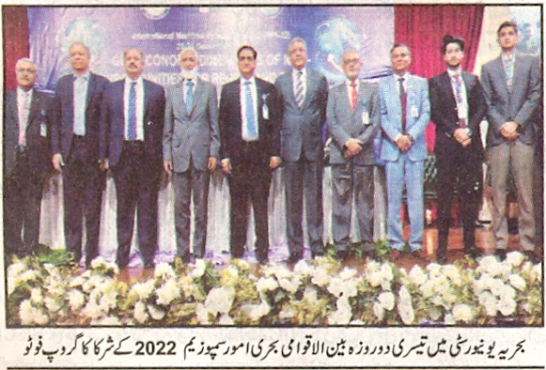

Bahria University Library Islamabad
Source: The News, Thursday Dec 22, 2022



Bahria University Library Islamabad
Source: Pakistan Observer, Thursday Dec 22, 2022



Bahria University Library Islamabad
Source: Daily Times, Thursday Dec 22, 2022

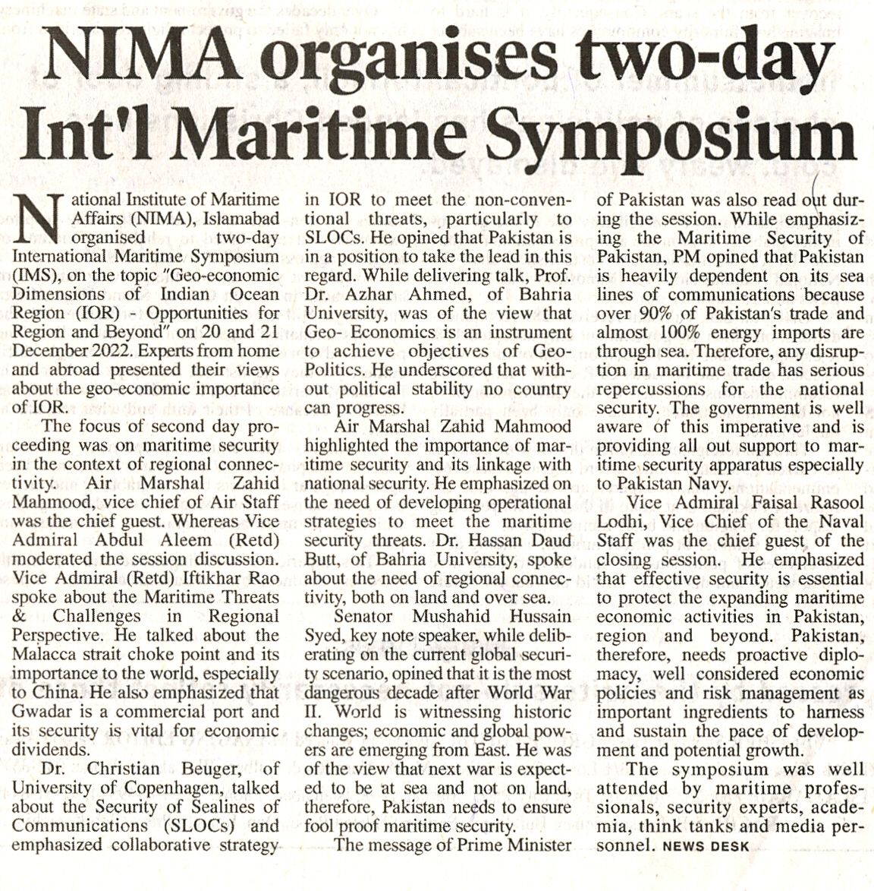

Bahria University Library Islamabad
Source: The Frontier Post , Thursday Dec 22, 2022

