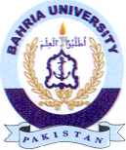
Bahria University Library Islamabad
Source: Nawa-i-Waqt, Wednesday Dec 21, 2022

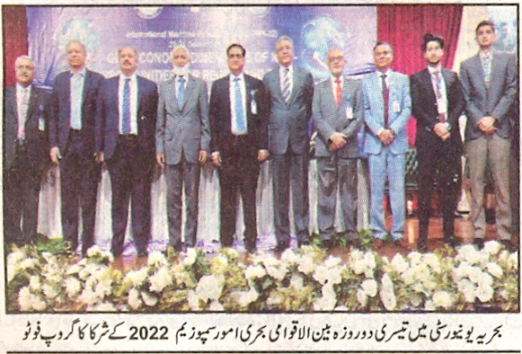

Bahria University Library Islamabad
Source: Nai Baat, Wednesday Dec 21, 2022

