
Bahria University Library Islamabad
Source: Express Tribune, Wednesday Dec 21, 2022

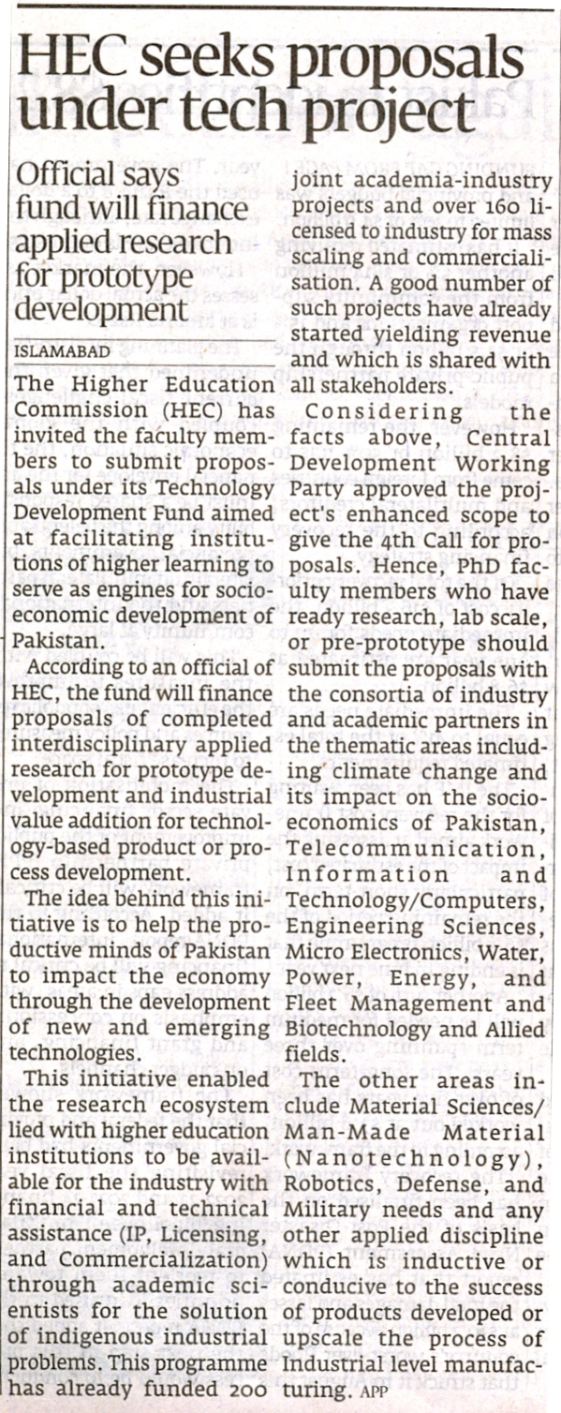

Bahria University Library Islamabad
Source: Pakistan Observer, Wednesday Dec 21, 2022



