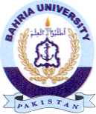
Bahria University Library Islamabad
Source: The Express Tribune, Thursday Dec 15, 2022

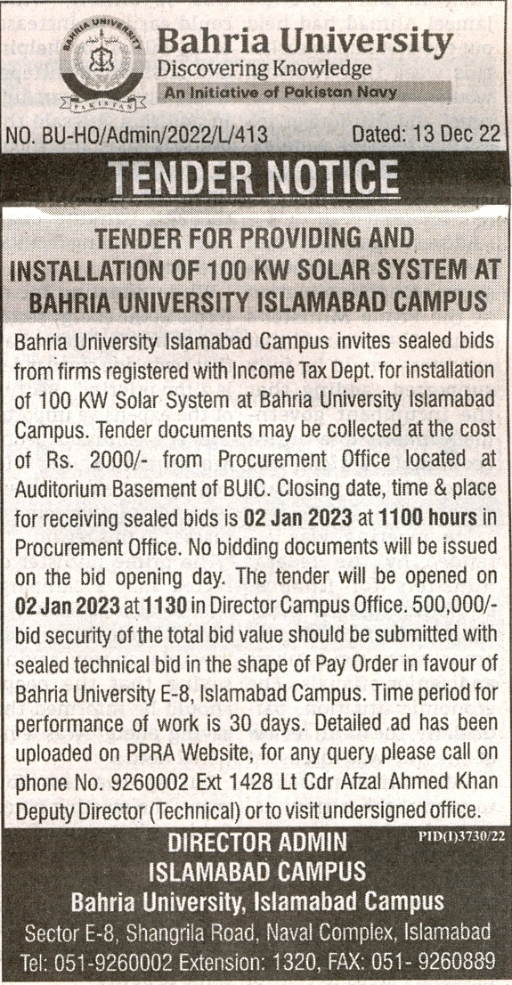

Bahria University Library Islamabad
Source: Nai Baat , Thursday Dec 15, 2022

