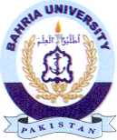
Bahria University Library Islamabad
Source: The News, Tuesday Dec 06, 2022

