TABLE OF CONTENTS
1.1 WHAT IS BTS? 4
1.2 GSM ARCHITECTURE 5
1.2.1 GSM NETWORK COMPONENTS 5
1.2.2 GSM NETWORK DIAGRAM 7
1.3 EXPLANATION OF GSM NETWORK 8
1.3.1 MS 8
1.3.2 NSS 9
1.3.3 O&MS 11
1.3.4 BSS 12
1.4 BTS 15
1.4.1 INTERFACE UNIT 16
1.4.2 BASEBAND UNITS 16
1.4.3 CLOCKING SOURCE 16
1.4.4 PROCESSING UNIT 17
1.4.5 RADIO FREQUENCY UNIT 17
1.4.6 ANTENNA PART 17
1.4.7 ALARMING SYSTEM IN BTS 17
1.5 FUEL MONITORING PART 18
2.1 OBJECTIVE AND PROBLEM STATEMENT 19
2.2 PROBLEM STATEMENT 21
2.3 OBJECTIVE 21
3.1 PROPOSED SOLUTION 22
3.2 FIRST LOGIC 23
3.2.1 LOGIC 24
3.2.2 TRANSMITTER CIRCUIT 25
3.2.3 FORMULA FOR 555 TIMER 25
3.2.4 RECEIVER CIRCUIT 26
3.2.5 PROBLEM WITH THIS LOGIC 26
3.2.6 SOLUTION OF THE PROBLEM 26
3.3 SECOND LOGIC 27
3.3.1 COMPLETE CIRCUIT USING SQ-40 27
3.3.2 HARDWARE SNAPSHOT 28
3.3.3 PROBLEMS WITH THE ULTRASONIC TRANSDUCER LOGIC 28
3.3.4 SOLUTION OF THE PROBLEM 29
3.4 THE FLOAT LOGIC 30
3.4.1 EXPLANATION 30
4.1 EQUIPMENT SELECTION 32
4.1.1 CONTAINER 32
4.1.2 POTENTIOMETER 33
4.1.3 CONTROL & PROCESSING UNIT 33
4.1.4 TRANSMISSION & DISPLAY UNIT 34
4.2 COMPONENTS 35
4.3 MICROCONTROLLER 89C51 35
4.3.1 DESCRIPTION 35
4.3.2 PIN CONFIGURATION 36
4.3.3 PINS DESCRIPTION ^{[7]} 36
4.4 MAX 232 39
4.4.1 PIN CONFIGURATION ^{[9]} 39
4.4.2 PINS DESCRIPTION 39
4.5 ADC 0804 41
4.5.1 PINS CONFIGURATION ^{[10]} 41
4.5.2 PINS DESCRIPTION 41
4.6 LCD 43
4.6.1 PINS CONFIGURATION ^{[11]} 43
4.6.2 PINS DESCRIPTION 43
4.7 DB9 45
4.7.1 PINS CONFIGURATION ^{[12]} 45
4.7.2 PINS DESCRIPTION 45
4.8 MOBILE PHONE 46
5.1 HARDWARE 47
5.2 POWER SUPPLY CIRCUIT 50
5.2.1 COMPONENTS USED 50
5.2.2 LOGIC OF THE CIRCUIT 51
5.2.3 SIGNALS AT DIFFERENT TEST POINTS 51
5.2.4 HARDWARE SNAPSHOT 52
5.3 ADC 54
5.3.1 PINS CONFIGURATION 54
5.3.2 WORKING 54
5.3.3 COMPONENTS USED 54
5.3.4 HARDWARE SNAPSHOT 55
5.4 MICROCONTROLLER 57
5.4.1 PIN CONFIGURATION 57
5.4.2 WORKING 57
5.4.3 COMPONENTS 58
5.4.4 HARDWARE SNAPSHOT 59
5.5 MAX 232 60
5.5.1 PINS CONFIGURATION 60
5.5.2 WORKING 60
5.5.3 COMPONENTS USED 60
5.5.4 HARDWARE SNAPSHOT 61
5.6 DB9 PORT 63
5.6.1 PINS CONFIGURATION 63
5.6.2 WORKING 63
5.6.3 HARDWARE SNAPSHOT 64
5.7 LCD 65
5.7.1 PINS CONFIGURATION 65
5.7.2 WORKING 65
5.7.3 HARDWARE SNAPSHOT 66
5.8 VOLTAGE REGULATOR 67
5.8.1 COMPONENTS USED 67
5.8.2 HARDWARE SNAPSHOT 67
5.9 MOBILE PHONE 69
5.9.1 SNAPSHOT 69
5.10 POTENTIOMETER 71
5.10.1 HARDWARE SNAPSHOT 71
5.11 COMPLETE HARDWARE FABRICATION 73
5.11.1 CIRCUIT DIAGRAM 73
5.11.2 COMPLETE FABRICATED CIRCUIT SNAPSHOTS 74
6.1 SOFTWARE 77
6.2 INTERFACING OF THE MOBILE USING AT COMMANDS 77
6.3 AT COMMANDS ON HYPER TERMINAL 78
6.5 RECEIVER SIDE 81
7.1 TESTING AND TROUBLESHOOTING 82
7.2 POWER RATING OF THE HARDWARE PARTS 88
8.1 COST ANALYSIS 89
8.2 FUTURE WORK 90
REFERENCES 91

1.1 WHAT IS BTS?
BTS Base Transceiver Station
BTS is an important part of BSS (Base Station Subsystem). It is used for the wireless communication between user and telecommunication network. BTS is part of both GSM and CDMA standards in the field of wireless communication. BTS itself contains many parts that are used for specific operations. Normally BTS contains equipment that is used for encryption and decryption of the communication data and also spectrum filtering tools like band pass filters.
As mentioned above, BTS is a part of BSS and BSS is an important part of the GSM architecture. We first see briefly the GSM architecture and its important parts so that we can be clear about the role of BSS and more precisely BTS in the wireless communication.
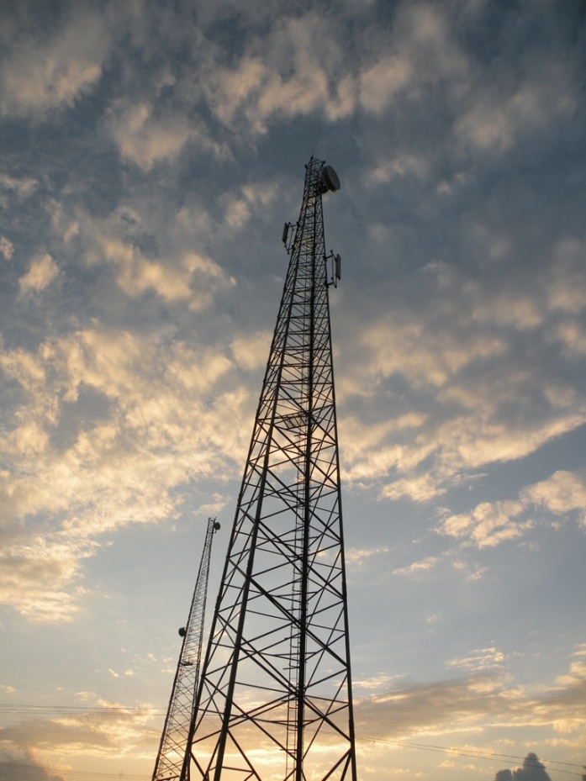

1.2 GSM ARCHITECTURE
1.2.1 GSM NETWORK COMPONENTS
The major GSM network components^{[1]} are:-
- MS (Mobile Station) ^{[1]}
- BSS (Base Station System) ^{[1]}
- NSS (Network Switching System) ^{[1]}
- O&MS (Operation & Maintenance System) ^{[1]}

These are the principle components of a GSM network. These are further divided into other components; brief details of those are given below.
- MS (Mobile Station)
  - ME (Mobile Equipment)
  - SIM (Subscriber Identity Module)
- BSS (Base Station System)
  - XCDR (Transcoder)
  - BSC (Base Station Controller)
  - BTS (Base Transceiver Station)
- NSS (Network Switching System)
  - VLR (Visitor Location Register)
  - HLR (Home Location Register)
  - AUC (Authentication Centre)
  - EIR (Equipment Identity Register)
  - EC (Echo Controller)
  - IWF (Interworking Function)
- O&MS (Operation & Maintenance System)
  - NMC (Network Management Centre)
  - OMC (Operation & Maintenance Centre)

1.2.2 GSM NETWORK DIAGRAM

1.3 EXPLANATION OF GSM NETWORK
1.3.1 MS
MS Mobile Station
Mobile station^{[1]} is basically the cell phone user is using. It is basically the equipment (handheld or fixed) that is used by the user for the communication. Software is also a part of mobile station along with the user equipment. Mobile station consists of two parts known as ME (Mobile Equipment) and SIM (Subscriber Identity Module).
ME
ME Mobile Equipment
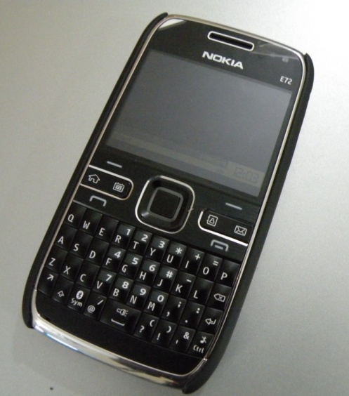
Mobile equipment is the hardware part that the user uses to access the network and communicate. Every mobile equipment has got its own one unique number which is the identity of that device. That unique key or number is called IMEI (International Mobile Equipment Identity). This IMEI number help the network operator in many ways especially in detecting that which mobile equipment is causing problems in certain situations. There are three main types of ME which are
- Vehicle mounted
- Portable mobile unit
- Hand portable unit
SIM
SIM Subscriber Identity Module
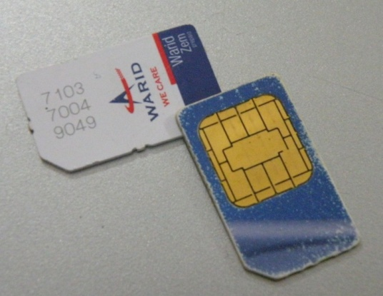
SIM is a card that is used in a mobile equipment to operate it and get the services provided by the specific service provider. The SIM also have a unique number known as IMSI (International Mobile Subscriber Identity). SIM card contains many kind of information e.g., IMSI, TMSI, LAI, KI, MSISDN.

1.3.2 NSS
NSS Network Switching Systems
NSS^{[1]} perform the main switching functions in the GSM network. The main purpose of the NSS is the management of the communication between GSM network and other communication networks. The components of NSS are already listed above and their brief description is given below:-
VLR
VLR Visitor Location Register
The purpose of VLR is to keep a copy of the information that is in Home Location Register. It’s a temporary kind of storage because it keeps the data till the subscriber is in the range or in the particular area that is covered by the VLR of that area. So, VLR keeps the data till the subscriber is alive or active. There is also some additional data stored in VLR that is
- Mobile status
- TMSI (Temporary Mobile Subscriber Identity)
- LAI (Location Area Identity)
- MSRN (Mobile Station Roaming Number)
HLR
HLR Home Location Register
HLR is used to store authentication parameters. Moreover it is also used to store the identification numbers and addresses. Whenever a new subscriber is attached network provider passes the information of that subscriber to HLR. All MSCs and VLRs can access the data remotely from the HLRS. The data that is stored in HLRs are given below:-
- IMSI (International Mobile Subscriber Identity)
- VLR (Visitor Location Register)
- Supplementary service information
- Authentication key
- Subscriber status
- MSRN (Mobile Subscriber Roaming Number)
AUC
AUC Authentication Centre
AS it is clear from the name it performs the authentication. We can say that it is almost very near to the HLR as it needs to update continuously with the help of HLR. AUC as well as HLR can be with the MSC or can also be remote.

EIR
EIR Equipment Identity Register
EIR is used to keep a check and validate the IMEI number of the mobile equipment. It checks the mobile station whether the IMEI number of the ME is valid or listed? EIR maintains a list so that the IMEI which are blocked and do not have to be entertained must be listed separately. EIR contains three types of lists which are:-
- White list
- Grey List
- Black List
EC
EC Echo Controller
Echo controller is part of the network that is located towards the PSTN side of the MSC in order to control unwanted echo conditions. There are usually different types of delays at the PSTN side. SO, EC is used to control it so that considerable delays can be reduced in the communication.
IWF
IWF Interworking Functions
IWF is used for the compatibility of GSM network systems with different data networks. It has to perform certain operations in order to make the network compatible with GSM network. The operations it usually performs are protocol conversion and data rates adaption.
1.3.3 O&MS
O&MC Operations & Maintenance System
The main purpose of this system is to provide compatibility and to facilitate in order to manage and control the system remotely. This system is flexible in a way that every network provider can set its standards and thresholds according to their standards of the provision of the services to their customers.
NMC
NMC Network Management Centre
NMC is the key responsible for the management of the entire network.
O&MC
O&MC Operations & Maintenance Centre
It is used to provide facility in order to manage the system 24/7. It also keeps a record of the data and management activities for long run.
1.3.4 BSS
BSS Base Station Subsystem
BSS^{[1]} is the part of GSM network that is located at the site. As we know that GSM is based on cell structure so BSS is located at the cell site. BSS contain combination of equipments that are digital as well as related to the RF. There are three major components of BSS namely BSC, XCDR and BTS. Their brief description is given below.
BSC
BSC Base Station Controller
It controls the base station and it communicates directly to the mobile service station centre. It also controls the BTS. This is not compulsory that one BSC will control only one BTS. Multiple BTS can be controlled by one BSC.

BSC is used to switch the traffic to and from BTS and MSC. The connection of channels and terrestrial circuits is done on air interface by the BSC. It also controls the handoff processes of the BTS under its supervision.
XCDR
XCDR Transcoder
It is used to compress the signals coming from the mobile station. This compression of the signals is done in order to make it convenient for the terrestrial interfaces to carry the signals.
There are different types of BSS configurations we use. Example of co-located BSS, remote BTS and daisy chained BTS are given below in diagram.

1.4 BTS
BTS Base Transceiver Station
BTS is base transceiver station as we have briefly discussed at start of this chapter. BTS is also known as cell phone tower as its core function is to provide the signals to the user cell phones in order to make the wireless communication possible. BTS is a main part of GSM architecture and has been used these days in all GSM based communication systems.
In GSM architecture we have hexagonal structure to cover an area and successfully perform the communication. BTS position in a cell depends on your way of covering an area. There are more than one ways that BTS can be places in a hexagonal cell.
We now discuss briefly, the parts of a BTS.

The main parts of BTS are
- Interface unit
- Baseband unit
- Clocking source
- Processing unit
- Radio Frequency unit
- Power supply unit
- Antenna part
We briefly see the functions of these parts.
1.4.1 INTERFACE UNIT
The data that interface unit is receiving is basically in standard formats like it is mentioned in the diagram i.e., E1, T1 etc. So, the purpose of the interface unit to make it in a form that is acceptable for the further units to process it easily. As its name shows that it is interfacing that incoming data to the processing units in BTS.
1.4.2 BASEBAND UNITS
Baseband units receive the data from the interface unit and process it. The data fed to the base band unit is digital and it performs the signal processing on it. It makes the incoming data in the form acceptable by the RF unit by applying signal processing on it.
1.4.3 CLOCKING SOURCE
Clocking source is providing a clock to all parts of the BTS processing. The purpose is to synchronize all the parts on the same clock so that data flow can be smooth and compatible within different parts of the BTS.

1.4.4 PROCESSING UNIT
Processing unit is the heart of the BTS. It is the main part doing all the necessary actions and processing in the BTS. All the BTS configurations, testing, initialization and maintenance check is done in this unit.
1.4.5 RADIO FREQUENCY UNIT
The radio frequency unit of the BTS is taking the processed data from the baseband unit and converting it into radio frequency so that it can be transmitted on the wireless medium.
1.4.6 ANTENNA PART
Antenna part is for transmitting the information which it is doing by the converting the electrical signal into electromagnetic signal.
1.4.7 ALARMING SYSTEM IN BTS
BTS site has got a complete equipment installed in it related to alarming. Different types of alarms are there in order to notify different actions, activities and notifications. There system installed on the BTS site for the alarming purpose is known as ABSAM. We briefly see that details of ABSAM.
ABSAM
ABSAM Auto BTS Site Alarm Manager
The ABSAM is a complete hardware product that is monitoring different parts of BTS in order to notify the service providers with the current indications and updates of the BTS equipment. The ABSAM is a hardware that is based on efficient and fast microcontroller based technology. The microcontroller is connected to a GSM modem circuit so that different alarm notifications can also be sent wirelessly to the control rooms of the service provider. The ABSAM in general used for following purpose
- Monitoring the temperature
- Monitoring the fuel level of generator
- Monitoring the status of backup batteries
- Monitoring the output load
The ABSAM can monitor around 28 to 30 alarms and can also transmit the information with the help of sms using the GSM modem circuit integrated with it.
1.5 FUEL MONITORING PART
We have seen the ABSAM also monitor the fuel level of the generator. But this equipment is of a very huge cost. Our main purpose is to suggest a way of fuel monitoring of the BTS generator that is efficient and also cost effective. We are designing and fabricating a way that will help to display the fuel level information at the site and also will transmit the information wirelessly with the help of a sms. Our main concern in doing all this is to make this all an efficient system and also a very cost effective.

2.1 OBJECTIVE AND PROBLEM STATEMENT

In every BTS, there are backup battery banks and generators for providing continuous power to the BTS. These batteries and generators are very useful especially in Pakistan, considering the amount of unannounced load shedding and power cuts that we experience daily. Whenever the commercial power supply is disrupted due to any reason the BTS automatically shifts to the backup battery banks and start operating on them before being shifted on the power supply provided by the generators. Since a generator takes time to start producing power, therefore the backup battery banks ensure uninterrupted power supply to the BTS.

These generators have limited fuel capacity and regular refilling of fuel is required in order to keep the BTS running in case the power coming from the commercial lines disconnects due to load shedding or any other reason. Every Telco has a fuel refilling team which visits all the BTS locations after a fixed amount of time for refilling the fuel. In many parts of the country, the load shedding is not scheduled and therefore sometimes it happens too often and at times it doesn't happen at all. Hence, the process of sending refilling teams to a BTS location after a specific amount of time is not practical as we are not sure whether the refilling is required or not. In case of additional power disruption, which happens at a fair magnitude, the fuel in the standby generator gets finished before the due time and this leads to site shutdown. This does not only result in interrupted service to the cellular subscribers but it also results in heavy revenue losses to the respective cellular operator. Sending teams for refilling fuel tanks are not a very practical solution as well, because it might result in useless visits when no fuel is used by the generator. Also, these refilling teams normally charge the Telcos on a per visit basis.
Every BTS has a number of sensors and alarms which monitor and sense different instruments in the BTS. These alarms go off whenever any instrument behaves in an unusual manner. Among these alarms, there is one for fuel level as well. This alarm goes off only when the fuel level reaches critical level. But these alarms are actually of no practical use because they only go off in the BTS site, where only one guard/technician is present.
Considering the corrupt nature of our society in general, the Telcos have experienced instances where the fuel was stolen either by the guard present at the BTS or by the refilling teams themselves. This issue is of major concern because there is no proper check on it.

2.2 PROBLEM STATEMENT

There is no mechanism to monitor fuel level at a centralized control room location where constant level of the fuel could be seen by the technical staff and the refilling visits could be scheduled accordingly. The stealing of fuel is another issue which needs to be addressed. A mechanism needs to be developed that can minimize the stealing of fuel from the BTS Generator fuel tank.

2.3 OBJECTIVE
To propose a solution which can help the Telcos monitor fuel level wirelessly at a centralized location. This solution should also cater the problem of stealing of fuel.
We want to design sensors which can monitor the fuel level of the generator’s fuel tank and to transmit it to the control room. The cheapest and most commonly used method is by sending the data with the help of SMS.
So, our objective is to design a system at the lowest cost and that can sense fuel level and also cope with the stealing of fuel.

3.1 PROPOSED SOLUTION
As we have seen in our previous chapter that our main objective is to propose a solution that can be designed & fabricated in a low cost and also it fulfills our requirements. Moving for a definite solution, we first had to move step wise.
Our first step was to plan and make a block diagram to define the parts of our project. We designed a block diagram according to our project. The block diagram we had made is given below.

Our first task is to select and design the method to measure the depth of the level with help of specific components. On our research we found that we can use different approaches to find level of fuel in the tank.
3.2 FIRST LOGIC
First we have selected the ultrasonic transducer logic^{[2]}. The block diagram of this is given below.

The parts involved in the circuit are given below
- Microcontroller
- Transmitter circuit (including the transmitting transducer)
- Receiver circuit (including the receiving transducer)
- Display unit
- Transmitter unit

3.2.1 LOGIC
We chose the ultrasonic transducer model OC-40. The ultrasonic transducer needs 40KHz to operate. More precisely the transducer work between 39KHz to 41KHz. So, our first step was to generate a 40KHz signal in order to make the transmitting transducer work. We designed transmitter in mono-stable state to drive our transmitting transducer. We achieved 40KHz pulse with the help of 555 timer.
The transmitted pulse in form of sound will strike the bottom and will reflect back as an echo for the receiving circuit. We need to amplify the received echo in order to pass it on to the microcontroller. So, we designed the receiver circuit which amplifies the received echo to a certain level.
When transmitting transducer is triggered by the 555, the timer of the microcontroller starts and when the received echo is amplified and given to microcontroller as an interrupt the timer stops. The round trip time is calculated in this way which can be processed to get the level of the fluid in the tank. The necessary calculations are done in the microcontroller and the results are displayed on the LCD which is on the site.
Once we get the correct level at the site on the LCD we can easily transmit it using the serial communication. The mobile phone is connected serially with the microcontroller and the level is transmitted with the help of AT commands through that connected mobile.

3.2.2 TRANSMITTER CIRCUIT
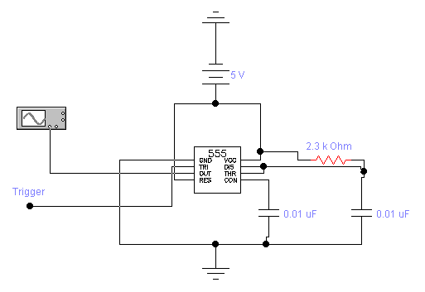
3.2.3 FORMULA FOR 555 TIMER
We have calculated the value of R1 resistor and C1 capacitor get a single pulse of 40 KHz. The values were calculated with the help of the formulas for 555 timer mono-stable state.
R1 = 2.3k
C1 = 0.01uF
The frequency calculation is showed below.
f = 1 / T
T = 1.1 x R1 x C1
T= 1.1 x 2.3k x 0.01uF = 0.0000253
f = 1 / T = 1 / 0.0000253 = 40KHz

3.2.4 RECEIVER CIRCUIT
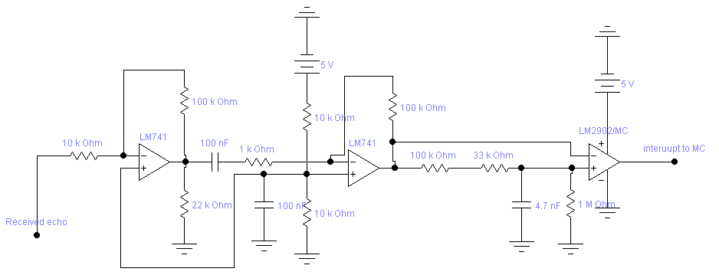

3.2.5 PROBLEM WITH THIS LOGIC
The transmitter and receiver circuit designed above were tested but there was problem with the transducers. On research we found that the model of the transducer we are using is not appropriate for the range finding or we say depth finding. So, we searched the appropriate transducer model and found one.
Another problem was this that we were triggering the transmitting transducer with the help of 555 timer. We studied and found that it is easy to trigger the transducer with the help of microcontroller we were using.
3.2.6 SOLUTION OF THE PROBLEM
The problem with the OC-40 transducer was solved by selecting the appropriate models to find the range or more precisely depth of the fluid in the tank. We selected the ultrasonic transducer SQ-40^{[3]} which has the transmitting transducer SQT-40 and receiving transducer SQR-40. Moreover in the modified logic we are triggering^{[4]} the transmitting transducer with the help of the microcontroller.
3.3 SECOND LOGIC
The logic is almost same that we used in the previous design. There is only change in the transducer model and also the triggering method of the transmitting transducer. In this logic we are triggering the transmitting transducer with the help of microcontroller. Rest of the process goes the same, the received echo is amplified and given to microcontroller as an interrupt.
3.3.1 COMPLETE CIRCUIT USING SQ-40

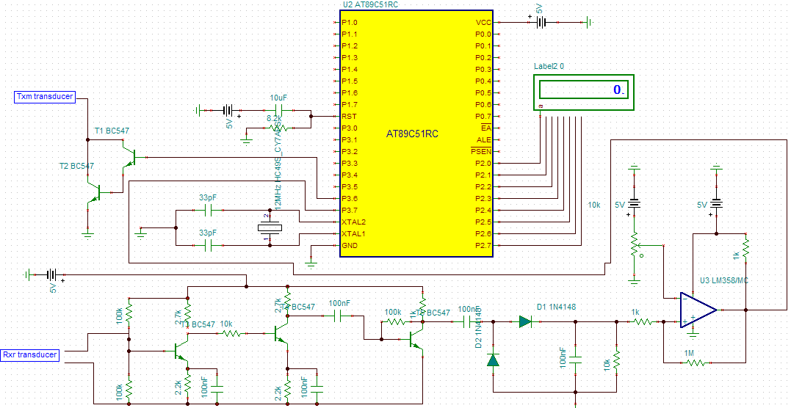
3.3.2 HARDWARE SNAPSHOT

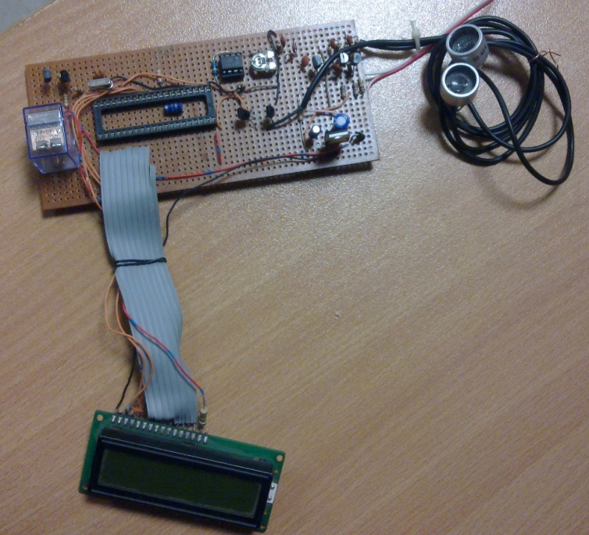

3.3.3 PROBLEMS WITH THE ULTRASONIC TRANSDUCER LOGIC
The problem faced by us here is that ultrasonic transducers are used normally to measure the range of any object from a certain point. They can also be used to find the range in any given medium other than air by simply using the coefficients and velocities of sound in that medium. But in our case to measure level of fuel in the generator tank can have different kind of liquids in it. We cannot just suggest a way to measure the depth of tank when it is containing the water. Because it is very easy to find the speed of sound in water but that method is not accurate to give precise readings of the depth of the tank.
We have designed the transmitter and also the receiver to get the sound transmitted and to receive the echo at the receiver end. We tested our circuit by taking water in a tank. One out of five reading was near to the real value but with amount of error that was not acceptable.
We have concluded that the ultrasonic transducer logic to measure the fuel level of BTS generator is not working accurately. The logic can still be useful and accurate enough to get precise readings if branded modules are used to sense the depth of the level. But the cost of those modules is high and we cannot use them in our project. The purpose of our project was and still is to suggest a method to measure the fuel level of BTS in a low cost. So, we are using another approach now that can be used with any kind of fuel to measure its depth.
The ultrasonic transducer logic is very accurate if you are finding the range of any object from a fixed point. The same logic is used in sonar as well as to find the distance between two vehicles. The ultrasonic logic is successful in air as we know the velocity of the sound in the air medium. The velocity of sound in different mediums is different depending upon viscosity and density of different types of fuel.
3.3.4 SOLUTION OF THE PROBLEM
We have seen above that the ultrasonic transducer logic is not helping us to find the depth of the tank. The logic itself is not wrong but it is only useful in finding the distance of objects from a fixed one and also in one medium.
The logic we used onward was a complete different one from the previous. We used the float logic to find the depth of the tank. The float logic is very common in measuring the levels of different fluids in our daily routine objects. We worked on the float logic onwards and we find it useful and appropriate in measuring depth of the generator tank. The complete details of the logic are given in rest part of this chapter. The description of the equipment, hardware and software will be coming in the next chapters.

3.4 THE FLOAT LOGIC
3.4.1 EXPLANATION
The float logic^{[5]} is very simple in understanding. The most common example to understand is the water tank we all have in our homes. There is a pulley type lever in the water tank that is made of plastic material so that it can float on water surface. As soon as water reaches the upper threshold value of the tank, the plastic pulley also come to almost the straight position which automatically forces the valve in it to close and stop more water coming into the tank. This closing of valve stops the tank to overflow. It can be more cleared from the diagrams given below.

The above pictures clearly show that how it works. As water level will be lowered the plastic globe will also go down with the surface of the water. This will open the valve again hence allowing water to fill the tank. This was very common example showing the main logic involved in the float approach.
We have used the same type of thing with little modification. We will use this logic with the help of our specific chosen components, which will allow us to measure the depth of the fuel in the tank. This logic is simpler than the ultrasonic because in this we are not depending on the type of fluid we are using. This logic will be same for all types of fluids. The ultrasonic logic forces you to depend on the velocity of sound in the medium and also the density of the fluid you are using in the tank.
We selected the float logic and worked on it. The next section contains the information about the equipment selection.

4.1 EQUIPMENT SELECTION
This part of the report covers the equipment we selected to practically implement our logic. Later in this chapter we will see that which equipment we selected and the benefit and reason of selection of the specific models.

4.1.1 CONTAINER
We needed a container that can contain some liquid on which we can give our demonstration. The container is basically playing the part of generator’s fuel tank. For the purpose of demonstration and implementation of our project on small scale we are using a plastic container that contains the fuel. In our demonstration part, the fuel is shown by water as any liquid can do the job so water is more appropriate for the demo. As our logic is not based on density or viscosity of the fluid we are using so it makes no difference that whatever the liquid we take for demo will do the job.
4.1.2 POTENTIOMETER
We are using float logic in order to measure the fuel level so we need a potentiometer. The potentiometer is needed to be fixed on the top of the container so that we can suspend weights on both side of it to float the object on the fluid surface. The potentiometer is controlled by the string that is tied by certain fixed weights on both side of it. The revolving part of the potentiometer is controlled by the thread which moves according to the level of the fluid in the tank.
4.1.3 CONTROL & PROCESSING UNIT
The control and processing unit contain different things in it namely
- ADC
- Microcontroller
- Serial converter
ADC
The data from the potentiometer is fed in an analog to digital converter (ADC). The ADC converts that data facilitating the microcontroller unit to process the data easily.
MICROCONTROLLER
The microcontroller is the main part that contains the code and the mathematical logic in it. The controller contains the code that is burnt on it to control the processing part. The controller performs all necessary processing on the data and has also got the final result that comes after the whole processing.

SERIAL CONVERTER
The serial converter is basically used in order to send the result successfully to a mobile phone that is connected to it.
4.1.4 TRANSMISSION & DISPLAY UNIT
This part of the project displays the results on site as well as transmitting the result through a sms using a mobile phone connected to the serial unit.
DISPLAY UNIT
The display unit contains an LCD that is on site which displays the results that is fed to it by the microcontroller.
TRANSMISSION UNIT
The transmission unit is the connectivity of a mobile phone to microcontroller with the help of a serial converter. The transmission unit sends the result with the help of a sms.

4.2 COMPONENTS
The main issue in making any hardware is to select appropriate equipment. After using different components we chose appropriate parts for our hardware, i.e.
- Atmel microcontroller 89c51
- Max 232
- ADC 0804
- LCD 16x2 JRD 162
- DB9 serial communication port
- Mobile for transmission of sms
4.3 MICROCONTROLLER 89C51
Atmel microcontroller 8051^{[6]} is a CMOS product which is used for controlling purpose. It is mask programmable device which can be programmed at the time of use and cannot be reprogrammed. So it alternative/derivative is 89c51 because it can be reprogrammed many times.
4.3.1 DESCRIPTION
Atmel 89c51 is a low power, high performance CMOS 8 bit microcomputer. It has 4k bytes of flash programmable and erasable read only memory (PEROM). It has 4-ports which are used as input and output. And all ports are bit wise programmed that is each bit can be used as I/P or O/P. it is 8-bit device which means each port have 8-bits for I/O, this makes total of 32-bit controller. The all four ports are not the same. They have different characteristics e.g., port 0 does not have internal pull-ups so we need to connect the external one.

4.3.2 PIN CONFIGURATION
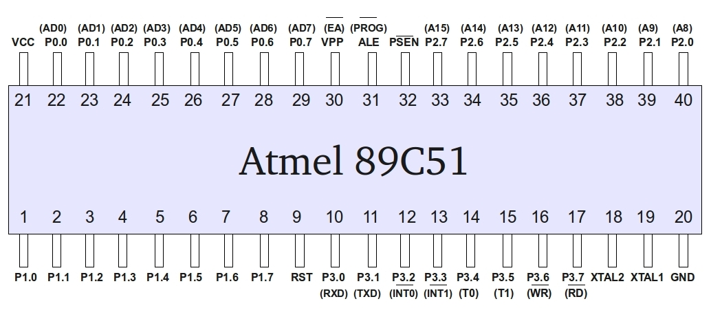
4.3.3 PINS DESCRIPTION ^{[7]}
PORT 0
Port 0 of the microcontroller 89c51 ranges from pin number 22 to 29. This port is an 8-bit open drain bi-directional input. Port 0 can work in two states. When we are talking about the first state that is when it is being used as multiplexed low order data or address bus. In this state it does not need external pull-ups; it is being served by the internal one. When we are in other state that is when we are using it to give the outputs of the code bytes during program verification. In this state there is no internal pull-ups given to it. So, we need to put external pull-ups that are external pull-ups resistor array to get the output from this port.
PORT 1
Port of 89c51 ranges from pin number 1 to 8. It is also 8-bit bidirectional input output port. This port does not need external pull-ups as it has got internal one. When we write ones on these port internal pull-ups gets high too so we can use it for input purpose.
PORT 2
Port 2 ranges from pin number 33 to 40. Port 2 of the controller is also 8-bit bidirectional with internal pull-ups. Same procedure is followed by this port as we seen it in port 1, if ones are given to this port internal pull-ups also got high hence allowing to use it as inputs.
PORT 3
Port 3 ranges from pin number 10 to 17. Port 3 is also the same as port 2 having internal pull-ups and allowing to be used as inputs. Moreover port 3 has several other functions too which we will see in the coming part.
GROUND
The ground pin of this controller is pin number 20.
VOLTAGE
The Vcc pin of this controller is pin number 21.
EA/VPP
This is external access enable pin. If we are fetching the code from external program memory then this pin should be grounded. To use the internal program executions, this pin should be connected to Vcc.
ALE/PROG
ALE is address latch enable and is used to show the start of any operation.
PSEN
PSEN stands for program store enable and is used to strobe external program memory. It is activated when we are using external program memory.
RXD P3.0
The pin number on the controller for this is pin number 10. It is the serial input port.
TXD P3.1
The pin number for this on the IC is 11 and is used for serial output port.
INT0 and INT1
INT0 and INT1 are located at pin number 12 and 13 respectively. These are two external interrupts for the controller.
T0 and T1
T0 and T1 are on pin number 14 and 15 and are serving as timer 0 and 1 for the external input.
WR
This is pin number 16 of the controller and is used for external data memory write strobe.
RD
This is pin number 17 and is used for external data memory read strobe.
XTAL2 and XTAL 1
These are pin number 18 and 19. XTAL1 is the input to inverting oscillator amplifier and also input to internal clock. XTAL2 is the output of the inverting oscillator amplifier.

4.4 MAX 232
MAX 232 is used for serial communication^{[8]}. It is compatible with the standards of RS-232. MAX 232 is basically a driver as well as a receiver. It is operated at 5V. Its most important operation is to generate supply voltage levels TIA/EIA-232 from a single 5V source. It converts the TIA/EIA-232 to CMOS TTL levels. EIA/TIA is the most commonly used serial line standards. MAX 232 requires 5 capacitors that are used by internal pumps in generating the required level. There are two receivers and transmitters in one MAX 232 so two serial communications can be done with a single chip.
4.4.1 PIN CONFIGURATION ^{[9]}

4.4.2 PINS DESCRIPTION
C1+ External capacitance of positive voltage multiplier unit
V+ Output of positive voltage of multiplier unit
C1- External capacitance of positive voltage multiplier unit
C2+ External capacitance of negative voltage multiplier unit
C2- External capacitance of negative voltage multiplier unit
V- Output of negative voltage of multiplier unit
T2out Output of transmitter’s data
R2in Input of receiver data
R2out Output of receiver data
T2in Input of transmitter data
T1in input of transmitter data
R1out Output of receiver data
R1in Input of receiver data
T1out Output of transmitter data
GND Ground
Vcc Supply voltage

4.5 ADC 0804
Analog to digital converter 0804 is very commonly used ADC. ADC0804 is a successive approximation 8 bit A/D converter. The main feature of this ADC is that it can be sued as a standalone converter. It does not need to depend on some other component with it. This model of ADC is very successful and efficient to be used with microcontrollers. So, the purpose for using this specific model is because it is easy for compatibility with the microcontroller. This ADC can be used simply to give digital data to a microcontroller. There is no need of some programming logic for its interfacing with the microcontroller.
Our purpose was just to convert the incoming data from the potentiometer in digital form and pass it on to the microcontroller. So, this ADC was a very good choice to use with our logic.
4.5.1 PINS CONFIGURATION ^{[10]}

4.5.2 PINS DESCRIPTION
CS Chip select
RD Read
WR Write
CLK IN Clock in
INTR Interrupt
Vin+ Analog voltage input
Vin- Analog voltage input
AGND Analog ground
Vref/2 Voltage reference / 2
DGND Digital ground
DB 7 to DB 0 Data bit from MSB to LSB
CLKR Clock reset
Vcc Positive supply

4.6 LCD
The LCD is used to display the information of the fuel level at the site of BTS. We have used the LCD model JHD 162A which comes with back light. The LCD is very simple to use. One just has to provide necessary voltage and ground to the LCD pins. The data to be displayed is given to the LCD with the help of data lines simply.
4.6.1 PINS CONFIGURATION ^{[11]}
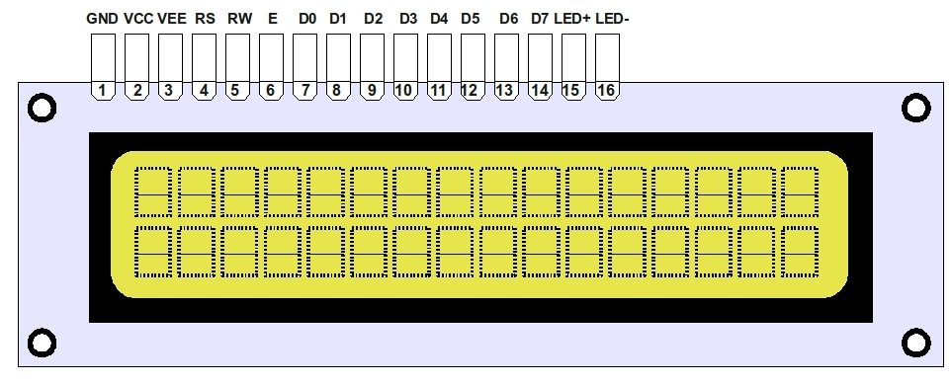

4.6.2 PINS DESCRIPTION
Pin 1 VSS
Pin 2 Vcc
Pin 3 Vee
Pin 4 RS
Pin 5 R/W
Pin 6 E
Pin 7 to Pin 14 DB0 to DB7
Pin 15 LED+
Pin 16 LED-

4.7 DB9
DB9 port is used for serial communication of the microcontroller using max232. The DB9 port is used to connect mobile with the help of serial communication. The pin configuration and its description of DB9 port are given below.
4.7.1 PINS CONFIGURATION ^{[12]}

4.7.2 PINS DESCRIPTION
DCD Data carrier detect
RD Receive data
TD Transmit data
DTR data terminal ready
SGND Ground
DSR Data set ready
RTS request to send
CTS Clear to send
RI Ring indicator

4.8 MOBILE PHONE

Mobile phone is connected to transmit the fuel level wirelessly with the help of a sms. The mobile phone we chose is T290 Sony Ericson. The reason for selecting this specific model is its compatibility with the AT commands. We first selected nokia 6020 and then sonyericson K300i. The issue with these models is that they support AT commands but they are in PDU mode that is the 0 mode when you check it on the hyper terminal. Only that specific model can be used with AT commands with any conversion which support text mode that is known as mode 1. The mode and compatibility of any mobile model can be checked by connecting it to the serial port of the computer and giving the AT commands at hyper terminal. The Sony Ericson T290 supports both mode 0 and mode 1. So, it was the right model for our project because we can use AT commands directly to send text messages at the required number.

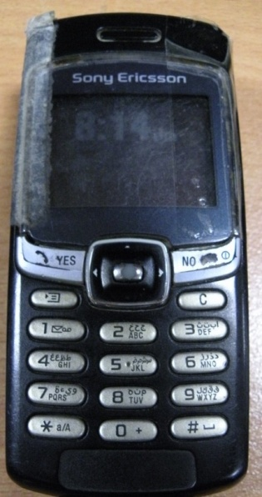

5.1 HARDWARE
The hardware part of the project is usually the most important one. The reason of its importance is because all the work done up till this stage is planned and designed to implement it on hardware. So, this part is basically the practical implementation of all the approaches and ideas thought and considered till now in order to get the required results.
The hardware part of our project contains the fabrication of circuits of different parts and then interfacing them to get the required product. We decided to go on with the fabrication process in steps.
The first step was to make the circuits on bread board in order to check them and make necessary changes if needed in the initial design and parts selection. So, all the circuits were first made on bread board to check their working and finalizing their components so that they can be fabricated for permanent use.
Now, we see that which circuits we had to make for the desired outcome. The hardware part contained the following things
- Potentiometer fitting on a container
- Power supply circuit
- Complete control & processing unit circuit
- Transmission & display unit circuit
- Interfacing of potentiometer unit with control & processing unit
- Interfacing of the control & processing unit with the transmission & display unit.

5.2 POWER SUPPLY CIRCUIT
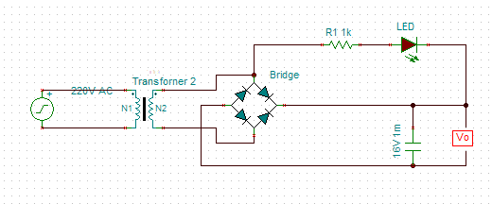
5.2.1 COMPONENTS USED
- Transformer 220 V to 9 V
- Bridge rectifier made of 1N4007
- Resistor
- LED
- Capacitor
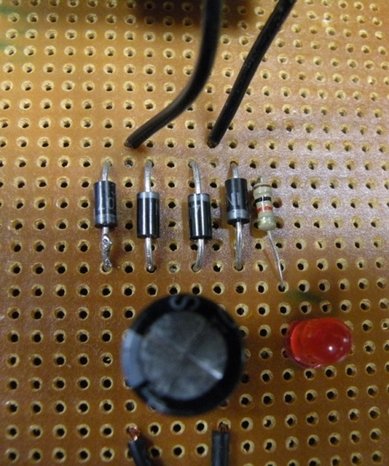

5.2.2 LOGIC OF THE CIRCUIT
The power supply is needed to convert the 220 AC voltage to 9V AC. The transformer we used is converting the 220V AC to 9 V AC. Further we have made bridge rectifier with the help of 1N4007 in order to rectify the input sine wave. Further we are using the capacitor to filter out the AC component in the signal. The final output is 9V DC. The LED and resistor are just used to indicate that we are getting the required voltage. It is basically working as an indication of the circuit to be on.
5.2.3 SIGNALS AT DIFFERENT TEST POINTS
Signal at output of transformer

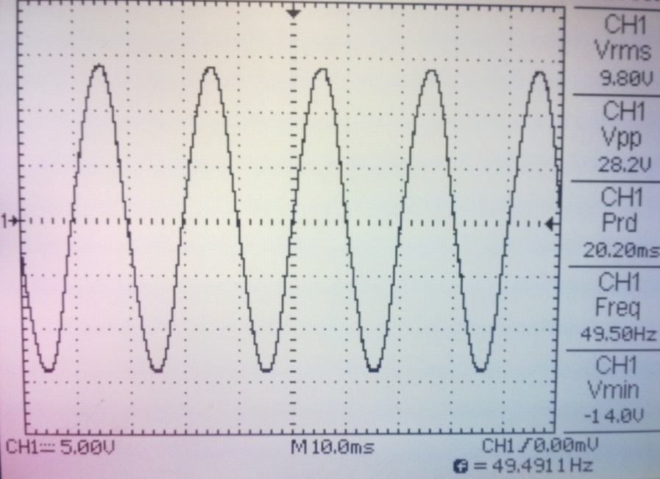

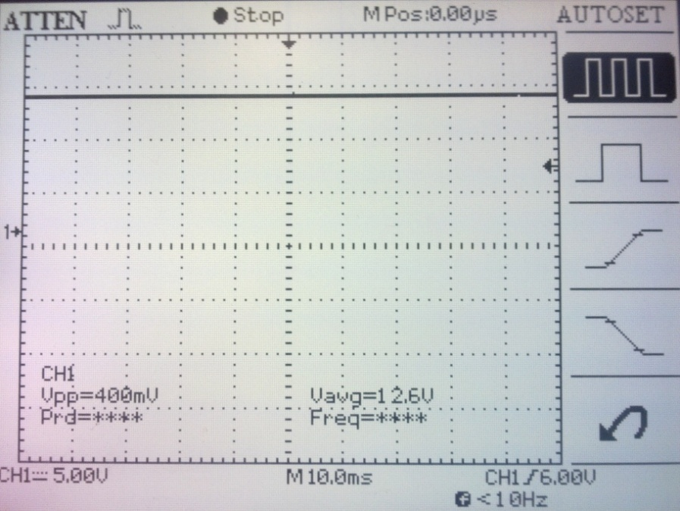
5.2.4 HARDWARE SNAPSHOT

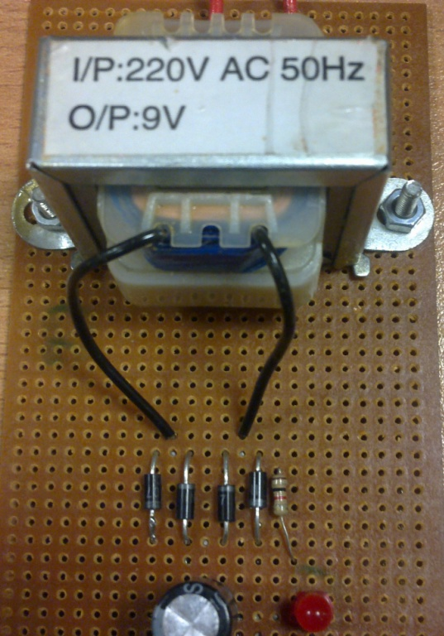

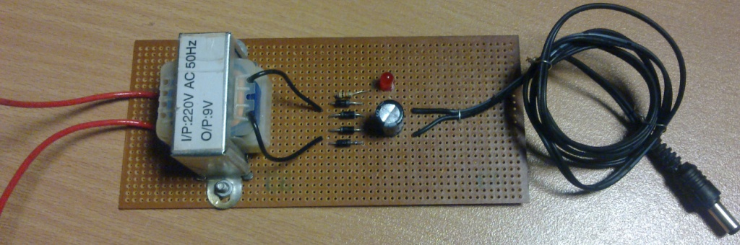
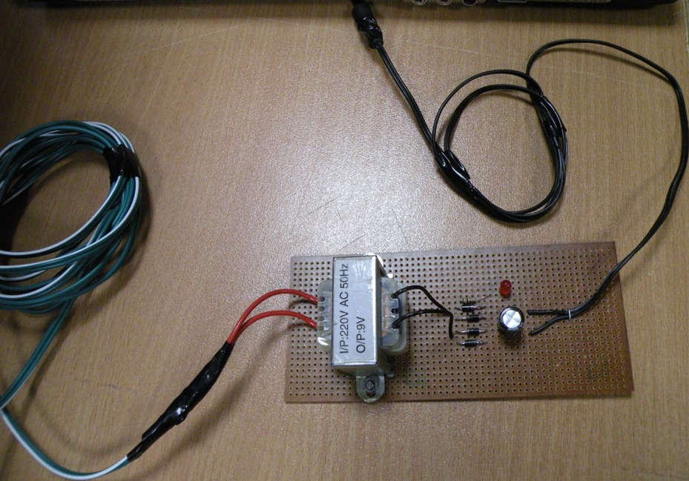

5.3 ADC
ADC Analog to Digital Converter
The model we used for analog to digital converter is ADC 0804. The pin configuration of the ADC 0804 is given below.
5.3.1 PINS CONFIGURATION

5.3.2 WORKING
The ADC 0804 is integrated in the circuit to convert the analog data coming from the potentiometer. The potentiometer is sending the analog data to the ADC so that it can be converted to digital form. The data is needed in digital form so that it can be processed in the microcontroller. The data pins of the ADC 0804 are from pin no 18 to pin no 11. Pin 18 is the least significant bit and the pin 11 is most significant bit. The digital data converted by the ADC is fed to microcontroller with the help of data pins of the ADC. The data is directly fed to one of the ports of the microcontroller. The hardware snapshot of the ADC fabricated in the hardware circuit is given below.
5.3.3 COMPONENTS USED
- ADC 0804 IC with jacket
- Capacitor
- Resistors
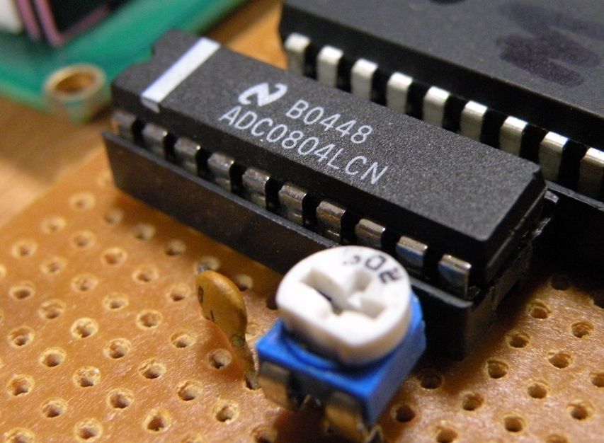

5.3.4 HARDWARE SNAPSHOT

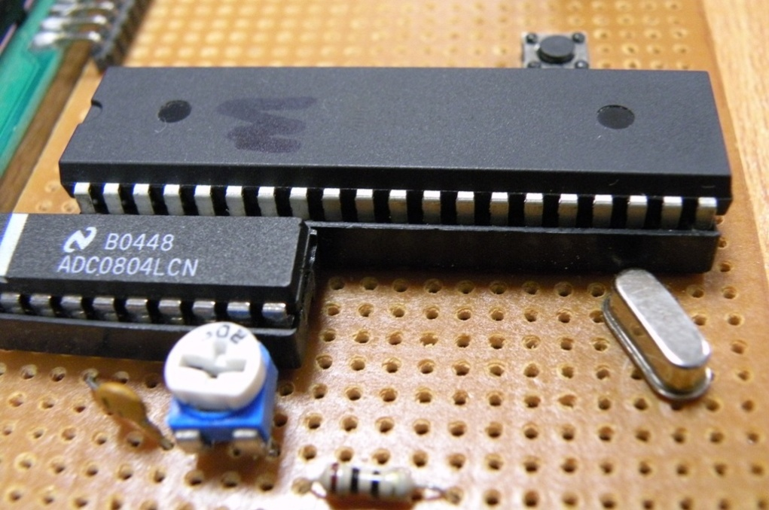

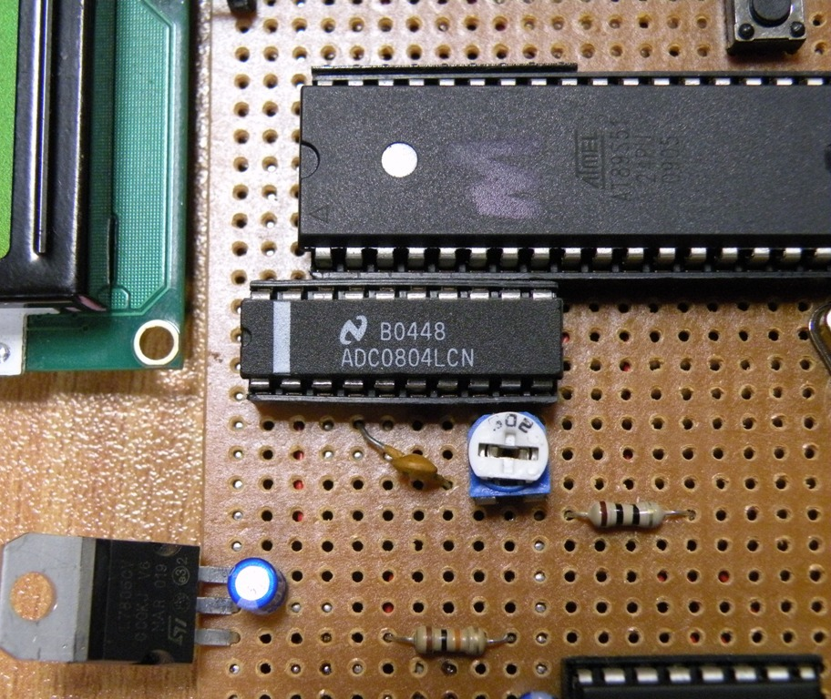

5.4 MICROCONTROLLER
The microcontroller we used is 89C51. The reason for selecting this microcontroller and also the specification of this model is already been discussed in the equipment selection chapter.
Microcontroller pin configuration is given below.
5.4.1 PIN CONFIGURATION
5.4.2 WORKING
The microcontroller is the main part of the hardware. It is controlling all the processing of the logic. The data is fed to its one of the ports by the ADC. The data fed is digital and is easy to process it.
The microcontroller coding is done by us in C language. The reason for using the C language for coding is this that we are familiar with the C language coding and is also easy than the assembly language coding. The code is burnt in the microcontroller which was made on the software first.
The coding part of the project will be explained in one of the next chapters that will be the software part. The main logic used is very simple. The data which is coming from potentiometer is giving variable values. The analog data is fed into the ADC to get the digital form of the data so that it can be easily processed by the microcontroller.
5.4.3 COMPONENTS
- 89C51 microcontroller IC with jacket
- Crystal oscillator
- Capacitors
- Resistors
- Push button
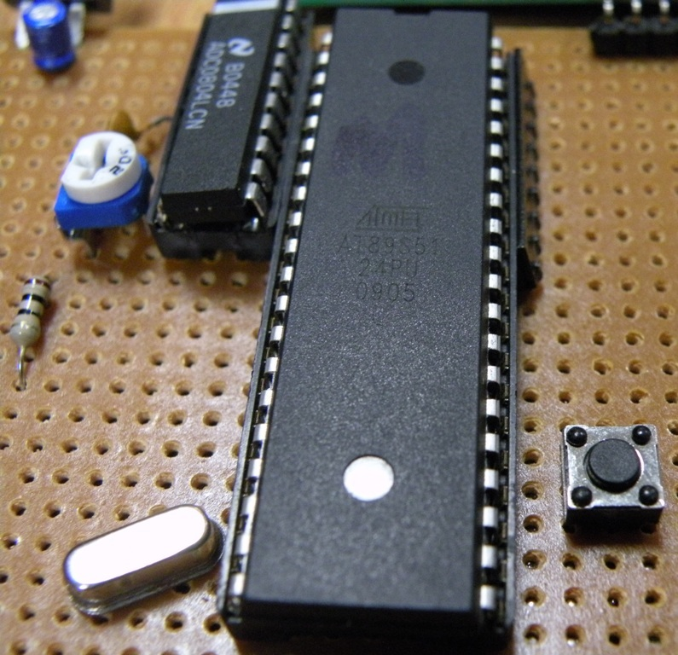

5.4.4 HARDWARE SNAPSHOT

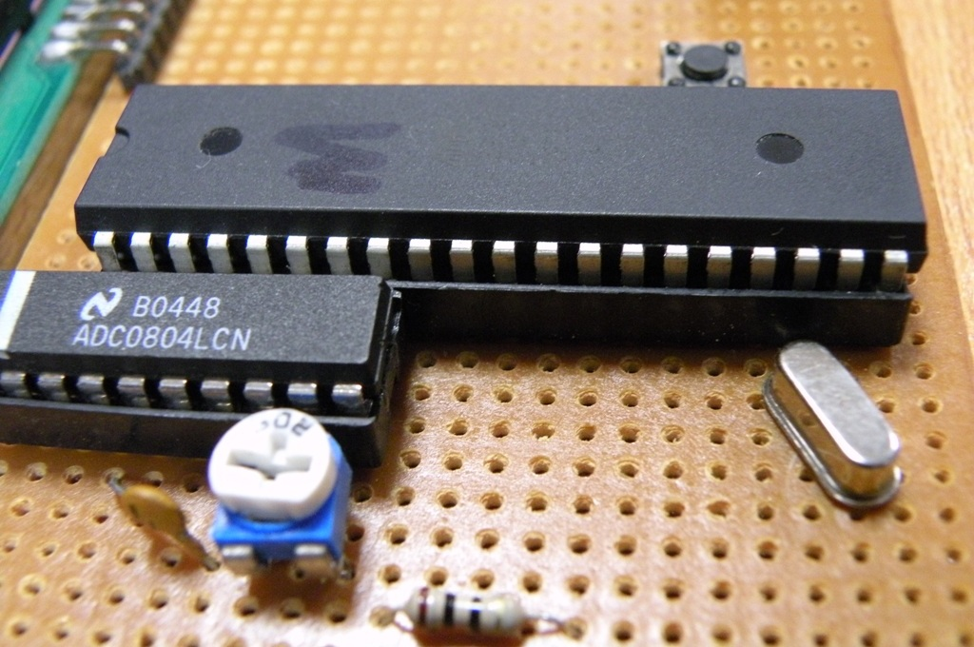

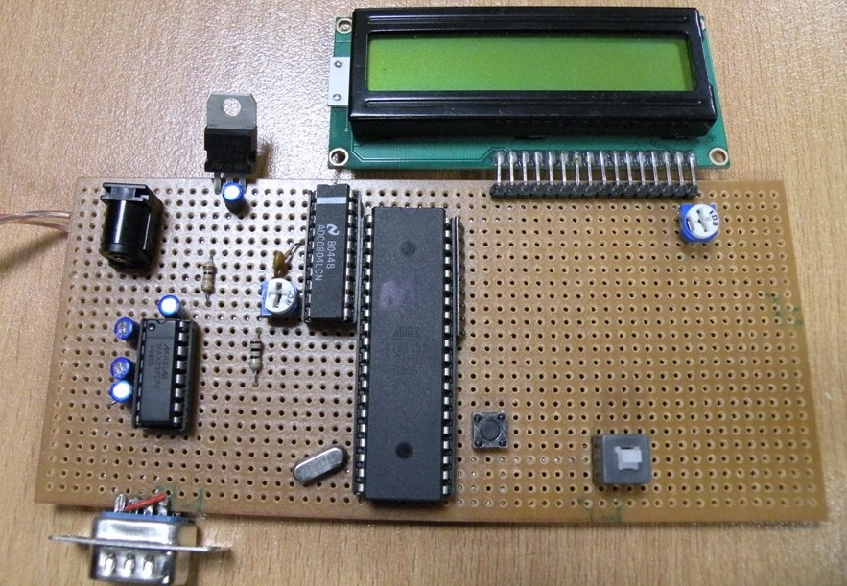
5.5 MAX 232
MAX 232 is used to connect microcontroller to the mobile phone serially. It is used to convert the information in serial form so that it can be connected to any serial device for transmission.
5.5.1 PINS CONFIGURATION

5.5.2 WORKING
The microcontroller processes that data and final result is fed to the MAX232 so that it can be interfaced to the serial port for communication through mobile.
5.5.3 COMPONENTS USED
- MAX 232 IC with jacket
- Resistors
- Capacitors

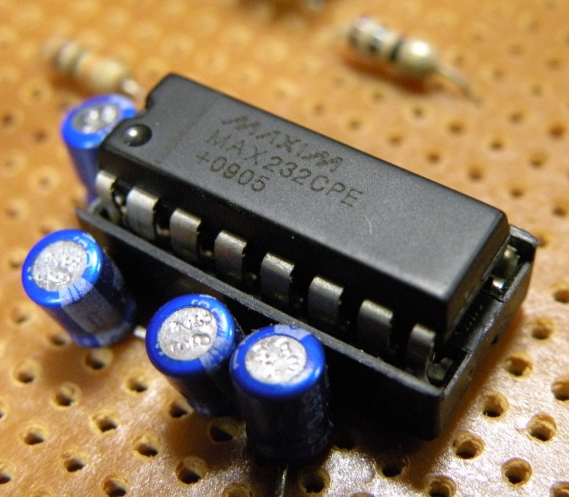

5.5.4 HARDWARE SNAPSHOT

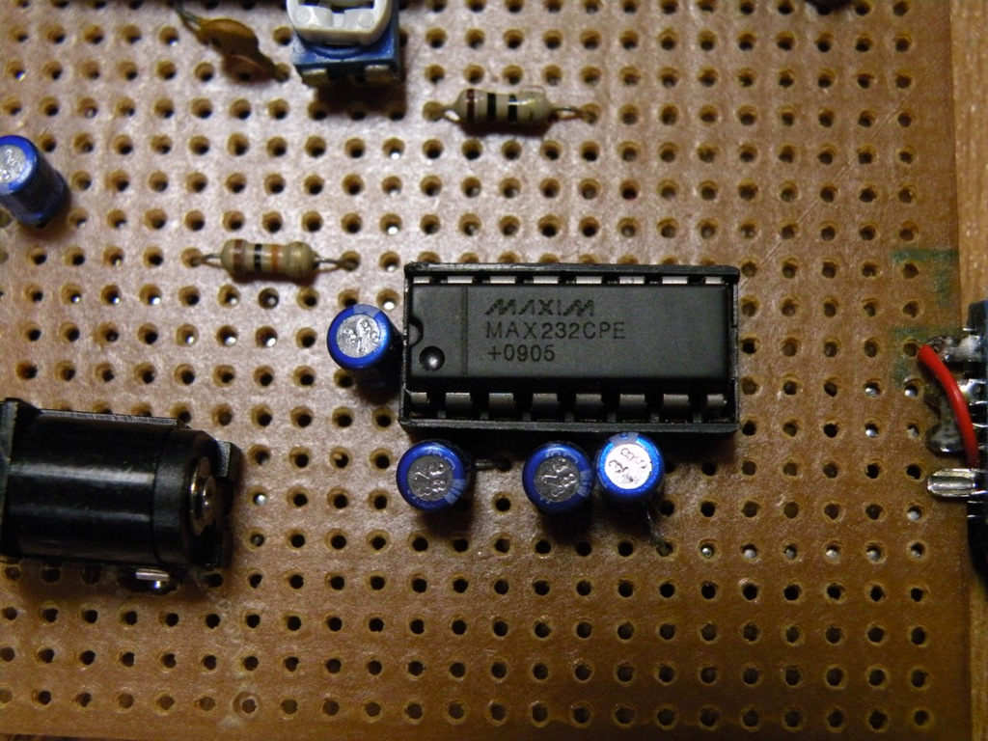
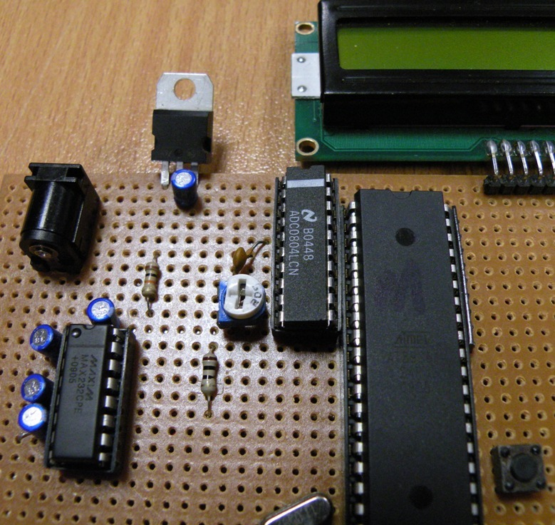

5.6 DB9 PORT
DB9 is used to communicate serially with the mobile phone. We need to send that data also wirelessly so we are using mobile that will be connected through DB9 port.
5.6.1 PINS CONFIGURATION

5.6.2 WORKING
The DB9 port is used to connect mobile serially to the microcontroller using the MAX 232. The MAX 232 is converting the information so that it can be connected serially to the mobile phone. The male port is connected with the circuit. The reason is that the mobile phones’ serial cables are having the female port so it can be connected easily to a male port in the circuit. The mobile is first checked by connecting to a computer serial port. The AT commands are checked in the hyper terminal. The AT commands used to send message will be discussed in the next chapter.

5.6.3 HARDWARE SNAPSHOT

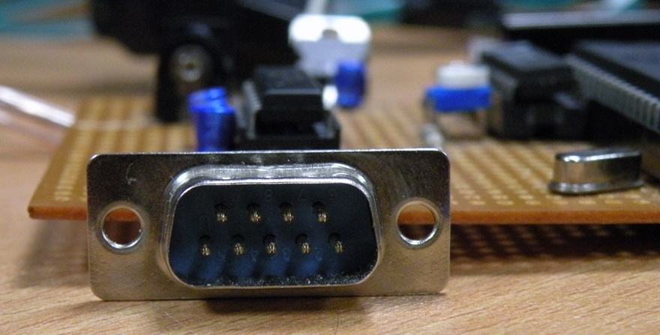

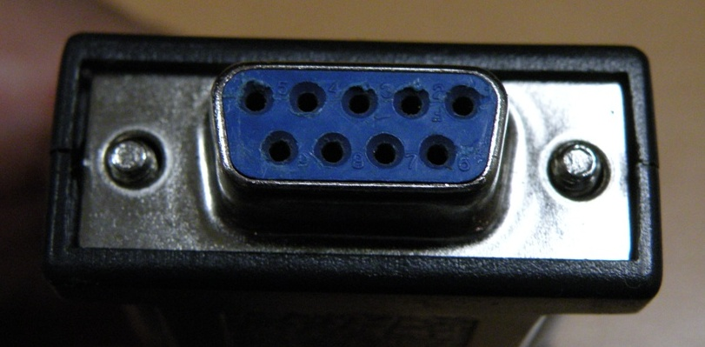

5.7 LCD
LCD is used to display the results at the site of BTS. We are transmitting the information via sms but we are also displaying information on LCD at site. The LCD is connected to port 0 of the microcontroller. It has been discussed earlier also that there is no internal pull-ups resistor in the port 0 of the microcontroller so we used external resistors in order to get the outputs from the port 0 of the microcontroller.
5.7.1 PINS CONFIGURATION

5.7.2 WORKING
The LCD working is simple. We are giving proper voltage and ground at the specific pins of the LCD. Moreover the data from port 0 is being sent directly to all data pins of the LCD. The LCD is simply displaying all the information that is being sent by the controller at the port 0. We have used a resistor array at the port 0 that is acting as external pull-ups. A variable resistor is also used with pin number 1 and 2 and output is given to pin number 3 of the LCD. The purpose of this variable resistor is to control the brightness of the LCD.
5.7.3 HARDWARE SNAPSHOT

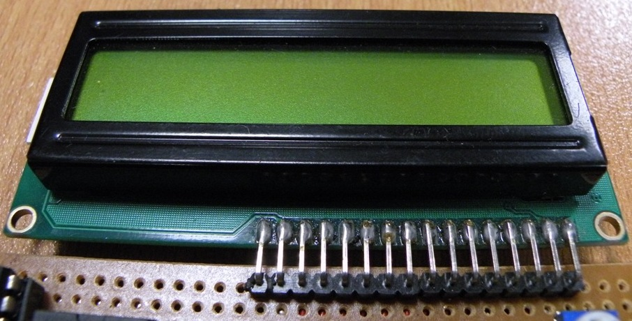

5.8 VOLTAGE REGULATOR
The voltage regulator is made in the circuit to maintain the voltage for all ICs and LCD to be 5V. The output of the power supply is 9V DC. So we are using a voltage regulator that will convert that 9V DC to 5V DC.
5.8.1 COMPONENTS USED
- Voltage regulator 7805
- Capacitor
5.8.2 HARDWARE SNAPSHOT

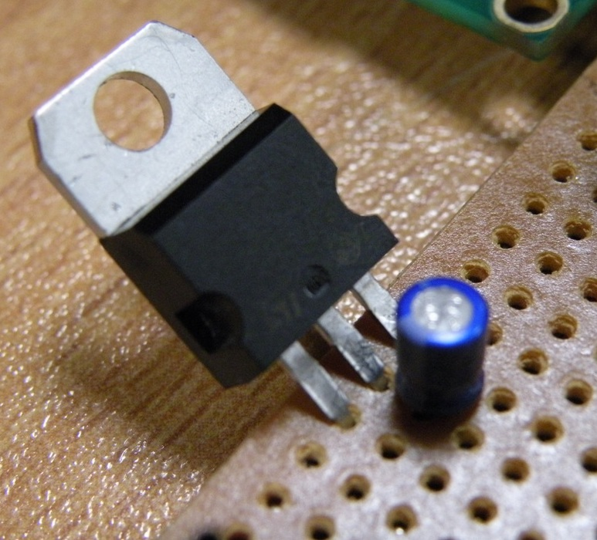

5.9 MOBILE PHONE
Mobile phone we are using is T290. It is connected to DB9 male port of the circuit with the help of a serial cable. The snapshot of that is given below.
5.9.1 SNAPSHOT
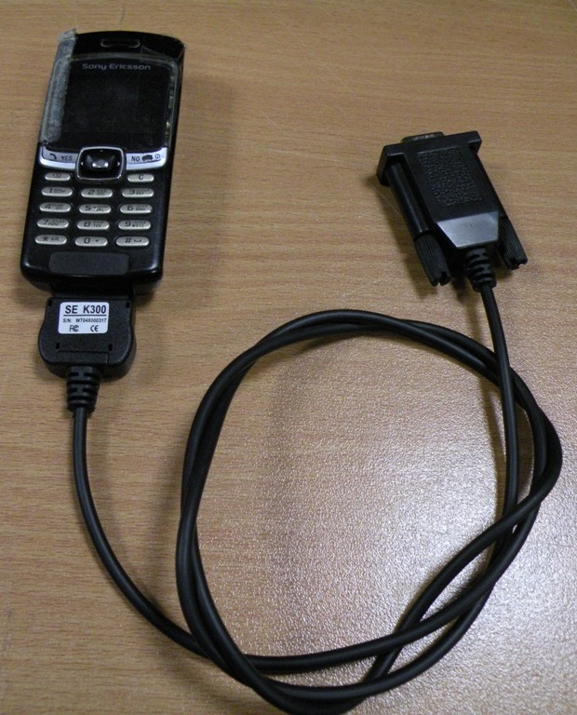
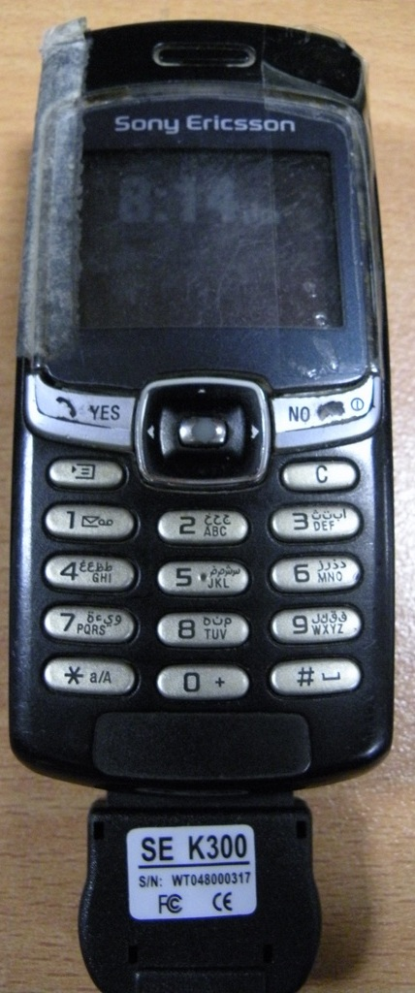
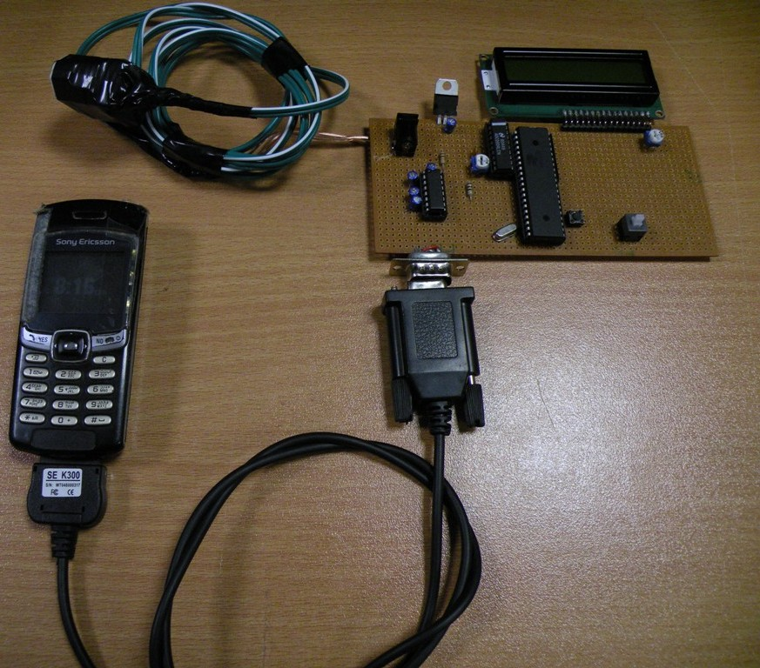

5.10 POTENTIOMETER
The potentiometer fixed at top of the tank to suspend wait in the water is the model that give 0 to 5 V in 255 steps. The steps are from 0 to 255 that make it 256 steps in total. The total number of steps explains the logic that it is 8 bit data that is send to the ADC to get its digital form. The 8 bit digital form of the data is send directly on data line to microcontroller for processing.
5.10.1 HARDWARE SNAPSHOT

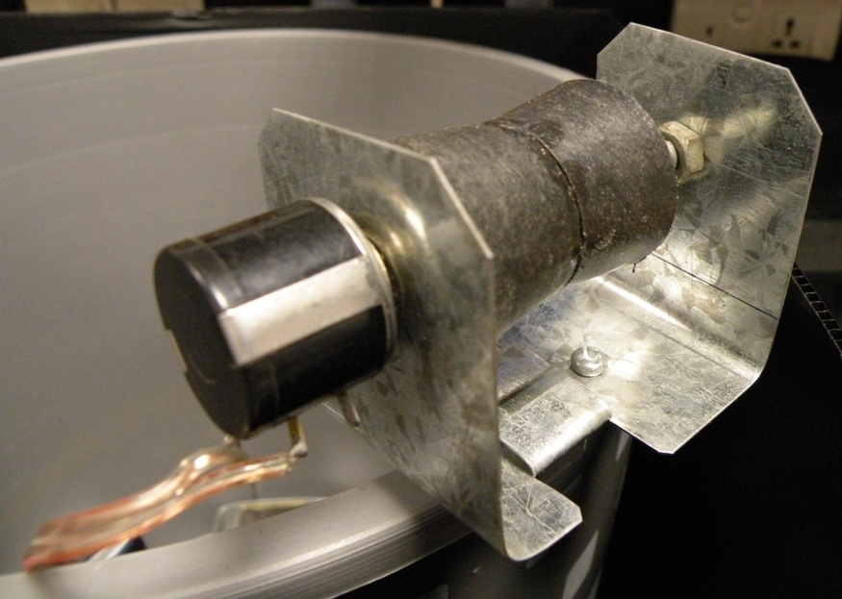

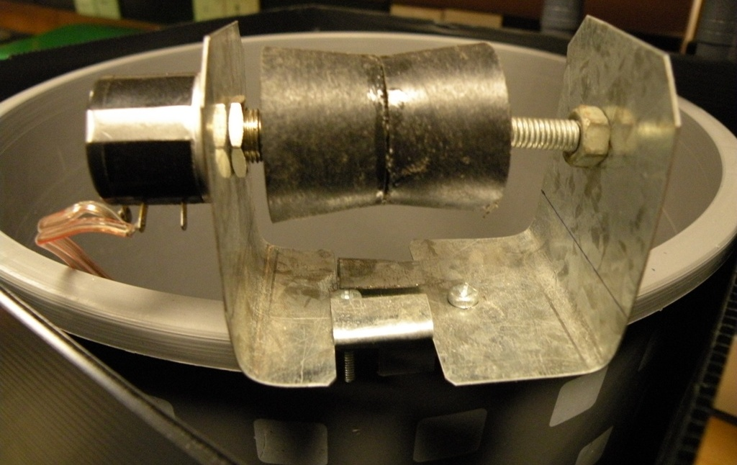
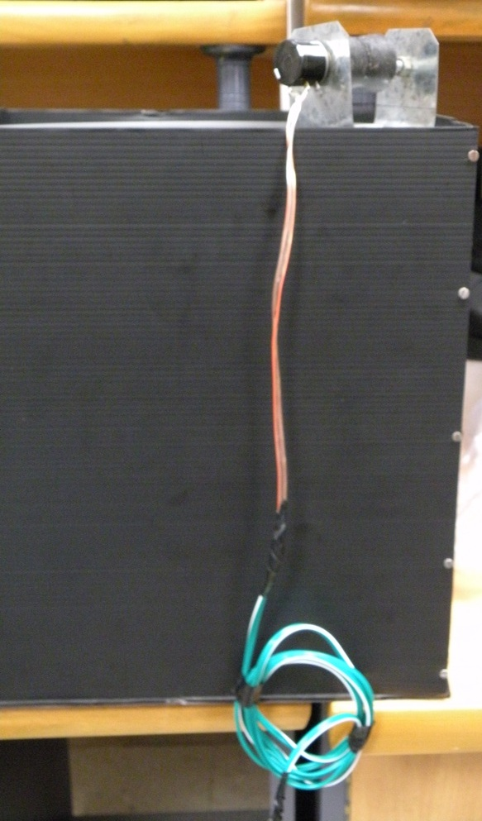

5.11 COMPLETE HARDWARE FABRICATION
The hardware was fabricated and different parts were interfaced with each other in order to complete the hardware. All the parts of the hardware were fabricated on Vero board and all the fixation of the components and the soldering was done by us. The circuit diagram and snapshots of the hardware are given below.

5.11.1 CIRCUIT DIAGRAM
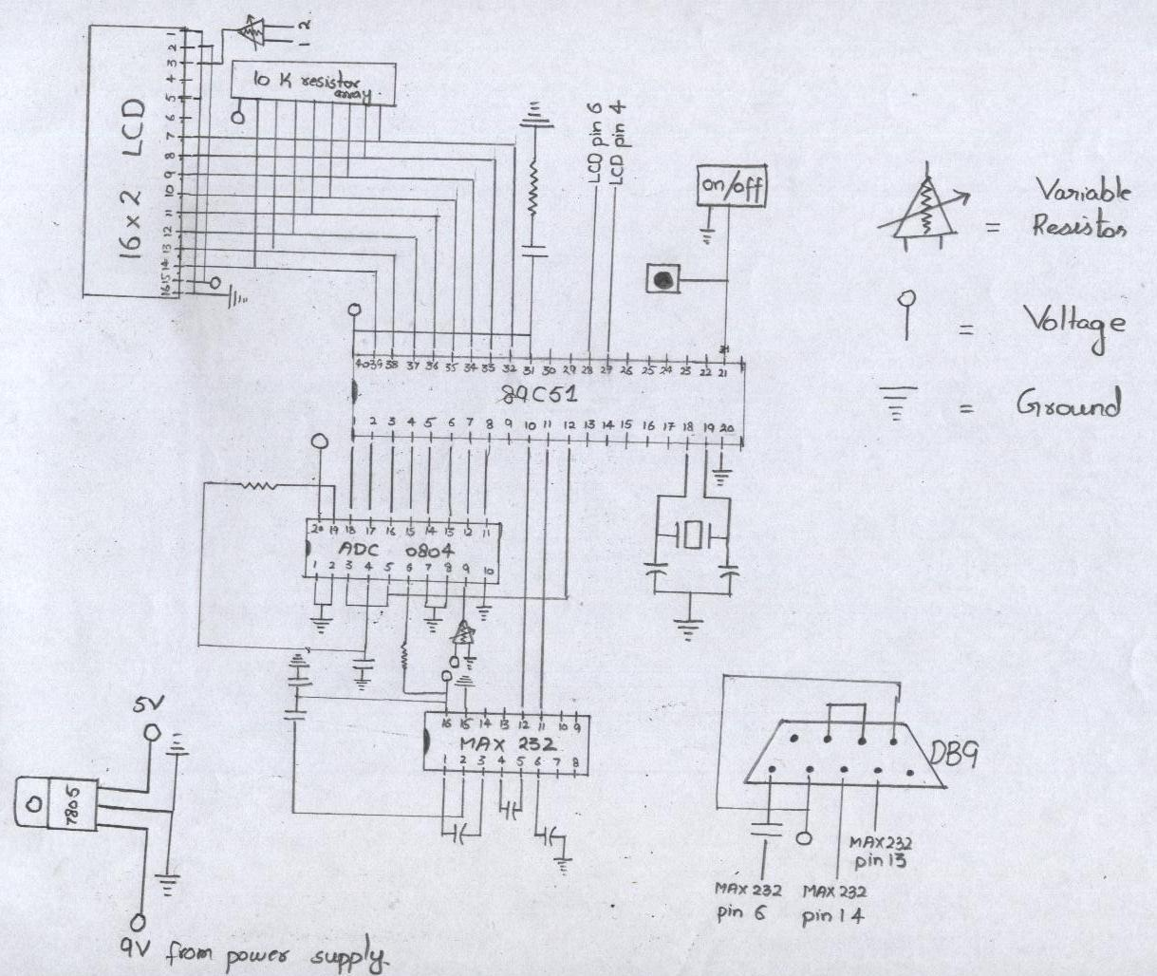
5.11.2 COMPLETE FABRICATED CIRCUIT SNAPSHOTS

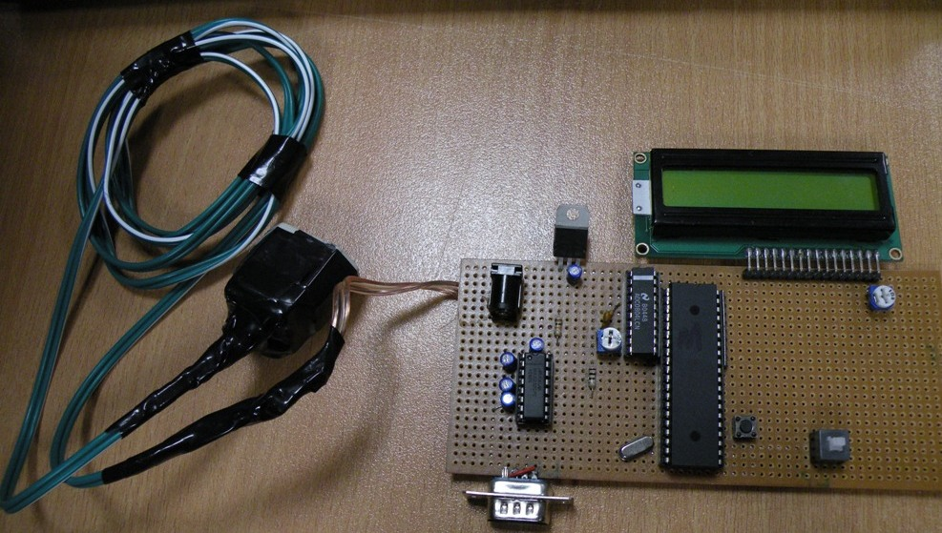
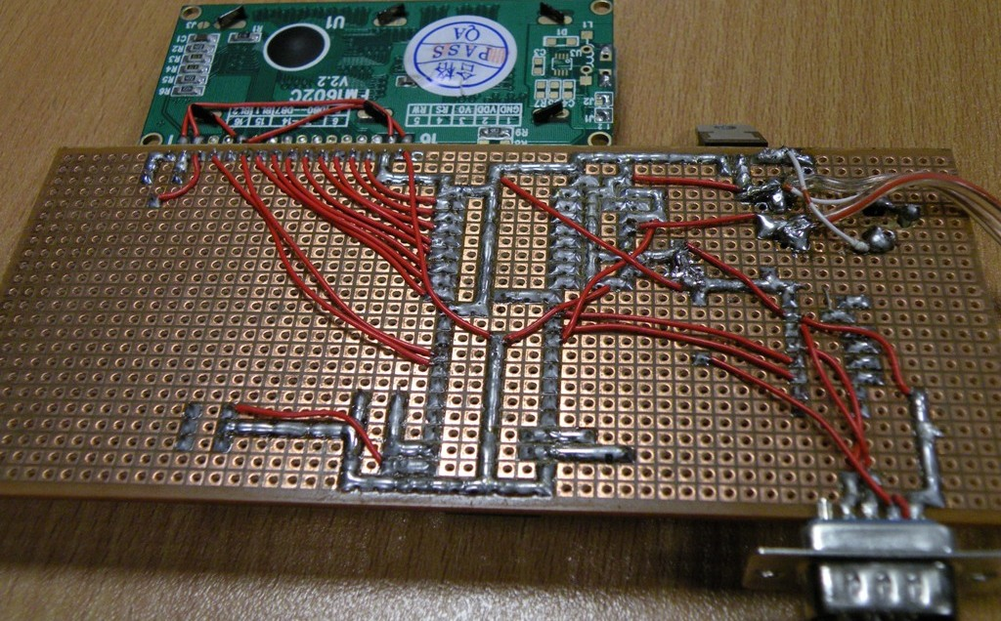

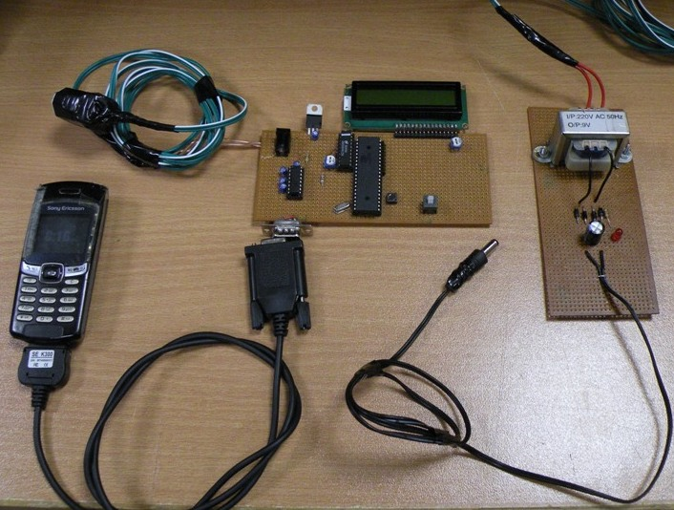
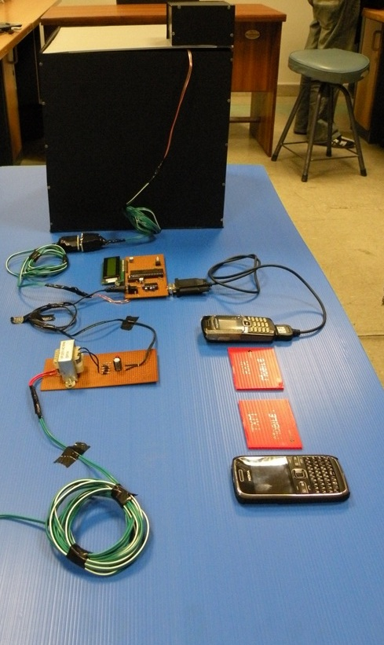

6.1 SOFTWARE
The software part of the project contains interfacing of the mobile with circuit by using AT commands^{[13]}, programming of the microcontroller and the ways of retrieval of the sent sms on the receivers side.
The purpose of our project is to measure the fuel level of the generator tank. We have seen the hardware part of the project that how we fabricated different parts and how we interface them with each other. The processing of the data that was coming in the microcontroller is done in the coding part of the project. We first see that how we interface the mobile using AT commands.

6.2 INTERFACING OF THE MOBILE USING AT COMMANDS
AT commands are the command set that is used to operate a mobile phone. Most of the phone in the mobile market support the AT command language.
We have already discussed in equipment selection chapter that we tried two to three mobile phones to get the appropriate mobile that can support the AT commands. We finalized the Sony Ericson T290 after testing the available mobiles. This model supports completely the AT commands and the AT command set that is used to operate the mobile.
Any mobile phone can be checked by connecting it to the serial port of the computer and by sending the commands from the hyper terminal. The hyper terminal is installed by default in windows XP. Now, we see how we check and send AT commands using the hyper terminal.

6.3 AT COMMANDS ON HYPER TERMINAL
When we connect the mobile to serial port of the computer, we open the application of hyper terminal. Once the correct port number and baud rate is selected we see a blank screen with a cursor blinking on it in front of us.
Now we discuss the AT commands we need for programming of the microcontroller. As our purpose of connecting mobile to the circuit is to send a text message so we need AT commands for this purpose.
To check whether mobile connected is alive or not we use the AT command ‘AT’. Type ‘AT’ and press enter. If the mobile phone is alive and connected correctly to the serial port it will respond with OK.
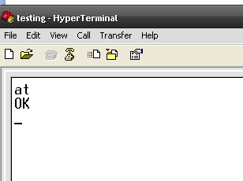
To check mode of the connected mobile AT command ‘AT+CMGF=?’ is used. The mobile phone responds with its mode. There can be 3 kinds of modes which are
- (0,1) which means the connected mobile support both the PDU and text mode.
- (0) which means the mobile support only the PDU mode so we need programming to send the message via sms.
- (1) Which means the mobile connected support the text mode.
When we give the AT command ‘AT+CMGF+?’ our mobile respond with the following reply:-
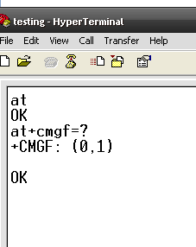
The (0,1) reply of T290 show that it supports both the modes. So, we are good to go to send the text message by simply using the AT command for the sms.
Next we use the AT command ‘AT+CMGF=1’. This command is used to check that connected mobile is text mode. If it is in text mode it will reply with OK.
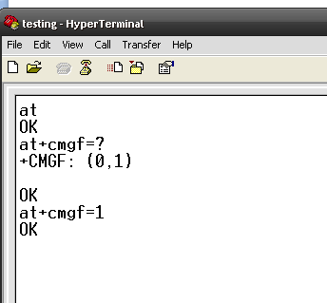
Now we apply the command of ‘AT+CMGS=”00923335248183”. This command is used to give the number of the recipient to which the text message is sent. By applying this command and pressing enter the hyper terminal will show ‘>’ which means enter the message you want to send to this number.
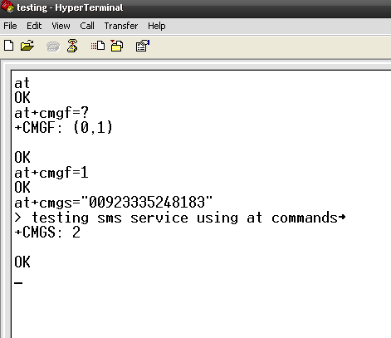
When you are done with writing the message then you just have to press ‘CTRL +Z’ to send the message. After delay of just few seconds it will respond OK which means message is sent to the desired number.
In this way the serial communication and compatibility of the mobile can be checked with the AT commands.

6.5 RECEIVER SIDE

There are so many ways to retrieve the sms at receiver side. It totally depend on telcos and their control room system that how they maintain the log of the received messages.

One simple way to connect the receiver mobile using the usb cable and connecting the mobile to computer in pc suite mode. So, you can maintain a log of the incoming messages and also you can back up the messages in the computer.

The other method is to connect the receiver mobile to com port of the computer. Then by using the MATLAB, Visual basic or any other software you can read the mobile data by reading the com port and the maintaining a log of the fuel levels or making a graph showing the fuel level of previous hours or days.

7.1 TESTING AND TROUBLESHOOTING
The hardware components we fabricated are interfaced to check the working of the circuits. All the components were interfaced and connected using appropriate cables and connectors.
All the fabricated circuits were working fine and there were giving the desired results. The level of the fluid in the tank is displayed on the LCD. Moreover the level is also transmitted automatically via sms through the connected mobile. The necessary AT commands to send the sms through the mobile is being given by the microcontroller. The microcontroller code also contain the AT commands that have been used to transmit the information via sms.
The snapshots of the testing of circuit are given below.

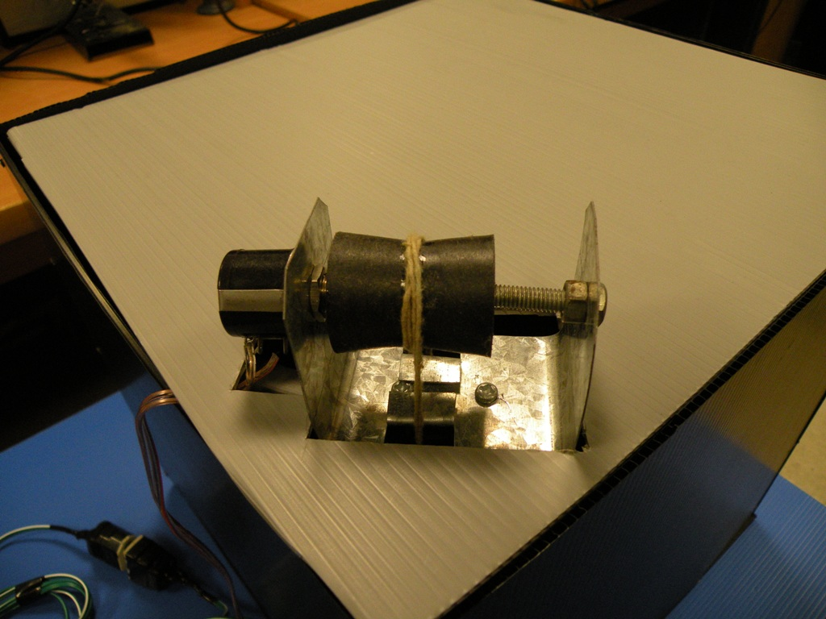
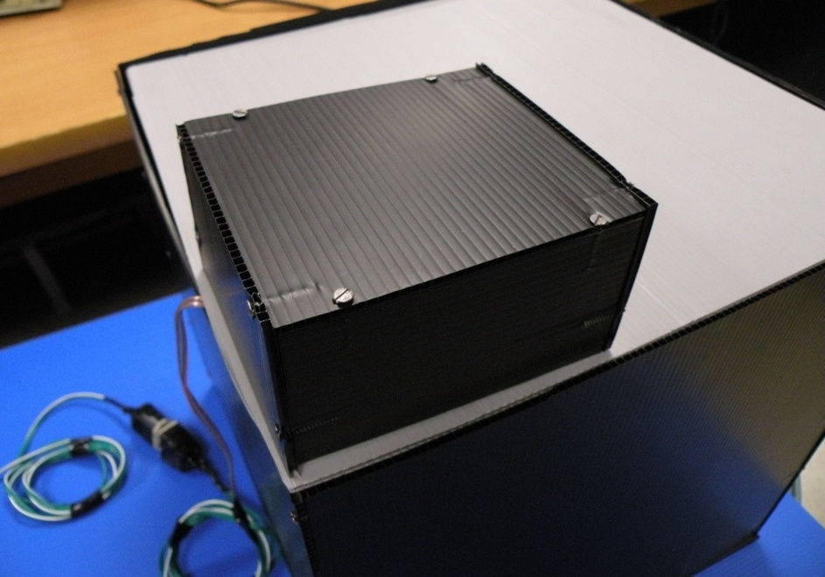

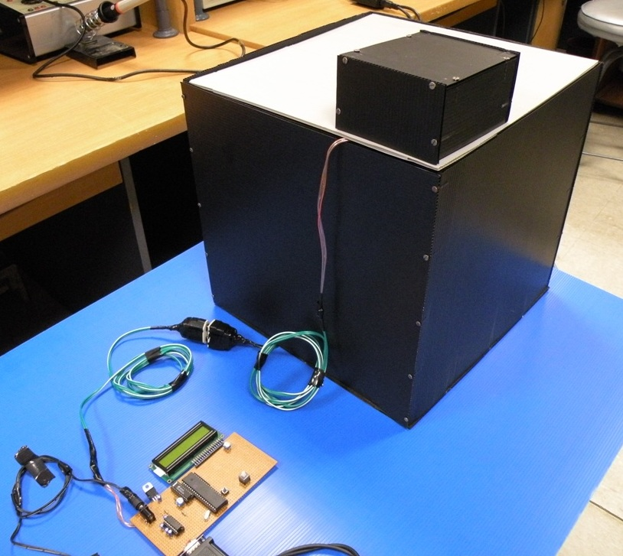
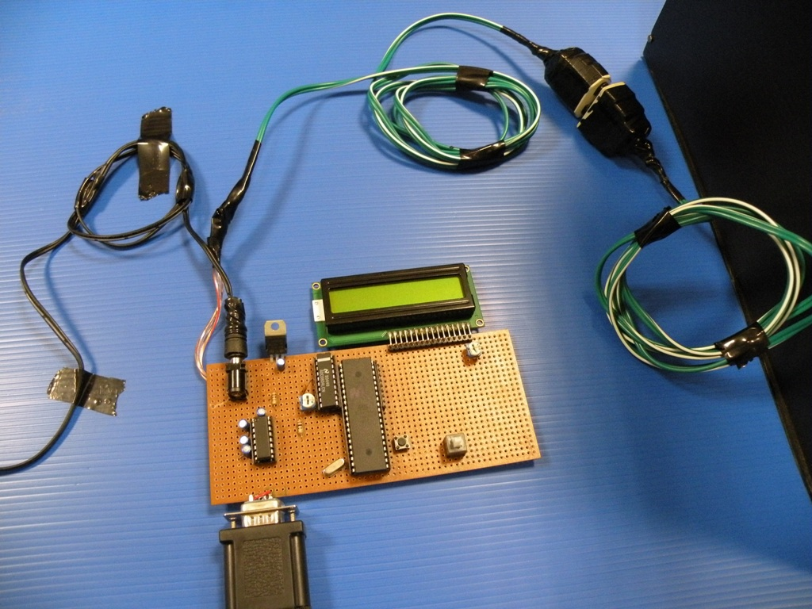

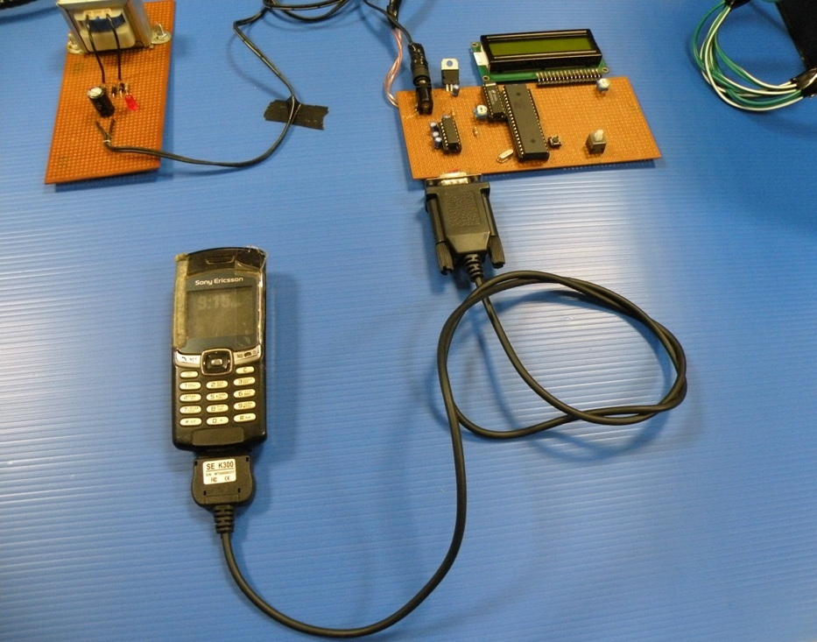
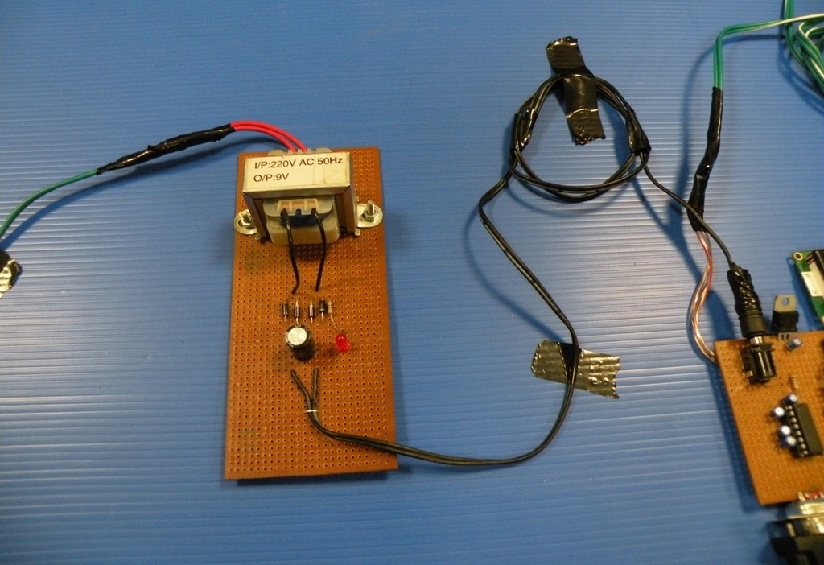

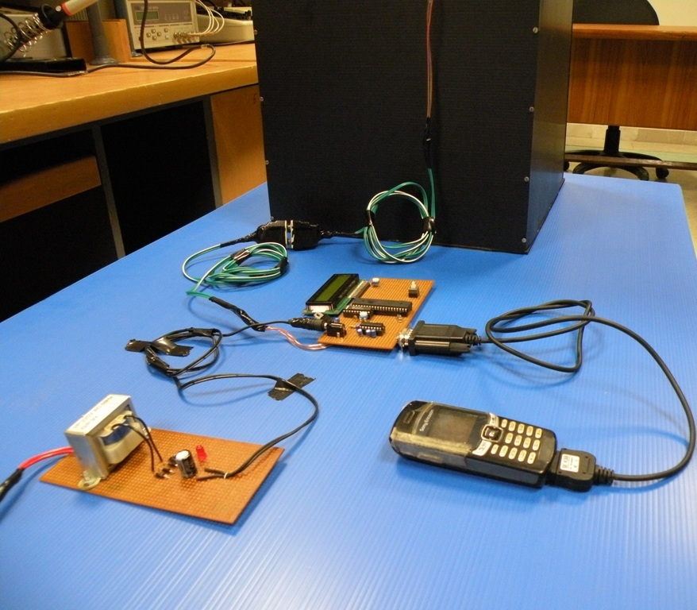
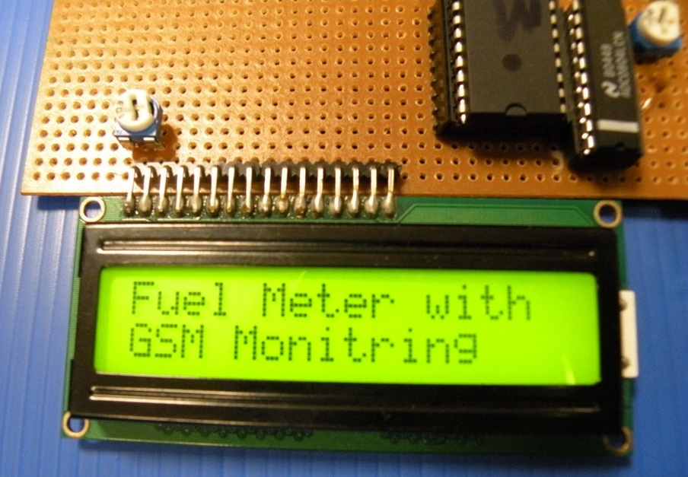

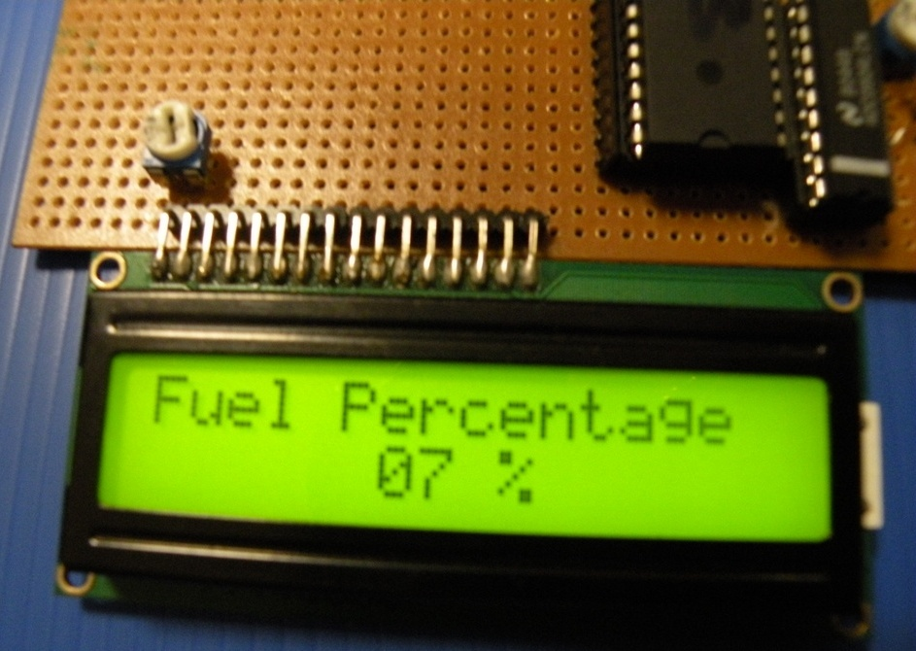
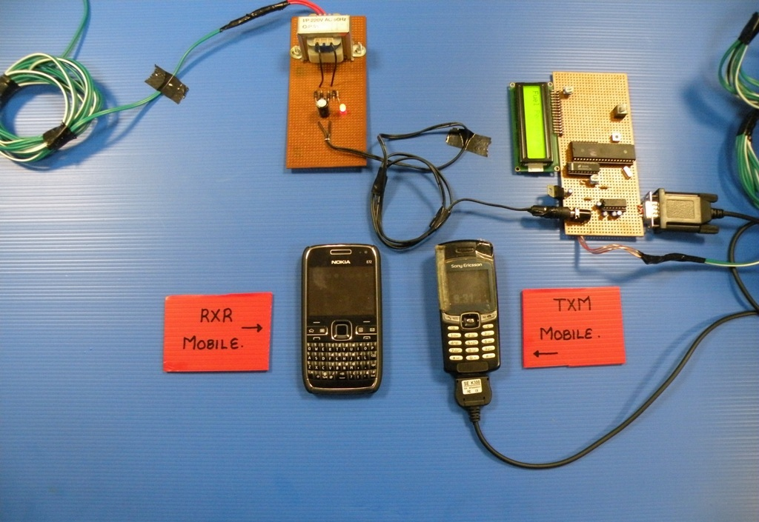

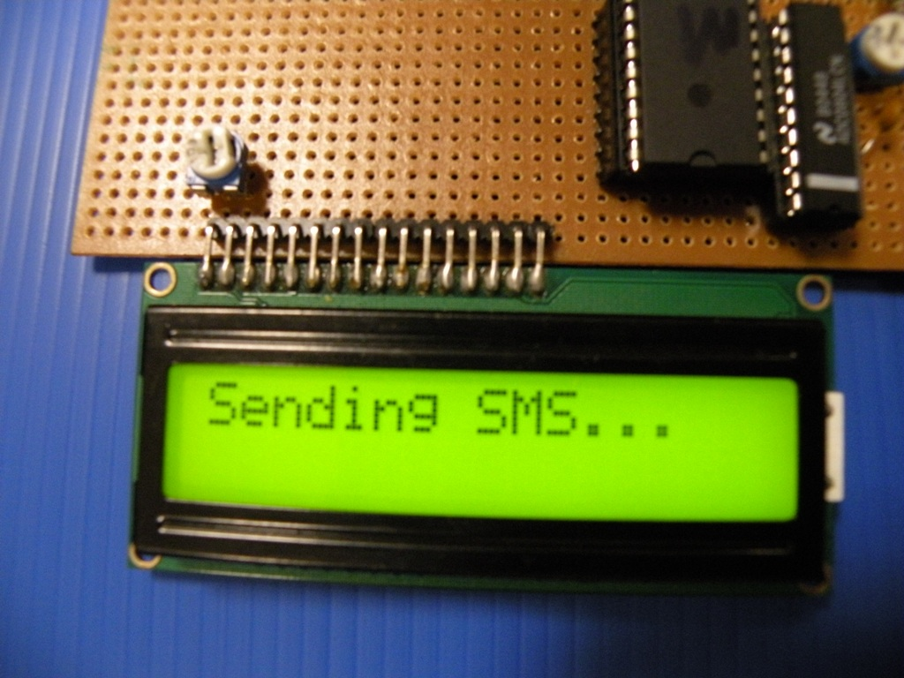
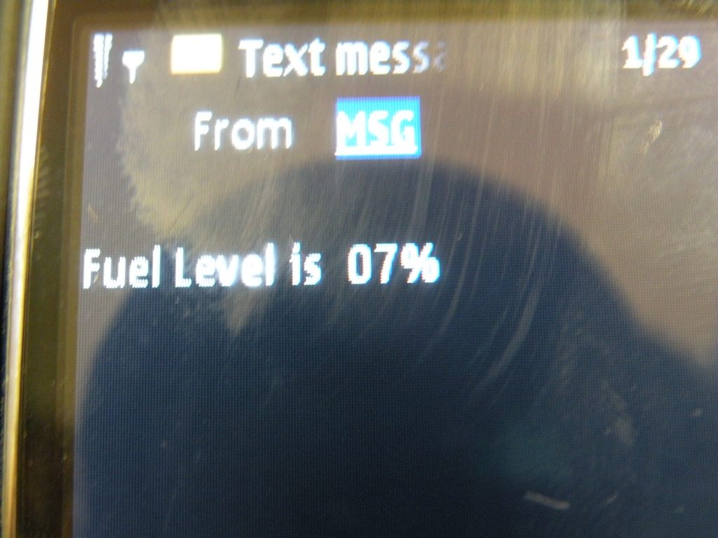

7.2 POWER RATING OF THE HARDWARE PARTS
The power rating of different components in the circuit is given below.
Component | Voltage (V) | Current (mA) | Power (W)
Microcontroller circuit board | 9 | 600 | 5.40
Mobile | 4.9 | 450 | 2.21
Potentiometer | 3.3 | 50 | 0.165
Total |  |  | 7.78

8.1 COST ANALYSIS
We tested different logics by using different components. Finally we succeeded in selecting the approach and logic to get the fuel level of the generator tank. The cost of design and circuits of the final logic that is tested successfully are given below.
Component Name | Cost in PKR Rupees
Potentiometer with tank | 300
ADC | 50
Microcontroller | 120
MAX 232 | 40
DB9 port | 40
LCD with backlight | 325
Transformer | 150
Other components | 250
Vero board | 100
Mobile phone with charger | 1000
Total Cost | 2375

8.2 FUTURE WORK
The float logic is used to measure the level of the fuel in the tank. This logic is very useful in measuring any liquid level in any tank or on larger basis. The same logic can be used to measure the water level in home tanks and getting the information about the level on your mobiles. This can be very useful as you need not to check the level by physically monitoring the water tank.
The logic and programming used to transmit the information wirelessly via sms can be used in so many applications. Car security systems are very important application for this. Whenever you leave the car and it is away from you, you can have a check on your car via sms. The circuit can be designed that can operate on your car battery. Whenever someone will start your car or try to steal it, you can get a sms giving information regarding the theft or starting of the car by unauthorized person.
These days home automated systems are very popular around the world. There are different functions in it like controlling different operations of your home via sms. You can control you home central air conditioning system with just one sms. There are so many other applications of this in home automated system.
The work we did on the project can be further taken forward to make the system more efficient and different other features can be added. On the receiving side of the messages you can have complete software that is controlling the fuel level. There can be fixed threshold levels of the fuel that whenever that level is reached an automatic sms is generated to the refilling team notifying that refilling is needed at the BTS site of some city or some mentioned place. Moreover, same circuit and design can be made as a product so that it can operate efficiently.

REFERENCES

[1]http://downloads.ziddu.com/downloadfiles/7773232/GSM%20MATERIAL%20CP02.pdf
[2]http://www.electronicsinfoline.com/Projects/Electronics/Infrared_and_Ultrasonic/Distance_Measurement/ultrasonic_range_finder_uses_few_components.shtml
[3] http://uk.farnell.com/multicomp/sq-40-t-10b/transmitter-ultrasonic/dp/213214
[4] http://www.best-microcontroller-projects.com/pic-sonar.html
[5] http://www.answers.com/topic/float-switch
[6] 8051 Microcontroller 3rd Edition Scott MacKenzie and 8051 microcontroller and Embedded System By Mazidi
[7] http://www.atmel.com/dyn/resources/prod_documents/doc0265.pdf
[8]http://en.wikibooks.org/wiki/Serial_Programming/MAX232_Driver_Receiver
[9]http://www.datasheetcatalog.org/datasheet/texasinstruments/max232.pdf
[10]http://www.datasheetcatalog.org/datasheet/nationalsemiconductor/DS005671.PDF
[11]http://www.alldatasheet.com/datasheetpdf/pdf/127934/ETC/JHD162A.html
[12] http://www.lammertbies.nl/comm/cable/RS-232.html
[13] http://www.lammertbies.nl/comm/cable/RS-232.html

