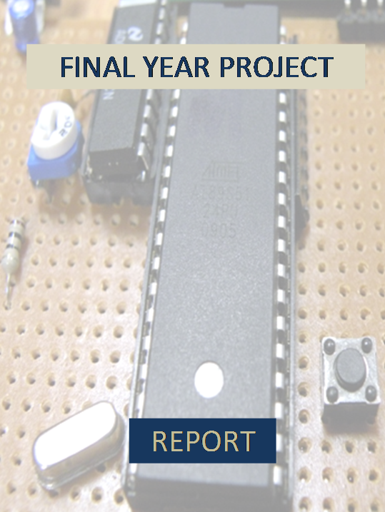

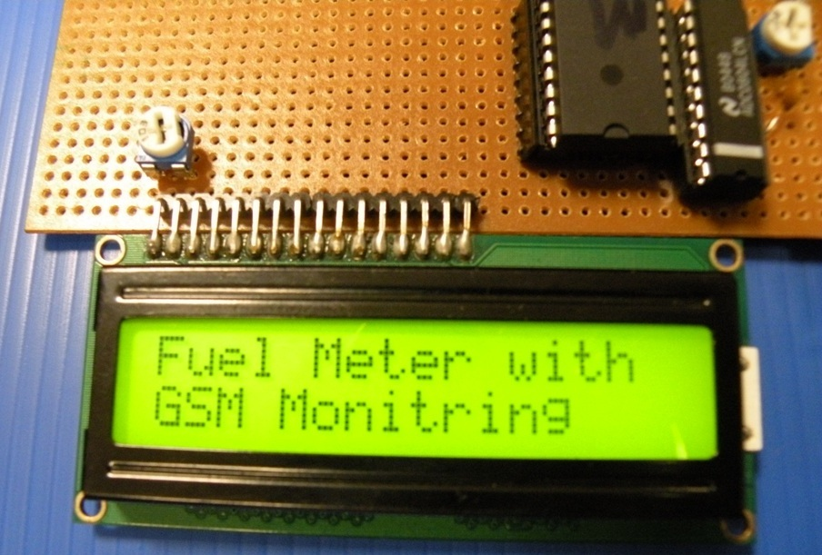

FINAL YEAR PROJECT



TITLE:-
“ BTS FUEL MONITORING AND STEALTH CONTROL VIA SMS ”

GROUP DETAILS:-
Sufwan Sarwar Gondal (01-133062-068)
Sadaf Shafquat Malik (01-133062-063)
Muhammad Alam (01-133072-031)

SUPERVISOR:-
Sir Imran Fareed

DEDICATION

This project and all its works is dedicated to all the flood victims who are suffering due to this natural disaster. We all dedicate this project to all the efforts of pehlimadad.org that have done so much for our brothers and sisters affected by the biggest natural disaster in our homeland history.

ACKNOWLEDGEMENT

Nothing is possible in this world without the kind and blessed support of Allah Almighty.

We owe great many thanks to a great many people who helped and supported us during this project.
Our deepest thanks to our Supervisor, Mr. Imran Fareed for guiding and correcting our mistakes with so much attention and care. He has taken the pain to go through the project and make necessary correction as and when needed.
We would thank with great respect to our parents and families for supporting us in this project without whom this can never be accomplished.
We also thank all the Lab Engineers who supported us in the lab work and make it very convenient for us to work in a very friendly and cooperative environment.

EXECUTIVE SUMMARY
Due to the frequent power failure, the cellular operators are using standby generators and battery banks at the BTS sites in order to provide uninterrupted services to their customers. The fuel refilling of BTS generators is pre-scheduled and is done on weekly or monthly basis depending upon the load shedding schedule in that specific area. The problem is that, there is unannounced load shedding in Pakistan on large magnitude which results in more usage of fuel in generators at the BTS sites.
Efficient fuel monitoring is needed at BTS sites in order to maintain and provide continuous uninterrupted services to the customers by the service providers. Moreover, fuel stealing from BTS generator tanks is very common these days.
We have designed and fabricated a project in this regard. We are hoping to solve the above mentioned problems with the help of our project. Our project comprises of both, hardware and software portion.
The logic and approach we are using to monitor the fuel level in the tank is the float logic. We first tried the ultrasonic transducer logic in order to measure the level of the fuel. The ultrasonic transducer logic is not efficient in measuring the fuel level as it depends on the density and viscosity of the fluid in the tank. The speed of sound changes in different medium. So, our project is based on the float logic and we are measuring the fuel level in the generator with the help of this logic.
The information of the fuel level in the tank is measured using the variable voltages of the potentiometer that is being rotated with the float logic. Then data from the potentiometer is sent to the analog to digital converter to get the digital form of the data. The digital data is passed to the microcontroller unit. The microcontroller is burnt with the processing code including the AT commands to send the information wirelessly in the control room.
The data is processed and sent to display unit which is also on the BTS site. Moreover, data is also transmitted serially via sms through a mobile phone connected to the circuit. The sms is generated automatically using AT commands that microcontroller is sending. The received sms in the control room can be seen on the computer using the serial communication. Moreover different software can be used to maintain the log and process the incoming fuel level in order to have the record of the fuel level at different times.
Our project is giving the fuel level successfully at the BTS site as well as wirelessly through sms. To enhance the efficiency and usage of our project, same design and logic can be used to make a product with specific branding in order to implement it in field on large scale. There are also different applications of the logic we used. Home automation systems are very common these days globally. So, sms based circuits and commands can be used to operate different function through sms. Car security systems are also based on such logics and great advancements are also in process in this field.

