FINAL YEAR PROJECT REPORT
SEMI-AUTONOMOUS UNMANNED AERIAL VIDEO PLATFORM

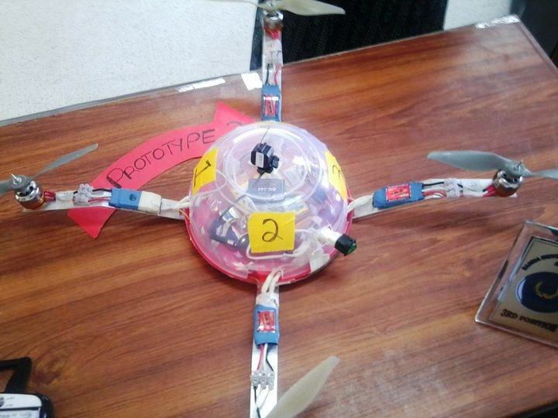

SEMI AUTONOMOUS UNMANNED AERIAL VIDEO PLATFORM

Farjam Mubarik
Anum Junaid
Anber Javed
Saad Hamid

EXECUTIVE SUMMARY

Technology is evolving with time. With this developed habit we nowadays are waiting for new advents all the time. One such advent is quadrotor or quad copter. This concept though not new but it was not until late 1990s that researchers started working on it viciously.
As the name suggests quadrotor is an aircraft with four rotors. The angle between each rotor is 90º. Two adjacent rotors are moving clockwise and other two moving counterclockwise. This scheme is adopted so that the total torque of the system is balanced. Torque balancing is necessary to keep the craft stable otherwise it will start rotating on its own axis.
It is capable of vertical takeoff, vertical landing (VTOL), and hovering. Control of such a craft is accomplished by varying the speeds of the four motors relative to each other. Quad-rotor crafts naturally demand a sophisticated control system in order to allow for balanced flight.
A mini wireless camera is also mounted to get the live feed at the ground station. This proves to be useful gadget, in cases of monitoring places after a disaster has struck and security purpose as well.
It is a complex craft to control and operate but complexity has its own advantages. The major advantage of a quadrotor over any other aircraft is its ability to move in any direction in its lateral plane on its axes.
Still a lot is to be achieved in this field and it’s open for researchers in many aspects. Proper test beds, testing facilities, equipment, funds and local availability of parts are the key requirements for these sorts of projects to make some real impact in the skies.

Acknowledgements

We would like to thank everyone who helped us in any way during the course of this project. First of all we would like to thank ALLAH for giving us the strength and ability to complete this project. Especially we would like thank our project supervisor, Miss Soyaiba Jawed for her untiring efforts in making this project easy for us and providing us with constant guidance. We are most grateful to the Head of Department of Bahria University Engineering Department, Mr. Jehanzeb Ahmed for his support and partial funding for the project. We appreciate the work of Qasim Shigri of Art Tech Hobbies (Rawalpindi) for arranging most of the equipment and the counterclockwise propellers from Hong Kong. We would also thank Hassan Mehmood from NUST who helped us with the electronics of the control system and technicians Imran and Shafiq for their help in assembly. Last but not the least we would like to thank our parents, friends and family for their constant support and encouragement

TABLE OF CONTENTS
CHAPTER 1: INTRODUCTION 1
1.1 Applications of UAVs 1
1.2 PROBLEM STATEMENT 3
1.2.1 Proposed solution -Unmanned Aerial Video Platform 5
1.3 The Quadrotor 6
1.3.1 Why Quadrotors? 6
1.3.2 Quadrotors’ preference over Helicopters 7
1.4 Project Goals 7
1.5 Design challenges 8
1.6 Project Constraints 9
1.7 Literature Review 9
CHAPTER 2: SYSTEM DYNAMICS AND CONTROLS 10
2.1 INTRODUCTION TO CONTROL SYSTEMS 10
2.1.1 Open Loop Control Systems 10
2.1.2 Closed Loop Control Systems 11
2.2 CONTROL SYSTEM OF A QUADROTOR 12
2.2.1 HARDWARE 16
2.2.2 CIRCUITRY OF THE SYSTEM 16
2.2.3 THE CONTROL HIERARCHY 16
2.2.4 FUNCTION OF MICROCONTROLLER 17
2.3 BASIC QUADROTOR MOVEMENTS 18
2.3.1 VERTICLE THRUST 18
2.3.2 ROLL 19
2.3.3 PITCH 20
2.3.4 YAW 22
2.4 THE EQUATIONS OF MOTION 26
CHAPTER 3: Design Analysis and Components Selection 27
3.1 FRAME STRUCTURE 27
3.1.1 Design Considerations 27
3.1.2 Frame Prototype 1 29
3.1.3 Frame Prototype 2 30
3.1.4 Construction with Prototype 1 and 2 31
3.1.5 Frame Prototype 3 33
3.2 PROPULSION/THRUST-PRODUCING UNIT 34
3.3 COMPONENTS DESCRIPTION 37
3.3.1 MOTORS 37
3.3.2 PROPELLERS 39
3.3.3 ELECTRONIC SPEED CONTROLLERS 42
3.3.4 BATTERIES 44
3.3.5 GYRO 47
3.3.6 WIRELESS VIDEO CAMERA 49
3.3.7 RECEIVER (Rx) 52
3.3.8 TRANSMITTER (Tx) 53
CHAPTER 4: PROJECT RESULTS 56
4.1 FLIGHT TESTING RESULTS 56
CHAPTER 5: Conclusion 58
5.1 Future WORK 59
REFERENCES 60
Appendix………………………………………………………………………..…………………………………………………63

List of Figures

Figure 1.1 Unmanned Aerial Vehicle…………………………………………………………2
Figure 2.1 Open Loop Control system block diagram………………………………………10
Figure 2.2 Open Loop Control System Implementation in Project…………………………11
Figure 2.3 Closed Loop Control System Block Diagram…………………………………… 12
Figure 2.4 Motor Rotations in a Quadrotor…………………………………………………. 13
Figure 2.5 Connection Diagram Between Components On The Quadrotor ……………….15
Figure 2.6 Role of Microcontroller in the Control System………………………………….. 17
Figure 2.7 Motor Speeds for Vertical Thrust ………………………………………………...19
Figure 2.8 Quadrotor Roll Movement ………………………………………………………..20
Figure 2.9 Quadrotor Pitch Movement ……………………………………………………….21
Figure 2.10 Quadrotor Yaw Movement……………………………………………………… 22
Figure 2.11 Quadrotor Yaw Movement to Rotate Left ……………………………………...23
Figure 2.12 Quadrotor Yaw Movement to Rotate Right …………………………………….24
Figure 2.13 Quadrotor Lateral Movement to Right …………………………………………25
Figure 2.14 Quadrotor Lateral Movement to Left …………………………………………..25
Figure 2.15 Torque Balance in a Quadrotor………………………………………………….26
Figure 3.1 Prototype 1 …………………………………………………………………………29
Figure 3.2 Prototype 2 …………………………………………………………………………30
Figure 3.3 Prototype 2 suspended in air for testing ………………………………………….31
Figure 3.4 Prototype 3………………………………………………………………………… 33
Figure 3.5 TOWER PRO 2410-12 Brushless Motor …………………………………………38
Figure 3.6 CW prop pair ………………………………………………………………………41
Figure 3.7 TowerPro W20A ESC ……………………………………………………………..42

Figure 3.8 iP LiPo Battery Back ………………………………………………………………45

Figure 3.9 GU344 Quad Flyer Gyro …………………………………………………………..48

Figure 3.10 Connections Diagram for Live Video Streaming ……………………………….50

Figure 3.11 ESKY Receiver …………………………………………………………………...52

Figure 3.12 WFLy RC Transmitter …………………………………………………………..54

Figure 3.13 Connections Diagram between all components ………………………………...55

List of Tables

Table 3.1 Material characteristics for frame structure……………………………..28

Table 3.2 Brushless motors characteristics ………………………………………….38
Table 3.3 Product description of CW props vs. CCW props...……………………...41
Table 3.4 TowerPro W20A detailed characteristics………………………………….43
Table 3.5 GU344 Gyro detailed specifications………………………………………..48

Table 3.6 Modules included in the 203C wireless camera package and their features………………………………………………………………………………….51

CHAPTER 1: INTRODUCTION

The advent of modern-day technologies has enabled mankind to monitor the lands from the skies through vehicles that do not need to be controlled by a pilot on board. The invention might seem new but the idea for such vehicles emerged during the time of Archimedes who perfected the principle of the rotating screw to be used as means to pull a liquid from a surface and push it up through the spiral path. This is in fact the same principle that is used by any modern-day rotor based air vehicle, more commonly known as a ‘Helicopter’, only in this case the liquid is replaced by a fluid, the air, and the mechanism is inversed to pull the air from above and push it downwards in order to create the lift off effect.
UAV stands for ‘Unmanned Aerial Vehicle’. They are also referred to as drones, Unmanned Aircraft Systems (UASs) or Remotely Piloted Vehicles (RPVs). The basic function of an unmanned aerial vehicle is to operate without a human pilot. They find their application in military and a number of other fields especially in scenarios where the presence of a human/pilot is either totally unnecessary or the risk of sending a human pilot in the field is unacceptable.

1.1 Applications of UAVs

Originally all types of unmanned-aerial-vehicles have found their applications in military but over the years this has changed and now these vehicles serve in every other field like police, civil applications and industrial applications. Some of the general applications are listed below:

- Remote Monitoring – To monitor a remote location through aerial video. The vehicle can be equipped with a high-resolution camera to obtain live imagery of a particular area in real-time. This eliminates the risk of any lose of human life. This may involve life-threatening situations such an area under heavy floods or a house on fire.
- Scientific Research – These vehicles can also be used in scenarios where data from a particular area needs to be sent to and from the observation base periodically. This can be used in scenarios of scientific research such as studying weather changes, volcanic activities or hurricane research.
- Transportation – To carry and deliver a variety of payloads.

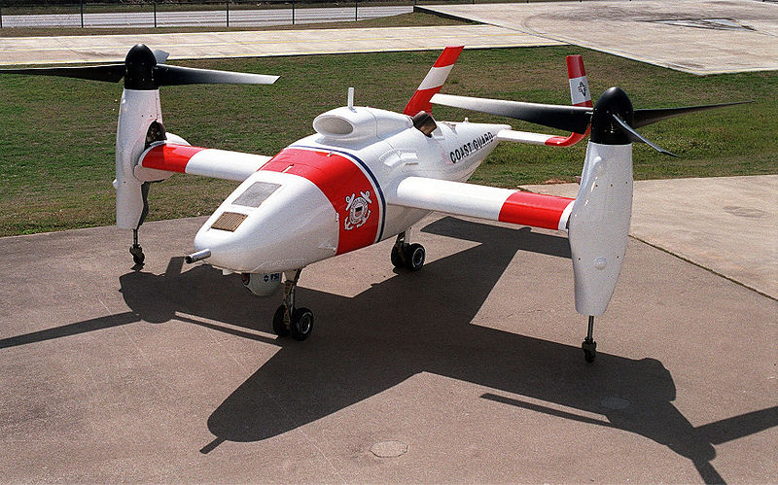
Figure 1.1 Unmanned Aerial Vehicle [13]

Here are some the industrial applications.

- Agricultural Industry – Mostly used with fertilizer and pesticide dispersing equipment to spray over large fields.
- Weather Monitoring – Monitoring the environmental status and weather conditions of a particular area.
- Crop Monitoring – The use of these vehicles can help in air remote surveillance of crops to keep check of their growth and yield.
- Mineral Exploration – The vehicles equipped with right statistical devices can be used to mine and explore minerals in places where humans are not able to reach.
- Remote Sensing – In areas which are usually inaccessible to humans, such as far off lands and underwater regions, these vehicles can provide means of locating resources remote. This is often termed as ‘remote sensing’.
- Emergency Telecom – They are finding use in telecommunications applications as mobile relay platforms, as well as in disaster zones for emergency telecommunications.
- News Broadcasting – These vehicles provide live video feeds to reporters who cannot reach in time to cover a particular event at a remote location.
- Air Traffic Control – Mostly used to monitor air traffic over busy airports.

1.2 PROBLEM STATEMENT

In modern times a lot of methods of remote surveillance of a particular area are available. These include means like being able to monitor a land through a plane, helicopter, live camera feed or having a reporter on scene who can see and report by means of a mobile telephone but there is a problem with each one of them.
- Helicopters/Planes – These are big and complex machines and their flight is very much dependant on atmospheric conditions in the area that is to be monitored. In order to monitor a land remotely, the use of such machines comes bundled with a lot of baggage and in most cases danger is involved too. Like always a trained and skilled pilot needs to be available who can fly such machines and handle them properly. Then there is the issue of fuel costs and the life of the pilot can be in danger while monitoring an area that provides a life-threatening situation such as wars, floods etc.
- Live Camera Feed – The problem with a live camera feed is that it’s still and pretty much restricted in terms of the view and the movement that it provides. It limits the observer to view only a specific portion of the area that is to be monitored remotely and cannot move about freely in space to provide a bird’s eye view of the whole situation. This limit denies the whole purpose of monitoring a location remotely as the reason to monitor a location in the first place is to have full view, through all angles and positions, of the very area.
- Live Human Reporters – In cases where a live human reporter would usually decide to provide live coverage of an area to the base station, he/she would usually choose to communicate through a mobile telephony services which includes voice, data and speech. The problem is that such means of observation doesn’t work on far-off lands such as mountains or high in the sky or even under water because telephony works on radio. Plus there is always the risk of the human losing their life as the location that is being observed remotely may pose some sort of danger. One may argue that satellite phones may be used in such conditions but it is to be noted that satellite phones are very expensive and their configuration is limited.
These were some of the disadvantages of the current means of remote monitoring.
Our need was to develop a device, vehicle, technique or method using which we are able to monitor an area without any of the shortcomings of the current methods of remote surveillance as discussed above.
The recent bombing threats and the flood disaster in Pakistan were two of the main events that served as an inspiration to our solution for this problem.
In case of bombings, usually no sufficient evidence could be obtained after such an event has happened because in most cases there was no method of remote surveillance deployed at a particular area or in very rare cases there would be a fixed CCTV camera which would provide a video footage of the event that the police would later analyze but in most cases that wouldn’t be of any help either because the footage would either provide only one-angle view that would not be sufficient for the investigation or in some cases the video data would even get corrupted due to noise and aftershocks of the blast in the vicinity.
As regards the floods, currently everyone in Pakistan from the NGOs to the Disaster Management Cell of the Government have to rely on third-party satellite imagery, like that provided by NASA, to analyze, observe, study and predict the behavior of the flood stream.
Our task was to find a solution that caters for two of these biggest problems as faced in Pakistan. Not only would it provide a way for the police to monitor a remote location that is under fire or a bomb threat with full live video footage with no chance of corruption or loss but it would also enable the relief workers to obtain live imagery of a town/area under flood and monitor the stream of floods to predict its behavior and hence provide proactive approaches to stop it or change its path.
Finally, after doing some research and homework over the discrepancies found in current methods of remote surveillance, we came up with a solution of our own that we call as the ‘Unmanned Aerial Video Platform’.

1.2.1 Proposed solution -Unmanned Aerial Video Platform
This particular project, the Unmanned Aerial Video Platform, is essentially a miniature UAV with four rotors i.e. Quadrotor (explained in the following section) with a video camera mounted on it that is able to broadcast live video feed to a video receiver or a television. This is the perfect solution to closely monitor a remote location under threat such as bomb or flood site, which saves the pilot or the observer from the risk of mortality.

1.3 The Quadrotor

A quadrotor is an aerial vehicle that is lifted and propelled by four mechanically independent rotors located at the front, rear, left, and right ends of a cross frame. The front and rear rotors rotate in a counter-clockwise direction while the left and right rotors rotate in a clockwise direction to balance the torque created by the spinning rotors.

It is capable of vertical takeoff, vertical landing (VTOL), and hovering. Control of such a craft is accomplished by varying the speeds of the four motors relative to each other. Quad-rotor crafts naturally demand a sophisticated control system in order to allow for balanced flight.

1.3.1 Why Quadrotors?
- The availability of sensors and high performance small size microcontrollers has resulted in the revival of the quadrotor concept.

- They are capable of hovering and slow flight speed which is advantageous for surveillance and targeting applications.

- In addition, the vertical takeoff and landing ability of quadrotors allows their deployment in almost any terrain while fixed-wing aircraft require a prepared airstrip for takeoff and landing.

- Quadrotors can move in any direction in its lateral plane.

1.3.2 Quadrotors’ preference over Helicopters
- No gearing required between the motor and the rotor as in helicopters

- No variable propeller pitch required for changing the angle of attack.
- No rotor shaft tilting required.

- 4 smaller rotors instead of one big rotor resulting in less stored kinetic
energy and thus less damage in case of accidents.

- Minimal mechanical complexity i.e. quadrotors require less maintenance
as compared to both helicopters and planes.

- quadrotor may also be able to fly closer to an obstacle than conventional helicopter configurations

1.4 Project Goals

The challenging nature and the uniqueness of the quad-rotor design were the main motives behind this project.

The goal of our project was to design and construct a quad-rotor vehicle capable of indoor and outdoor flight and hover. Through the use of an integrated control system, this vehicle would be capable of various take-off, hover, and landing capabilities, through pre-programmed flight paths.

1.5 Design challenges

- Semi-autonomous hover with active controls system which is capable of continuously taking dynamic information from sensors mounted on craft.

- Stable hover, with addition of variations in altitude and variations in directional movement movements based on human input for thrust,pitch,yaw,roll.

- Implementation of manual remote control system for UAV.

- Incorporating a reliable semi-autonomous control system in these small vehicles, so that the operator does not have to constantly monitor their performance or location and can land safely in case of remote control failure.

- An endurance long enough to perform a meaningful mission

- Implementation of wireless communication via Live video feedback to the ground station by the use of on-board cameras. This is used for surveillance applications mostly.

- Robust, low cost and flexible architecture capable of addition of new applications if required.

- Camera stabilization and control, and target recognition ability

- Software will have to be very compact to fit in the available memory, but powerful enough to provide intelligent control with sensor data of limited quality

- The long-term goals of this research are to add additional sensors to increase the autonomy of this inexpensive quadrotor.

1.6 Project Constraints

- Time contraints
- Size constraints
- Development costs
- Local availability of parts

1.7 Literature Review

The project required extensive research into similar systems. By reviewing others work, we gained insight that helped in developing our system. Research papers and thesis from various UAV groups were used as guides in the early development of the dynamics and control theory.
Quad rotor platform adopted is somewhat same as used in research, having four mechanically independent rotors located at the front, rear, left, and right ends of a cross frame. However, there were some groups who designed their own platforms. Commercially available models were the DraganFlyer, the X-UFO and the MD4-200.
C. Balas master thesis titled “Modeling and linear control of a quadrotor” provides a working model that we used to get idea and understanding while working through the complex dynamics of the quad rotor system. Another big benefit of having this resource is that many required parameters (thrust, roll, pitch, yaw etc) were already well quantified.

CHAPTER 2: SYSTEM DYNAMICS AND CONTROLS

2.1 INTRODUCTION TO CONTROL SYSTEMS

A device or combination of devices which are designed to monitor, control, authenticate and regulate another device or combination of devices is called a control system.
Control system can be manual, semi autonomous or completely autonomous. Every working device now exhibits a control system e.g. a modern car has a very complex set of control system including many sensors for every part, an everyday massage chair has a control system even a washing machine nowadays has a control system.
Control systems can be categorized in two categories.

2.1.1 Open Loop Control Systems
These systems are only controlled by the input. The input is fed to the controller which can be any device e.g. amplifier. From here signal is transferred to the processor which again can be any device which performs some sort of operation e.g. motor.
Figure 2.1 Open Loop Control system block diagram

In the case of a motor connected to an amplifier in which an input signal is fed, the input signal will control the rpm of the motor and its direction of rotation through the amplifier. By increasing the amplitude of the input signal the speed of the motor can be increased and vice versa. And similarly by changing the polarity of the input signal the direction of rotation of the motor can be changed.

Figure 2.2 Open Loop Control System Implementation in Project

2.1.2 Closed Loop Control Systems
Closed loop control system used feedback to control the output. The feedback signal is sent back to the comparator where is it compared with a set value and next value is determined on the difference of feedback value and set value.

Next value = feedback value – set value

A closed loop control system has following parts:
  - Comparator
  - Controller
  - Processor
  - Feedback device

Figure 2.3 Closed Loop Control System Block Diagram
The example of a closed loop control system can be a thermostat. It continuously measures temperature and then compares it with a preset value of temperature. If the value is not less than a preset value then it increases the temperature and vice versa.

2.2 CONTROL SYSTEM OF A QUADROTOR

The basic requirement of the control system of a UAV is to provide simple movements and one can stretch the scope of the control system up to the level of complex navigational purposes. The basis of these control system is always a mathematical model of the UAV. This part will highlight the control design of the “semi autonomous aerial video platform” with the help of an experimental model.
Nowadays many quadrotors, the likes of HMX-4 and RCtoys’ Draganﬂyer are being made for research and for commercial purpose as well. Most of these quadrotors are made up of plastic or carbon fiber frame, just to keep the weight to minimum. Propellers used are also made up of plastic and they are usually powered by Lipo or NiCd batteries. Their control system is usually closed loop control system where gyros and accelerometers provide the feedback.
Quadrotor is the most difficult of all the UAVs to control. 4 rotors make is very unstable. Actually there is no adjustment of pitch or elevator or rudder in quadrotor but only thrust. A difference of 5rpm in any motor can lead to an unstable hover or accident. Therefore to control a quadrotor one need state of the art circuitry and a professional flyer at the controller.
The four rotors move independently of each other. The thrust of one rotor does not have any electrical effect on others. These rotors provide the control of the quadrotor. Roll, pitch and yaw can be controlled by varying the RPM of each rotor which can only be done if they rotate independently.
Lift can be generated by increasing RPM of all the rotors at the same time. For hover it is necessary for all the rotors to rotate at same RPM. Even the slightest of difference can cause instability. The thrust from each rotor when varied provide maneuverability to the craft.
Figure 2.4 Motor Rotations in a Quadrotor
The engines, in this case Tower Pro brushless motors provide rotation to the propellers (rotors). These motors provide the necessary RPM to produce thrust and thus lift the craft. For this purpose the motors need to be light weight as well.
For stability pitch, roll and yaw needs to be controlled. For a stable and continuous hover pitch and roll angles need to be zero. The scope of current work is to stabilize the aircraft in roll, pitch and yaw.
Quadrotor is controlled by changing the thrust produced by every motor. Every motion or move can be made just by changing the thrust of one or two motors. That is why no other control is required but thrust control and that is the reason it is such a difficult rotor to handle.
Many attempts have been made to make a simple quadrotor stable but no satisfying results have been obtained as yet other than one or two occasions. So it still remains a very open topic for further research.
We tried to modify the control system of as helicopter instead of building a new control system. Helicopter was chosen because its controls are the closest to the controls of a quadrotor which makes working a lot easier. The control system of an RC helicopter has controls for thrust, elevator, aileron and rudder. Each of them can be controlled from a separate channel on the transceiver. Each channel is connected with a receiver on the quadrotor and can be controlled by an RC transmitter at the ground manually.
We removed the channels for thrust, elevator, aileron and rudder and plugged 4four channels of gyro to the receiver which is on the craft. Then to the four channels of the gyro we connected the ECSs. Motors were connected to the ESCs with the help of triplex connectors. Each ESC is also connected to the battery through a security switch and a duplex connector which is used to turn the quadrotor on or off. Single line diagram of the system will help to understand the connections made.
Figure 2.5 Connection Diagram between Components on the Quadrotor

2.2.1 HARDWARE
- CPU: ELAN EM78P458
- Sensors: GAUI® GU 344 Quad Flyer Gyro.
- User Input: ESKY® Radio Control (RC) receiver receiving input from a WFLY RC handheld transmitter.
- Motor Control: TOWERPRO® brushless motors controlled by TOWER PRO® electronic speed controllers (ESCs).
- Software: Equipment with preprogrammed software was used. That software is programmed in the C language. Software is out of the scope of the project.
All the details about the hardware are given in the earlier sections.

2.2.2 CIRCUITRY OF THE SYSTEM
The circuitry of the system is used to amplify the sensor signals and send them to the microcomputer, as well as the circuit used to amplify the PWM outputs in order to drive the motor. There are also schematics for the individual connections made to each of the sensors and the microcomputer.

2.2.3 THE CONTROL HIERARCHY
The control objectives of the quadrotor UAV can be ordained in a hierarchical structure at different levels. These are:
- Sensing correct thrust, yaw, pitch, and roll control by providing efficient decoupling and stability of control actions. These are basic requirements in the manual control of the quadrotor helicopter.
- Realizing basic operation modes and maneuvers as hovering in a stable position, ascend/descend, forward/backward and lateral movement.
The first step is the construction of a test structure and implementation of an Attitude and Heading Reference System (AHRS) in the vehicle. After implementation, the quadrotor vehicle was connected with a microcontroller board. The microcontroller is used for the control of rotational speed of the rotors and reception of AHRS signal as an input signal. ESKY electronic board was used for this purpose.

2.2.4 FUNCTION OF MICROCONTROLLER
The microcontroller in use is: EM78P458. The circuitry is equipped with gyro and an electronic control board on which a microcontroller is embedded. The function of microcontroller in our sort of system (closed loop system) is not only to receive and send the data from different devices but it receives data from the gyro through a feedback loop, processes it, compare it with a desired value and then increase or decrease the value accordingly.
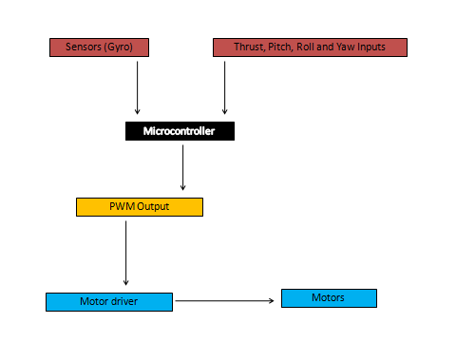
Figure 2.6 Role of Microcontroller in the Control System
Different modes of PWM can also be selected from the 8-bit microcontroller in use. The code in use uses Fast Pulse width modulation (PWM) mode which can change range between o and 255 due to 8-bit microcontroller. High frequency waveform is an option with Fast PWM mode. PWM uses a square wave duty cycle varied resulting in the change in the average value of the duty cycle of waveform. PWM is useful in the control of power to other devices. In our case PWM is used to control the ESC for motors.

2.3 BASIC QUADROTOR MOVEMENTS

There are 4 basic movements of a quadrotor. They are responsible for the maneuverability of the craft. These are:
- Vertical thrust
- Roll
- Pitch
- Yaw
These movements are explained in detail in following sections.

2.3.1 VERTICLE THRUST
The force required to lift the quadrotor from ground and keep it in air is called thrust. It is generated by the all the propellers.
Figure 2.7 Motor Speeds for Verticle Thrust
Vertical thrust must be greater than the weight of the body of the craft for it to be airborne and it must be equal to the weight of the body for hover. The overall thrust of the body is also termed as “throttle”. It can be achieved by increasing the RPM of every motor at the same time and by the same amount, for negative thrust the RPM is decreased.

2.3.2 ROLL
According to our reference axes movement in the yz-plane is roll movement. It is achieved by increasing the RPM of left rotor and at the same time decreasing the RPM of the right rotor and vice versa. This is done for three purposes:
- To get roll movement
- To keep the vertical thrust same
- To keep the total torque balanced
Figure 2.8 Quadrotor Roll Movement

2.3.3 PITCH
Pitch is identical to roll but for difference. The difference between pitch and roll is that in former the motion is along yz-plane and in later the motion is in xz-plane. Pitch movement is achieved by increasing the RPM of front rotor and at the same time decreasing the RPM of the back rotor and vice versa.
Figure 2.9 Quadrotor Pitch Movement

2.3.4 YAW
Yaw is responsible for the turning of quadrotor in the xz-plane. To get yaw movement the RPM of front and rear rotors is decreased by the same amount at the same time and the RPM of left and right rotors is increased and vice versa. This leads to a slight change in the system’s overall torque which is needed for turning.
Figure 2.10 Quadrotor Yaw Movement

Further movements of the quadrotors are explained with the help of following pictures.
As explained in the picture when the clockwise (CW) rotating pair of motors is slower than the counterclockwise (CCW) pair then the craft will rotate to its left. This can be done by changing the RPM from hand held RC transmitter.
Figure 2.11 Quadrotor Yaw Movement to Rotate Left

If the craft were to rotate right then we will increase the RPM of CW rotors than CCW rotor and its nose will start rotating.
Figure 2.12 Quadrotor Yaw Movement to Rotate Right

To make the quadrotor move towards right we just need to decrease the RPM of the left rotor.
Figure 2.13 Quadrotor Lateral Movement to Right
To make the quadrotor move left we just need to decrease the RPM of left rotor.
Figure 2.14 Quadrotor Lateral Movement to Left

2.4 THE EQUATIONS OF MOTION

As mentioned earlier, the quadrotor is controlled by varying the RPM of the rotors. Equations of motion of the following quadrotor are given below:
Figure 2.15 Torque Balance in a Quadrotor
T = Ƭ₁ -Ƭ₂ +Ƭ₃ -Ƭ₄
R = $l($Ƭ₂- Ƭ₄$)$
P = $l($Ƭ₁ –Ƭ₃$)$
Y = Ƭ₁ -Ƭ₂ +Ƭ₃ -Ƭ₄
Where Torque of i^{th} rotor = Ƭ, Vertical thrust = T, Rolling moment = R, Pitching moment = P, Total Yaw = Y

CHAPTER 3: Design Analysis and Components Selection

3.1 FRAME STRUCTURE

3.1.1 Design Considerations

The frame of a quadrotor is basically the skeleton of the vehicle. While designing the structure of any quadrotor frame, weight and power consumption are critical issues and must be kept at a minimum to ensure stable and prolonged flight. Moreover lesser weight would in fact mean less structure which would be easy to handle and repair, so that focus can be maintained on other important design issues.

Stability of the frame structure is of prime concern so that it is able to sustain the weight of all the components as well as any extra payload that might be deemed necessary without introducing turbulences.

Another of the key requirements is that the quadrotor be as compact as possible to allow for indoor flight and simple construction.

In order to meet therefore mentioned requirements, a study of all the relevant construction materials was carried out and compared for further analysis. The table below shows a comparison of the relevant materials and their properties that are generally considered for quadrotor frames.

 | Carbon Fiber | Basswood | Balsa Wood |  | PVC | Aluminum
Density (g/cm^3) | 1.490 | 0.398 | 0.130 |  | 1.500 | 2.600
Tensile Strength (Gpa) | 1.379 | 0.060 | 0.075 |  | 0.062 | .0150
Young’s Modulus (Gpa) | 631.000 | 10.091 | 6.000 |  | 4.140 | 70.000
Deflection (cm) | 0.0586 | 0.0563 | 1.272 |  | 1.431 | 0.275
FS* | 3.006 | 3.004 | 3.002 |  | 3.001 | 3.002
b (mm) | 2.297 | 6.525 | 6.060 |  | 6.456 | 4.810
h (mm) | 2.297 | 6.525 | 6.060 |  | 6.456 | 4.810
Approx Weight at FS =3 | 3.931 | 8.473 | 2.387 | 31.260 |  | 30.077
Table 3.1: Material characteristics for frame structure

*FS (Factor of safety):

The study revealed that balsawood has the lowest weight per factor of safety, carbon fiber being slightly worse. Though Balsawood would have been the most lightweight option, however, due to its ease of breakability, Basswood was considered the best available choice for our frame.

3.1.2 Frame Prototype 1
The first frame was constructed as a simple concept model for testing so that it’s cheap, quick to make and we could test our thrust modules with. The spars were made out of Basswood. Two spars each of length 2’ and having a cross sectional diameter of 1.5” were criss-crossed and hammered with nails in the centre as shown in the figure below.
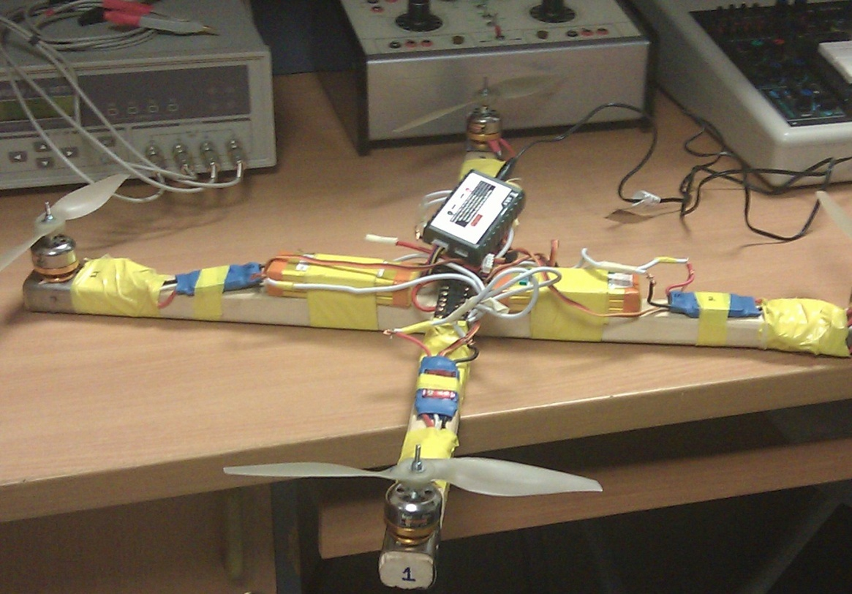
Figure 3.1 Prototype 1
The first prototype was built as simple as possible with the motif of getting a better understanding of how the components would fit together, to observe the functional relationship between each and to improve on ideas for building the future designs.
Problems encountered with prototype 1:
Though the first prototype was able to give us a clear idea about the working of the motors, propellers and other components, however it was quiet bulky and bigger in size than the minimum requirements. It was realized that to increase the thrust and eventually flight endurance and stability, the frame must be replaced with a lighter and more compact version.

3.1.3 Frame Prototype 2
Our second frame was similar in structure to prototype 1 but was updated from the several evaluations of it. The Basswood spars crossing in overlap in the center of a base plate were each made of length 50cm. This time the cross sectional diameter was much smaller. i.e. 2cm . A base plate of dimensions 8cm by 8 cm was nailed in the centre where all the electronic equipment was to be mounted, as shown in the figure below.

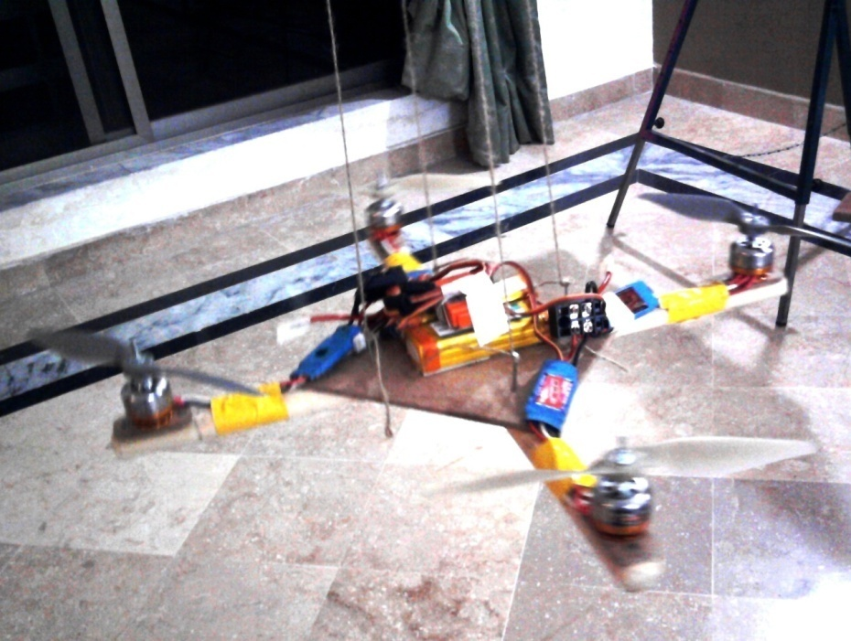
Figure 3.2 Prototype 2

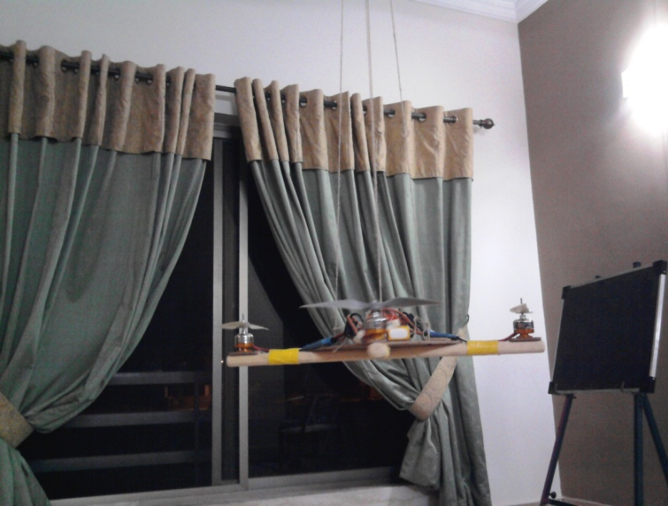
Figure 3.3 Prototype 2 suspended in air for testing
Observations with Prototype 2:
With lesser dimensions, this frame was more light weight and as a result the motors provided greater uplift to the quadrotor than prototype 1.
However a problem that pertained to both the specimens was not having a very balanced centre of gravity. As a result the quadrotor would land flat on the ground with a jerk and cause damage to the sensitive components like motors.

3.1.4 Construction with Prototype 1 and 2
Each of the four motors were mounted at a distance of 2” from the tails of the spars. As the motors come attached to rectangular mounting plates, the plates were folded over spars and nailed through the holes in them.
The four ESCs were attached to the spars using duct tape. They were placed along the spars such that the downwash created by the propellers could be used to cool the ESCs during operation. Each ESC was connected to the corresponding motor with the help of metallic connectors. Care was taken that any extra wires did not come in contact with the propellers.
The two lithium batteries were also mounted symmetrically on the base plate. A 1to2 connector allowed each battery to power two motors at a time, and placed in such a way that they could be connected at the last minute to the ESCs.
The receiver was attached on top of the base plate using duct tap, and the receiver’s wire antenna was wrapped around the base plate. 4 of the channels of our 6 channel receiver were connected to each of the ESCs to control their speed.
The four APC 8x6 Slow Flyer propellers were then attached to the shafts of the motors. The propellers were arranged in such a way so that pairs of pusher and puller propellers were across from each other (no two adjacent propellers were alike). In order to check the working of each motor and propeller, the throttle from the transmitter was then increased to ensure that the propellers were all spinning in their correct respective directions. Once all motors/props were found in the running condition, the construction of protype1/2 was considered complete.

3.1.5 Frame Prototype 3
The thirds prototype was built with the motif of having a balanced centre of gravity which was found absent in the earlier prototypes. Moreover, weight considerations also needed to be accounted for. For this purpose aluminum was selected as an alternative to the wooden spars. The spars were bent at an angle of 60 deg. to increase the distance between the motors and the ground for motor safety (refer to appendix A1).
A round PVC base plate was used in order to keep the base plate weight to a minimum. All the components were assembled on top of that base plate and secured with double and duct tapes as shown in the figure below.

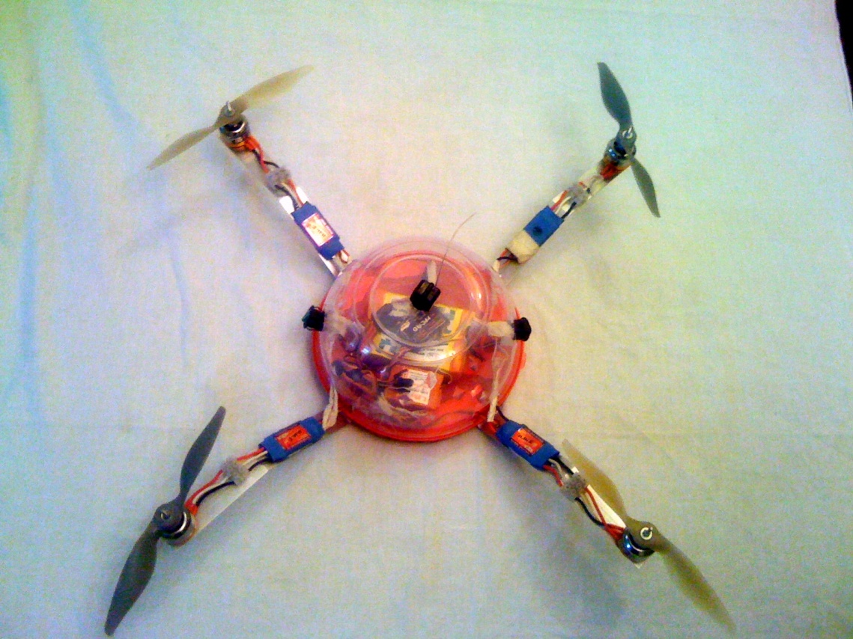
Figure 3.4 Prototype 3

3.2 PROPULSION/THRUST-PRODUCING UNIT

The propulsion unit compromised of the motors, propellers, ESCs and batteries and their selection required careful and extensive research. Before the final decisions could be made, each component was supposed to meet our desired propulsion requirements, while keeping availability, cost and compatibility issues in mind.
The propulsion requirements were defined as below:

- Total Thrust: The net thrust provided by four motors must be 1kg to account for the weight of the vehicle as well as minimum hover thrust. The maximum weight of the vehicle was set to 400g. So each motor must be able to provide a thrust of at least 100g. For greater altitude adjustments and maneuvering, each motor must approximately provide 1.5 times this hover thrust i.e. 150 g. (hence 4*150 =600g )

- Flight Endurance: The minimum flight time was set to 5 mins. This value would be suitable to our surveillance applications as well as correspond to battery timings.

The specific propulsion requirements for each of the components were also defined prior to selection:
- Motor Requirements

  - The mass of each motor must not exceed 50g. So that their combined mass is equal to 2kg maximum.

  - The maximum amperage draw was set to 20 A. The amperage value in turn effects the time of flight and determines the battery size. So a maximum value of 20A would ensure that flight time can be at least 15mins.

  - The motors must have maximum possible kV rating. The kV rating gives the ratio of the Revolutions Per Minute to the battery voltage. Hence the greater the RPM value, the greater will be the thrust provided y the motor.

  - The RPM value was set to 11,000 and the thrust was calculated using this value in the thrust equation given in ensuing paras.

- ESC Requirements

  - The ESCs’ function is simply to adjust the motor speeds, and hence it was deemed necessary that they should be as lightweight as possible.

  - The current rating of each ESC must be high enough so that it can endure high currents being drawn by the motor.

- Batteries’ Requirements

  - The battery rating must be enough to sustain the flight time of 15mins.

  - A high energy density to weight ratio is essential to allow the battery to power multiple motors at a time.

- Propeller Requirements

  - Greater the diameter of the prop, more efficient will the props be in terms of moving a lot of air by a small amount as opposed to moving little air by a large amount.
  - The lower the pitch, the more efficient will be the thrust produced per input power. Higher pitch props tend to produce inefficient thrust at zero forward velocity.

  - The propellers should perform at the specific RPM value without fluttering.

  - Minimum bladed props are ideal. 2 bladed props are used for quadrotors.

Propeller Thrust Equation
Before the motors and propellers could be researched and selected, the total necessary thrust was calculated using the general equation for propeller thrust:
Thrust (kg) = P(in) * [D(in)^3] * [RPM^2] *[10^-10] * 0.02835
The total thrust was calculated to be taking values P(in) = 6 , D(in)= 8, RPM= 1000/V as given in propulsion requirements. After this initial calculation a variety of motor/propeller combinations were researched and analyzed and we chose the best possible options available suited to our requirements.

3.3 COMPONENTS DESCRIPTION

Once the general vehicle requirements were settled upon, the team needed to make specific choices regarding component selection and design. Much of the efforts fell into the proper combination of the propellers, motors, batteries and ESCs (thrust producing module). The selection of a suitable gyro and transceiver followed in later stages of the project. The team worked towards selecting the best available options in each of the categories and the final choices are explained in this section.

3.3.1 MOTORS
There was a wide range of motors available in terms of functionality and manufacturers. Electric motors generally fall into 2 broad categories; brushless motors and brushed motors. The overriding criterion while selecting motors is to have the maximum output power to weight ratio to have maximum performance.
Four 2410-12T-3(DELTA) brushless motors were used to drive the vehicle, shown below in the picture. Upon examination of motor specifications in detail, it was revealed that the brushless motors are better than simple DC motors because they have:
- High RPM

- Low noise and no sparking.

3. No brushes or commutators wear out- hence no maintenance required.

4. Better thrust producing capacity as there s no friction from the brushes
which slows the motor down – hence greater flight times and battery life.

5. Higher power to weight ratio – makes it ideal for use in quadrotors.

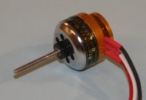
Figure 3.5 TOWER PRO 2410-12 Brushless Motor
The detailed specifications of these motors are given as follows:
Motor Model | TOWER PRO 2410-12 Brushless Motor – Delta/Triangle
Battery | 2-3 LiPo
kV | 1000
Voltage | 7.2V-12.6V (10V ideally)
Dimensions | 31 mm diameter x 46.5 mm length
Maximum current | 9A
No-Load current | 0.4A
Shaft diameter | 3mm
Recommended props | 8x4 DD
Weight | 64g
Firewall mount capable
Comes with two prop nuts and one washer
Includes 12 Stator Poles, 14 Magnets
Table 3.2 : Brushless motors characteristics [15]
Note: The Kv rating of a brushless motor refers to the RPM it turns per volt .

3.3.2 PROPELLERS
A quadrotor requires a total of four propellers i.e. two pullers and two pushers. The pusher props have a clockwise rotation and the pullers provide counter clockwise rotation. i.e.

- Front = Motor #1 and Back = Motor #2 clockwise props
- Right = Motor #3 and Left = Motor #4 counter clockwise props

The nomenclature of quadrotor props is generally “diameter length * pitch length” defined as follows:

Pitch: The pitch length would give the distance that the propeller moves through the air, in the forward direction, in one complete revolution. Lower the pitch length, flatter the camber of the blade will be.

Diameter: The diameter of a prop is basically the length of the prop between its ends.

Prop Selection

A variety of prop sizes and types were studied prior to final selection.
The values for prop diameter and pitch need to be chosen carefully to be compatible with the motors and match the thrust requirements. General web research such as Hobby Forums and experimentation revealed that there were certain prop characteristics best suited for our quadrotor:

- Two Clockwise props and two Counter Clockwise props.

- Electric props needed to be installed (as opposed to wooden ones for helicopters and planes)

- Slow Flyer (SF) props are best suited for quadrotors. Sports props may also be used but preferable for RC helis and other heavier vehicles.

- The upper limit to propeller diameter was set to 8 inches so that it is compact and lightweight to match the frame size and provides the vehicle with enough thrust.

- The pitch length was set to a minimum 6 inches so that it fulfills the necessary thrust requirements calculated in the thrust equation.

- APC props are preferred by the hobbyist community in terms of weight and stiffness. As compared to their competitors they have a narrower, more efficient tip and overall more efficient design.

Problems encountered in buying Props

Of the major problems encountered during the course of this project was the non-availability of the propellers, especially the CCW pair, locally. All local shops and hobby groups were initially visited. Almost 10-15 nation wide Hobby shops were then contacted via phone and e-mail. To the utter disappointed of our group, none of the shops had the CCW pair available due to the fact that quadrotors are still an alien concept in Pakistan and lesser demand for these parts.

It was then mutually decided to get the pair ordered online or by-air from abroad. Another major difficulty encountered was the fact that either online stores were out of stock for the particular parts and/or the facility of delivery was not available to Pakistan and/or it took at least 2-3 weeks for the products to get delivered(minus the time it took for custom clearance).

Since APC props were found to be the most widely used props, so a relative(Mr. Col. Asim) living in USA was contacted and requested to buy the CCW prop pair and sent to us via courier. To our utter surprise, a few hobby shops that Mr. Asim visited in USA locally were also out of stock for the CCW props.Finally the pair was ordered through a local hobby shop in Rawalpindi (Pakistan) from Hong Kong.

Product Description:
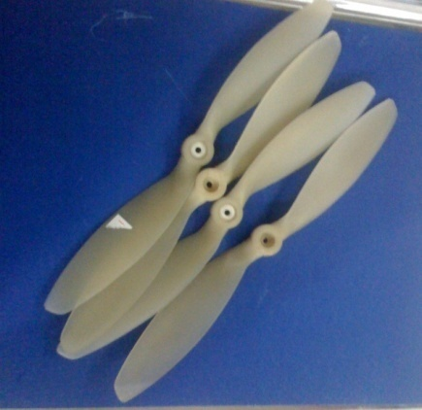
Figure 3.6 CW prop pair
The CCW and CW pairs of props essentially had the same specifications. But since the CCW pair had to be imported, they had slightly different features than those of CW pair listed below.

Field | CCW pair | CW pair
Category | Sports props | No special category
Function | Pullers | Pushers
Price | 550Rs/prop | 150Rs/prop
Company | APC manufactured | Made in China
Dimensions (dia*pitch) | 8*6 | 8*6
Material | PVC plastic | PVC plastic
Weight | 14g | 14g
Type | Slow Flyer | Slow Flyer
Table 3.3 Product description of CW props vs. CCW props

3.3.3 ELECTRONIC SPEED CONTROLLERS

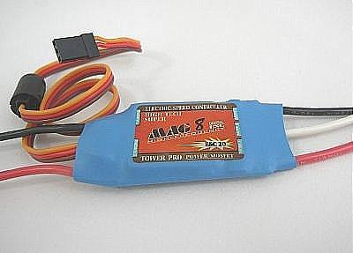
Figure 3.7 TowerPro W20A ESC

Role of ESC

An ESC is basically a device, often used on electrically-powered radio controlled models, with the purpose to vary an electric motor's speed, its direction and also to act as a dynamic brake. Brushless DC motor ESC s are a little more complicated than brushed motor controllers because they have to convert the DC from the battery into phased AC (usually three phase) in order to produce the changing magnetic field.

ESCs used in our Project
In our project, four TowerPro W20A ESCs were used to control the speed of each of the brushless motors. The picture above shows the particular model used. This ESC acts as a stand-alone unit (instead of being in-built inside the receiver) which plugs into the receiver's throttle control channel and hence controls the motor’s speed according to directions from the transmitter at the ground station.

The detailed product description is given below:
ESC Name | TowerPro W20A
Dimensions | 42*25*10mm
Weight | 22g
Operation Limit | Max 22A/Continuous 10 min 18A
BEC Output* | 5V, 1.5A, 4-5mini servo
Price | 18$
Voltage Range | 6-12V
Number of Batteries | LIPO 3, NIMH/NiCd 5-12
Performance | BEC, MCU Power Supply separately/Cell type/number set/Braking choice Timing Mode
Protective Functions | 3LIPO,6.2V/8.1V /Stop after no signal
3.5mm Bullet connectors included
Table 3.4 TowerPro W20A detailed characteristics [16]

*BEC (battery eliminator circuit) is used to regulate voltage for the receiver, removing the need for receiver batteries

3.3.4 BATTERIES
For power-providing in quadrotors usually Lithium-Polymer batteries or LiPos are used. LiPo (Lithium Polymer) batteries provide high energy storage to weight ratios as compared to NiCad or NiMH batteries. Three most important factors that needed to be considered before buying the batteries were

- Voltage

LiPo battery cells have a voltage rating of 3.7V per cell as opposed to 1.2V per cell in NiCad or NiMH batteries. So they were best suited for use in a quadrotor to allow for minimum weight issues.

- Capacity

The capacity of a battery indicates how much power (indicated in milliamp hour- mAh) the battery pack can hold for 1 hour at which time the battery will be fully discharged. Hence higher the capacity, greater will be the flight time of the vehicle. The capacity of a battery can be changed within a specific range. However size considerations must be taken into account because greater the capacity, larger will the size of the battery pack.

- Discharge Rate

The discharge rate of a LiPo battery indicates how fast can the battery be discharged safely and is given by ‘C’ rating. For e.g. a ‘20C’ would mean the battery can be discharged at a rate 20 times the capacity of the battery. However it is important to note that the rate of increase of current draw is inversely proportional to the time of flight. So if the battery is discharged at a rate 20 times the capacity, the fight time would reduce 20 folds.

Formula for time of flight:

Pack capacity(in mAh) / [Pack Capacity (in mAh)/60 * ‘C’ rating

Or simply

Flight time = 60/C

Batteries Used In Our Project

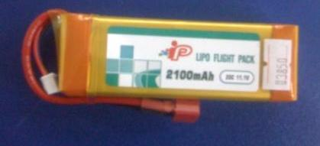
Figure 3.8 iP LiPo Battery Back

For a quadrotor LiPo-packs with three or four cells are generally used. They have a voltage of 11.1 V or 14.4 V respectively. Hence in our project, the batteries finally chosen had the following specifications:

- Two ‘IP’(company name) manufactured LiPo batteries were installed each powering two adjacent motors at a time.

- The total battery package weighted 200 grams, enough for the quadrotor to sustain while hovering in air.

- Each battery has 2100 mAh capacity implying they drain 2100mA of current in 1hour discharge time.

- Each battery had 11.1V voltage rating i.e. 11.1 volt battery = 3 cells x 3.7 volts (3S)*. Lower values such as 7.4V, 2100 mAh battery did not provide a long enough endurance time

- The discharge rate of the batteries is ‘20C’.

*S= number of cells connected in series inside the battery [17].

3.3.5 GYRO
Requirements
The purpose of having a gyro in a quadrotor is to provide stabilization and automatic control to the vehicle .Before selecting a gyro, it is important to understand that the basic controls provided by the control system are
- Throttle
- Rudder
- Aileron
- Elevator

So a gyro having minimum 4 channels is needed to control the vehicle. Any gyro having sensitivity more than 50deg/s will do for gyro selection and the gain can be later adjusted according to the configuration requirements. Moreover, there must be at least three gyros, one for each of the axes (X,Y,Z).

Working of a Gyro

When the gyro is not receiving any signal from the receiver (to vary the speeds of the motors), the gyro will automatically send a positive or negative signal to the relevant ESC to counter the movement in particular axis direction.
However, when the transmitter sends a signal to the receiver, the gyro will let this signal pass as it is to the ESC and hence the quadrotor is controlled manually this way.

AHRS (Attitude and Heading Reference System)
The AHRS sensor GU-344 which is used in this project is a product of GAUITM. The GU-344 is a miniature, gyro-enhanced Attitude and Heading Reference System. It provides drift free orientation as well as calibrated acceleration. The GU-344 is an excellent measurement unit for stabilization and control of robots, vehicles, toy crafts and other equipment.

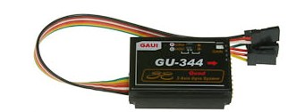
Figure 3.9 GU344 Quad Flyer Gyro

The detailed characteristics of this gyro are given in the table below:
Gyro Name | GU344 Quad Flyer Gyro
Control systems | AQDCS (Active Quad Digital Control System)
Model | 210344
Brand | GAUI
Dimensions | 44.5 x 31 x 14mm
Operating Voltage | 4 ~ 6V DC
Content | 3- Axis gyro
Weight | 18g

Table 3.5 GU344 Gyro detailed specifications
(Taken from Prestige RC [14])

3.3.6 WIRELESS VIDEO CAMERA

The basic aim of our project was to provide an aerial video platform for surveillance and other monitoring purposes. To achieve this, a wireless camera needed to be implemented in the quadrotor that would wirelessly transmit its audio and video recordings to a ground station. The receiver falling within the wireless range limits would receive
this signal and an LCD/TV screen connected to it would provide the audio/video display.

Desired Requirements

- Since weight and size considerations were of utmost priority in our project, therefore the camera (to be mounted on the vehicle) needed to be small and lightweight.

- Moreover the desired range of the antenna needed be large enough to be put to any useful surveillance applications (approx 100m was decided ideal).

- A major factor that also needed to be considered before selecting a suitable wireless camera was the ability to provide clear video reception in non-LOS (line of sight) conditions such as in indoor applications.

Keeping all these factors in mind, a market research was conducted by the team. The picture below shows the camera that best suited our requirements and was installed in the vehicle.

WIRELESS CAMERA Connections

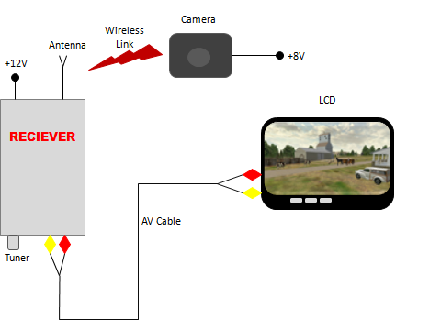

Figure 3.10 Connections Diagram for Live Video Streaming

Product Description

Module | Description
Pinhole Camera | -Model: 203C, 50mW power, RC100A, PAL system camera  - To be connected to 9V alkaline battery  -8V adapter as alternative to battery  - Range 150-200 feet
Radio AV Receiver | - 2 outputs (Audio And Video )  -Tuning Knob  -Antenna port  -9~12V adapter port
AV lead | -4 pin lead( Video I/O and  Audio I/O)
Receiver Antenna | - connected with the receiver
2 AC/DC adapters | -8V/500mA for camera  -12V/1A max for receiver

Table 3.6 Modules included in the 203C wireless camera package and their features

3.3.7 RECEIVER (Rx)
The Receiver is located inside the quadrotor and it receives the summing signals sent wirelessly from the transmitter. It then processes this summed signal (containing information of all the channels), converts it into PWM (pulse width modulation) waveform and feeds it as input to the gyro. This signal will be processed by the gyro into separate channels which feeds the ESCs and will be used to drive the quadrotor.

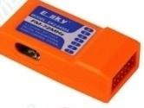

Figure 3.11 ESKY Receiver

Product Details:
- Manufacturer : ESKY
- Model: ER2872A
- 6 Channel Receiver
- Microcontroller used EM78P458
- Weight: 15g
- Dimensions: 51.3*36.3*16.8mm
- Current Drain: 11.5mA
- Demodulation type: frequency demodulation
- A thin single wire antenna approx 1m long.

Caution: Do not cut or loop the antenna wire. This will reduce the radio range and will cause disastrous effects on the vehicle.

3.3.8 TRANSMITTER (Tx)
Quadrotor Transmitter

The control system of a quadrotor essentially requires human input for the vehicle’s balancing, maneuvering and throttle control. A transmitter is therefore the main box that you hold to control your model. There are several different type of RC-transmitters available mainly depending on the number of channels supported and other features.

To control a quadrotor a 4+ channel transmitter is needed. Any commercial RC-transmitter with at least four channels, one for each motor, can be used. It consists of 2 control joysticks, and additional switches and dials on top of the transmitter body. A movable axis of a control joystick is seen as one channel (i.e. up-down). So two joysticks movable along two axes each provide four channel functionality for the system.

More channels can be added with the help of additional switches or moving dials/potentiometers. They can provide with additional features such as switching lights or control the camera-movement or switch the gyro on-off.

WFLY 6-channel transmitter W/Tx
- The WFLY 6-channel transmitter W/Tx crystal was chosen for our project. Operates at 72MHz

- 4 channels provide control functions for each of the four motors, the 5th channel controls the gyro and the 6th channel (meant for pitch) is kept idol (in our project).

- Sound notifications in low power conditions. When the transmitter battery is low, it beeps.

The figure below shows the operations of the transmitter.
Figure 3.12 WFLy RC Transmitter
Operations:

The transmitter takes its input via the joysticks, dials or switches. When the joysticks are moved forward/backward or left/right, or the switches are flicked on/off, or the dial is rotated, a corresponding RF signal is transmitted wirelessly through the transmitter antenna and is picked up by the receiver antenna on the vehicle. This signal passes to the gyro and causes a proportional change in the motors’ throttle, direction of the vehicle, movement etc.

Here ‘proportional’ change means that the change in the throttle is directly in correspondence with the amount of stick movement that was applied by the person. A small movement would cause small changes in the movement of control surface whereas pushing the stick to its maximum will cause full throttle movement.
CONNECTIONS BETWEEN ALL COMPONENTS

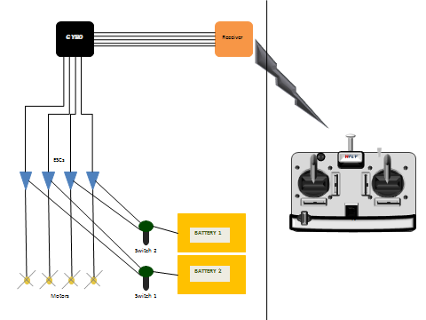

Figure 3.13 Connections Diagram between all components
Note: The motors were connected to the ESCs via special 3 port plastic connectors.

CHAPTER 4: PROJECT RESULTS

4.1 FLIGHT TESTING RESULTS

The team managed to successfully assemble and couple all the components together. Further we managed to terminate all the connections properly and we ensured that all the components were optimally functioning. A major success of this project was that the quadrotor did manage to hover for a slight duration of time about 3 feet off the ground.

However, stable and continuous flight could not be achieved in the course of our project. The main factors hindering the complete success of this project were:

- Hardware and motor failures

During flight and component tests, a major factor hindering the progress of our project was the fragility of the electric motors and other equipment such as props. Most of the time, one or more of the motors got damaged during test flights, causing delay in further developments.

- Non-availability of funds to buy expensive components.

In order to achieve stable flight/hover, sensitive and costly sensors, accelerometers and other control circuitry needed to be implemented. The cost of these components was beyond the reach of our team and the team is still working towards finding a project sponsor for further improvements.

- Insufficient testing facilities like test beds.
The thrust producing modules needed to be tested first with suitable testing equipment which is so far not available locally. For hardware testing we needed
- Prop Testing Rigs
- Special Landing platforms
- Hover testing stands

- Incompatible Lab equipment.

Such a high scale project required precise and customized lab equipment and its availability could have resulted in much better performance results.

- Non-availability of most of the parts locally.

As mentioned in earlier sections, the CCW propellers, gyro and the sensors for quadrotors are not available locally and it took us a lot of time, money and effort to get all the correct equipment imported from abroad. Had the equipment been available locally, time and money constraints would not have hindered further development of the project.

- Lack of trained/knowledgeable personnel in this subject.

The concept of quadrotors is still a new one to Pakistan and hence not many control system experts were able to have a complete knowledge of the subject matter.

- Time constraints for such a large scale project.
The time limit for our project was 6months. However, such a large scale project requires in depth analysis and its phases may even spread to years.
- Stable flight is beyond the scope of the project

The quadrotor control system is itself an MSc level Thesis and was beyond the scope of our team to be able to grasp it completely.

CHAPTER 5: Conclusion

The aim of our project was to have a fully functional quad-rotor vehicle capable of Semi-autonomous hover with active controls system which is capable of continuously taking dynamic information from sensors mounted on craft with addition of variations in altitude and directional movement movements based on human input for thrust, pitch, yaw, roll. We barely achieved our first goal of autonomous hover. During test runs we achieved lift of the craft, and some level of directional movement, with perceptible corrections from the control system.
A Robust, low cost unmanned Ariel video platform has been designed. The components have been integrated and manual remote control system has been implemented successfully. Our final product weighed in at 650 grams, having space for an additional 322 grams for an on-board batteries, the total vehicle weight still falls well below the total lift of 1800 grams provided by all the four motors

Since the quad rotor is not fairly in a state where it can fly, several areas in the hardware, control system, and model can be improvised in order to get the vehicle flying. Of all the changes that need to be made, hardware issues are seen currently most restraining towards achieving flight.
In addition to the above mentioned accomplishments, quite an amount of work was also completed to aid in the further evolution and modification of the project and vehicle. Though initial goals established by the team seemed patronizing and at times unachievable, the final product produced argues for the proficiency and perseverance of the entire team.

5.1 Future WORK

Given the challenging nature and the uniqueness of the quad-rotor design and the strict time limitation on completion of the project, we would pursue many future improvements having more time and resources:
Based on the analysis, a future improvement would be to integrate an accelerometer to compute losses in altitude, which will give way to a proper refined control system. Research for better combinations of motor, propeller, ESC and battery technology might improve on the performance of the current propulsion system. Another addition could be incorporating an intelligent landing system, so that the vehicle can land safely in case of remote control failure.

REFERENCES:
[1] Quad-rotor Unmanned Aerial Vehicle, Final Report, May 2, 2007 Columbia University
[2] Paul Pounds, Robert Mahony, Peter Corke. Modelling and Control of a Quad-Rotor Robot. Australian National University, Canberra, Australia
[3] Anuj Puri. A Survey of Unmanned Aerial Vehicles (UAV) for Traffic Surveillance. Department of Computer Science and Engineering University of South Florida
[4] A. A. Wahab , Rosbi Mamat and Syariful Syafiq Shamsudin. The Development of Autopilot System for an Autonomous UAV Helicopter Model. Universiti Teknologi Malaysia
[5] Scott D. Hanford, Lyle N. Long, and Joseph F. Horn. A Small Semi-Autonomous Rotary-Wing Unmanned Air Vehicle (UAV). The Pennsylvania State University
[6] Eryk Brian Nice. Design of a four rotor hovering vehicle. MSc Thesis Cornell University
[7] Thae Su Aye, Pan Thu Tun, Zaw Min Naing, and Yin Mon Myint. Development of Unmanned Aerial Vehicle Manual Control System .World academy of science and engineering and Technology 42 2008
[8] Haomiao Huang, Gabriel M. Hoffmann, Steven L. Waslander, Claire J. Tomlin. Aerodynamics and Control of Autonomous Quadrotor Helicopters in Aggressive Maneuvering
[9] Alexandros Soumelidis, P´eter G´asp´ar, P´eter Bauer, B´ela Lantos, and Zolt´an Proh´aszka. Design of an embedded microcomputer based mini quadrotor UAV
[10] Chad C. Haddal, Jeremiah Gertler. Homeland Security: Unmanned Aerial Vehicles and Border Surveillance. July 8, 2010
[11] C BALAS. Modelling and Linear Control of a Quadrotor. MSc THESIS. Cranfield university 2006-2007
[12] DraganFly-Innovations, DraganFlyer IV. 2006. http://www.rctoys.com.
[13] http://en.wikipedia.org/wiki/File:VUAV_Eagle_Eye.jpg
[14] Prestige RC. http://www.prestige-rc.com/product_info.php?products_id=19845
[15] http://www.rcgroups.com/forums/showthread.php?t=659170
[16] http://www.pencenaroundrc.com/towerpro-20a-esc.html
[17] http://www.rchelicopterfun.com/rc-lipo-batteries.html
APPENDIX

A.1: Drawing Sheets
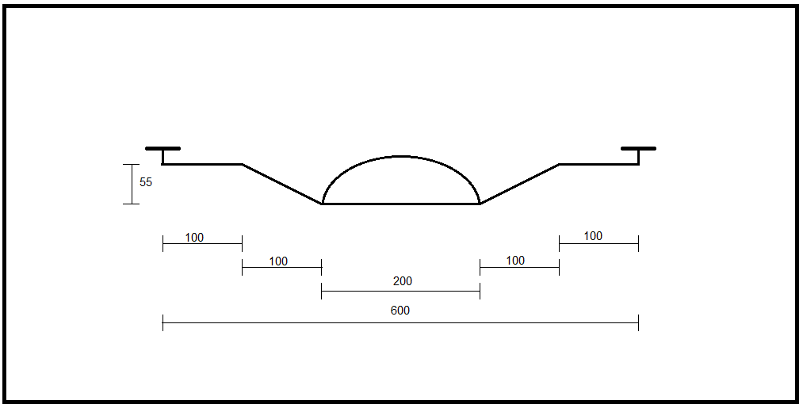
Prototype 3
Front View
Dimensions | mm

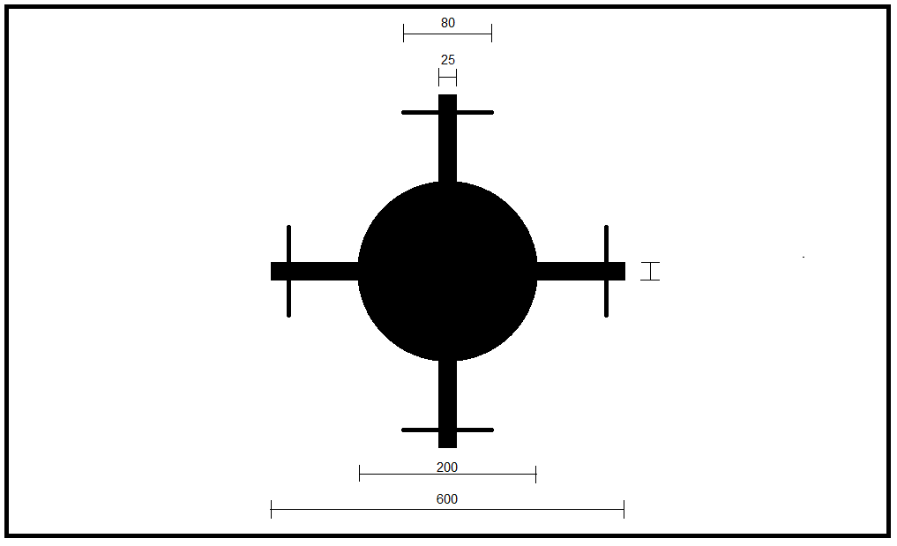
Prototype 3
Top View
Dimensions | mm

A modulation technique that generates variable-width pulses to represent the amplitude of an analog input signal.

