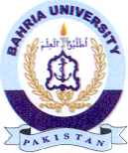
Bahria University Library Islamabad
Source: Jang, Sunday Nov 27, 2022

