
Bahria University Library Islamabad
Source: The News, Friday Nov 25, 2022

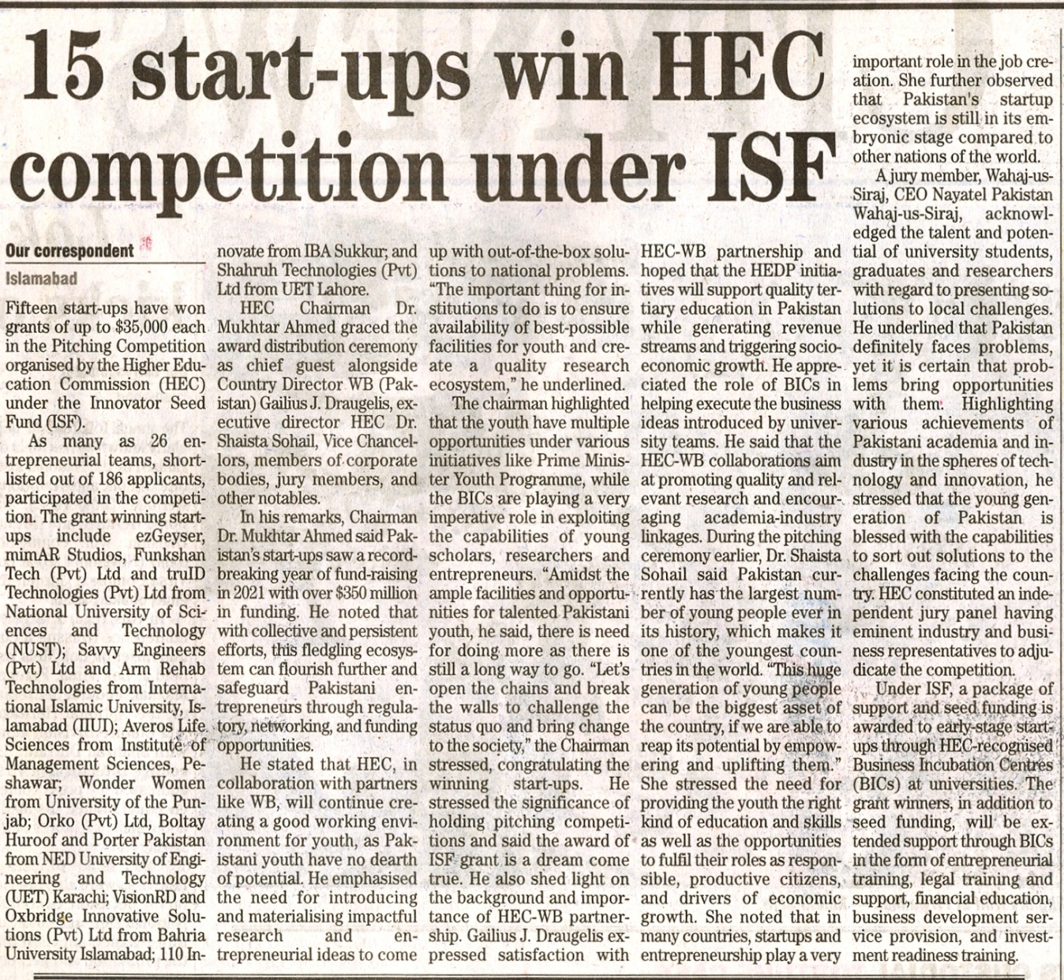

Bahria University Library Islamabad
Source: Dawn, Friday Nov 25, 2022
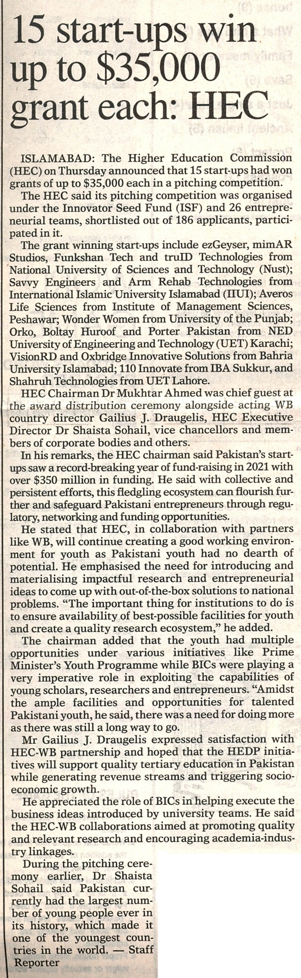

Bahria University Library Islamabad
Source: Pakistan Observer, Friday Nov 25, 2022

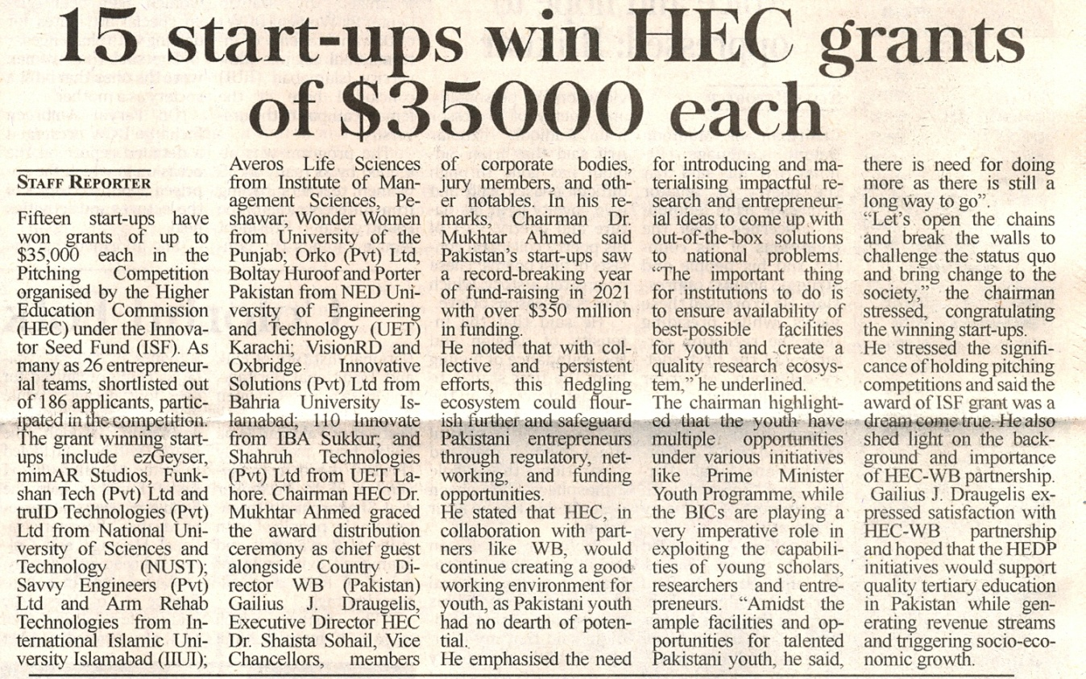

Bahria University Library Islamabad
Source: Daily Time, Friday Nov 25, 2022

