
Bahria University Library Islamabad
Source: The Nation, Wednesday Nov 23, 2022

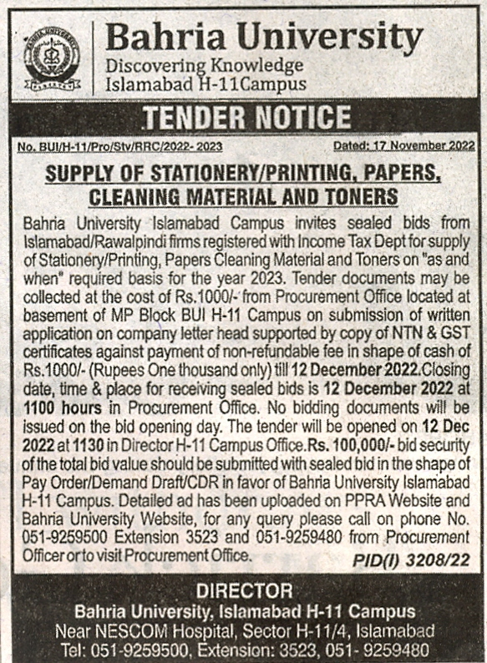

Bahria University Library Islamabad
Source: Nai Baat , Wednesday Nov 23, 2022

