
Bahria University Library Islamabad
Source: Pakistan Observer, Wednesday Nov 23, 2022

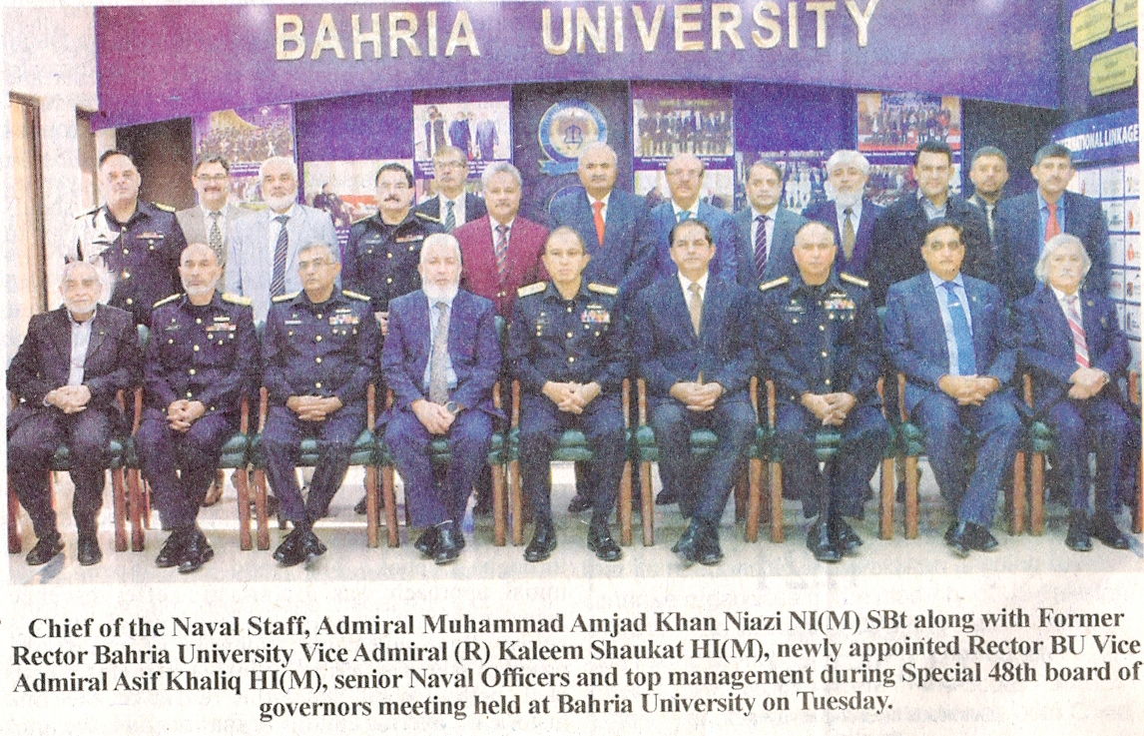

Bahria University Library Islamabad
Source: Jang, Wednesday Nov 23, 2022

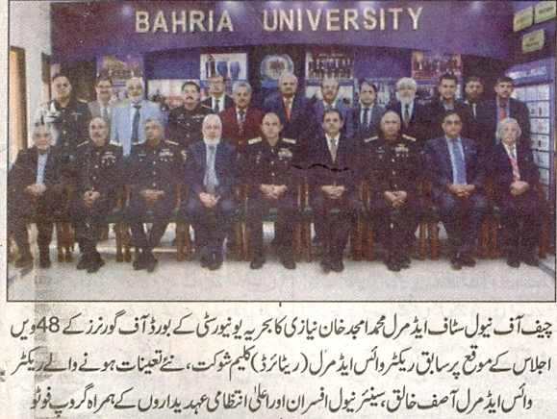

Bahria University Library Islamabad
Source: Express, Wednesday Nov 23, 2022

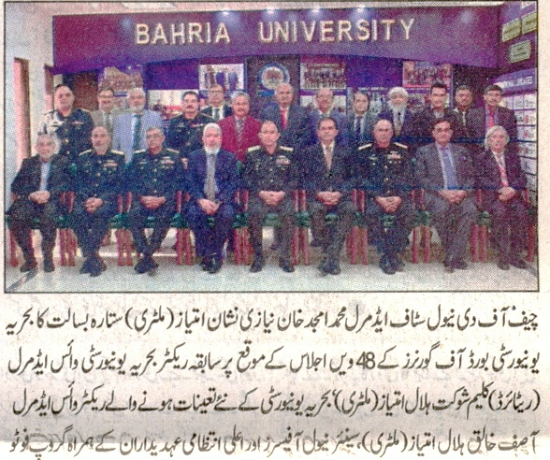

Bahria University Library Islamabad
Source: Dunya, Wednesday Nov 23, 2022

