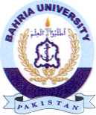
Bahria University Library Islamabad
Source: The News & Jang, Friday Nov 18, 2022

