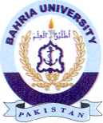
Bahria University Library Islamabad
Source: Jang, Thursday Nov 03, 2022

