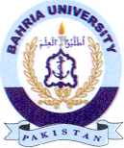
Bahria University Library Islamabad
Source: The News & Jang, Wednesday Nov 16, 2022

