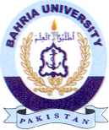
Bahria University Library Islamabad
Source: Dawn, Friday Nov 11, 2022

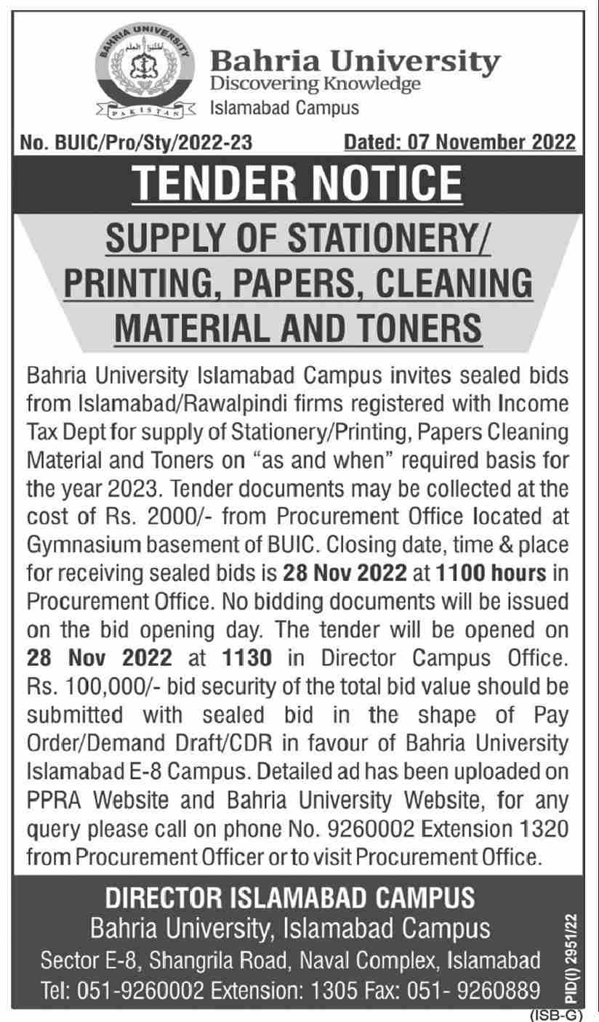

Bahria University Library Islamabad
Source: Express, Friday Nov 11, 2022

