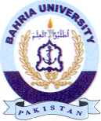
Bahria University Library Islamabad
Source: Jang, Nai Baat & Dunya, Sunday Oct 23, 2022

