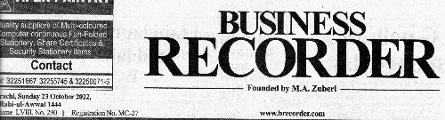
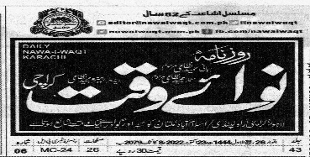

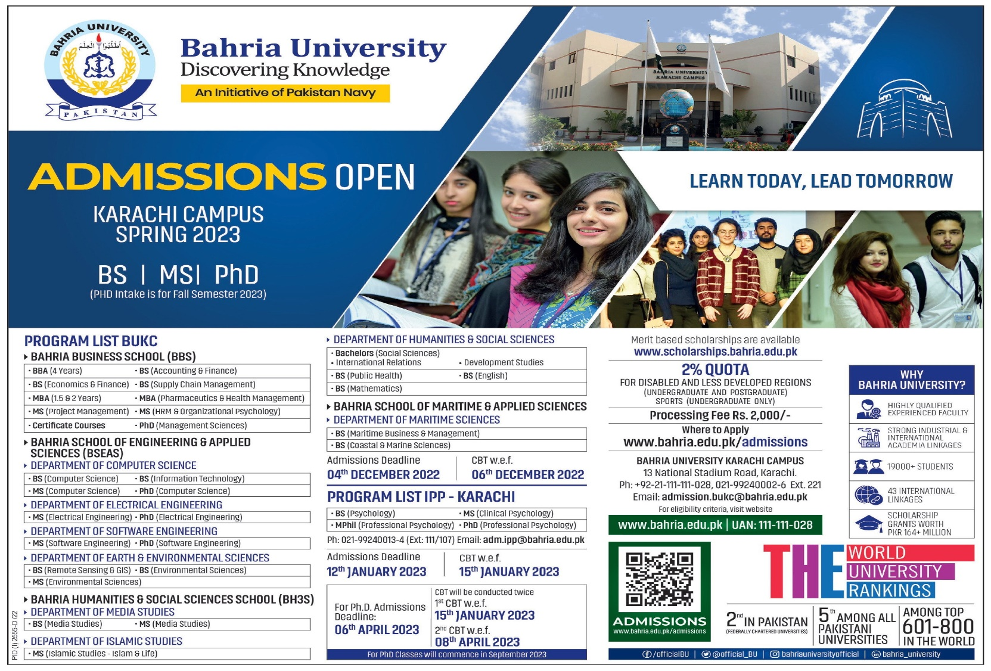
BAHRIA UNIVERSITY KARACHI CAMPUS CENTRAL LIBRARY
BUKC ADMISSIONS ADVERTISEMENT SPRING 2023
PAGE # 2
PAGE # 3
PAGE # 2

