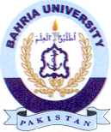
Bahria University Library Islamabad
Source: Daily Nawa-i-Waqt , Friday Oct 21, 2022

