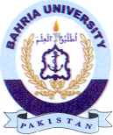
Bahria University Library Islamabad
Source: The Nation & Daily Express, Tuesday Oct 18, 2022

