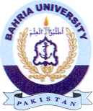
Bahria University Library Islamabad
Source: DAWN, Sunday Oct 16, 2022

