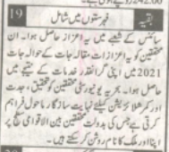
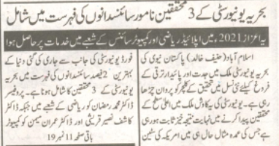
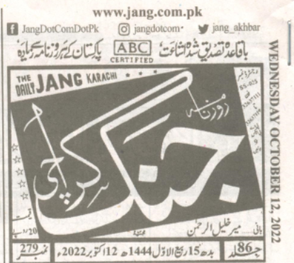
BAHRIA UNIVERSITY KARACHI CAMPUS LIBRARY
NEWS CLIPPING BUKC SCIENTISTS
PAGE # 11

