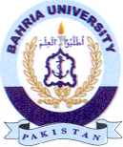
Bahria University Library Islamabad
Source: Dawn & Jang, Sunday Oct 09, 2022

