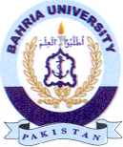
Bahria University Library Islamabad
Source: Dawn & Jang, Thursday Sep 29, 2022

