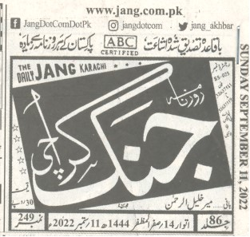
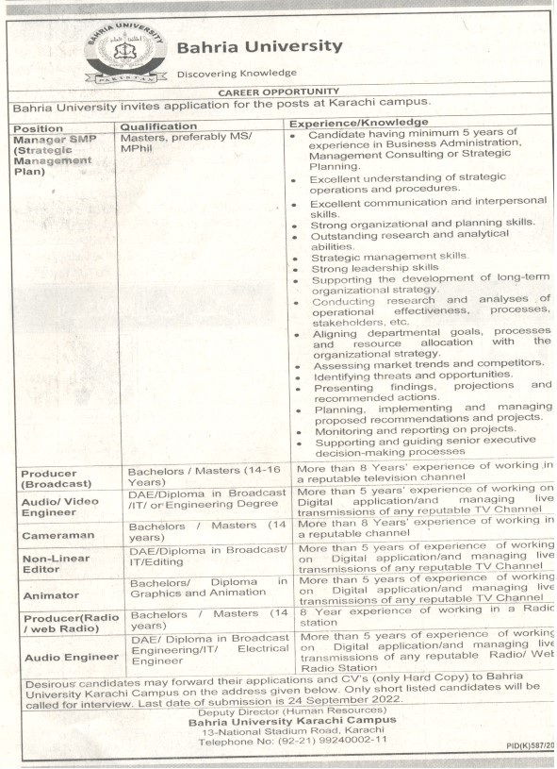
BAHRIA UNIVERSITY KARACHI CAMPUS LIBRARY
NEWS CLIPPING CAREER OPPORTUNITY IN BUKC
PAGE # 21

