
Bahria University Library Islamabad
Source: Express Tribune, Tuesday Sep 06, 2022

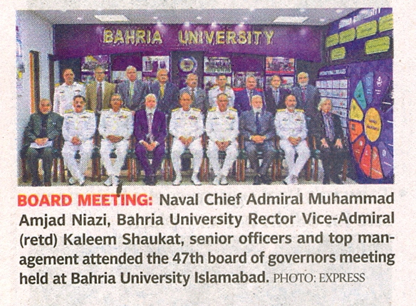

Bahria University Library Islamabad
Source: The News, Tuesday Sep 06, 2022

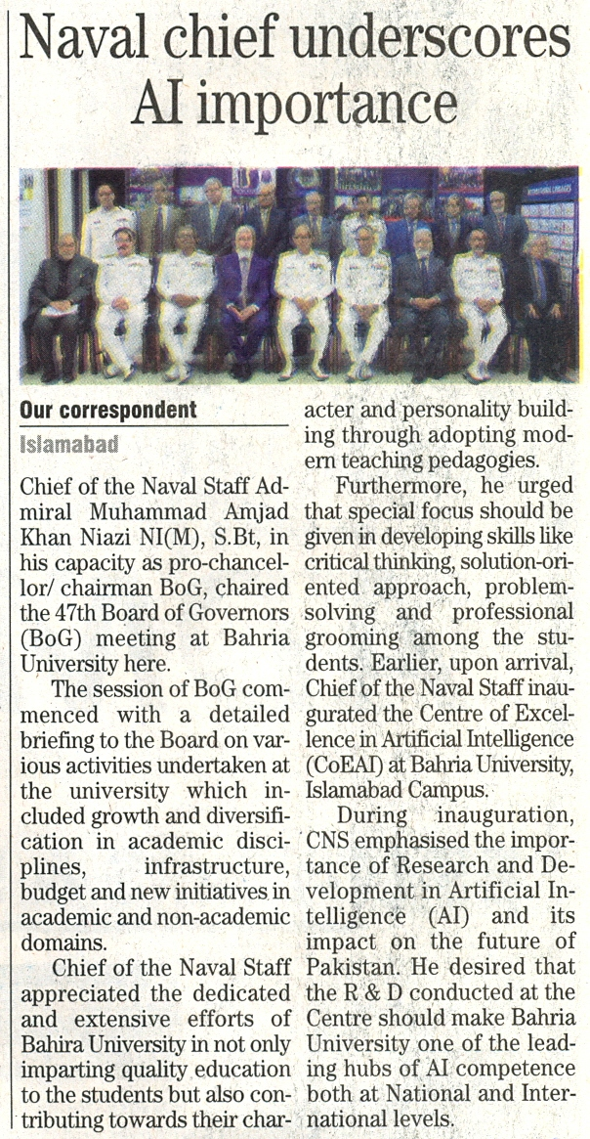

Bahria University Library Islamabad
Source: Pakistan Observer, Tuesday Sep 06, 2022

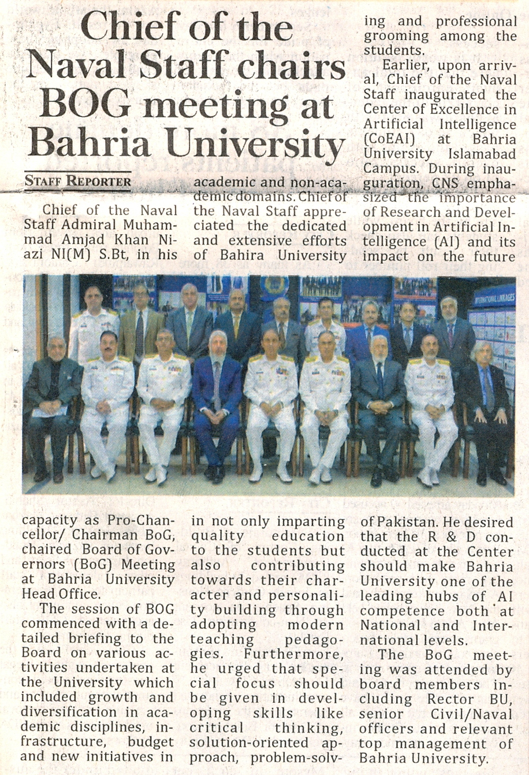

Bahria University Library Islamabad
Source: Jang, Tuesday Sep 06, 2022

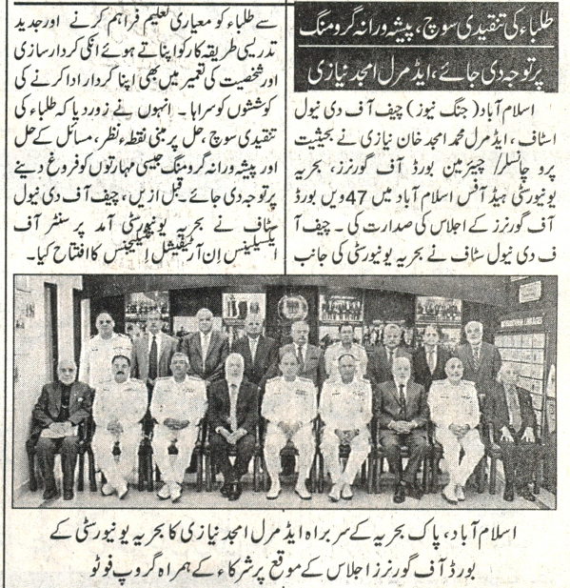

Bahria University Library Islamabad
Source: Nai Baat, Tuesday Sep 06, 2022

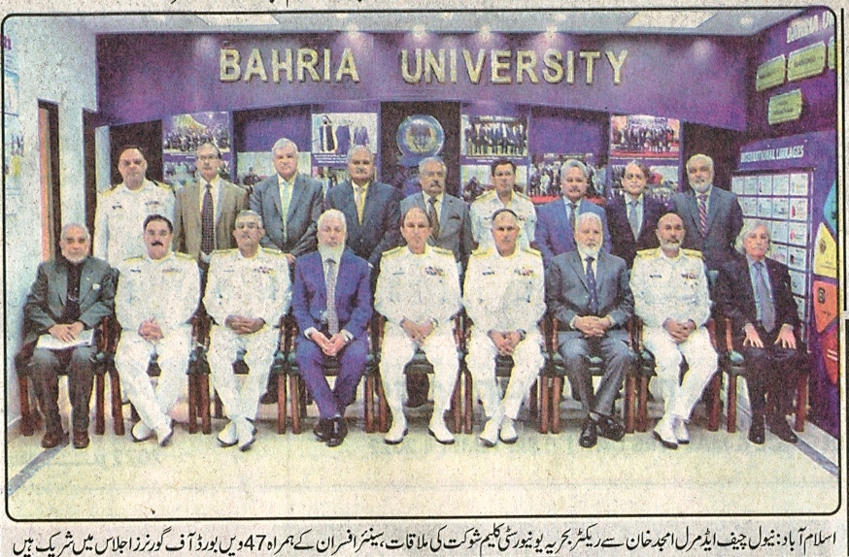
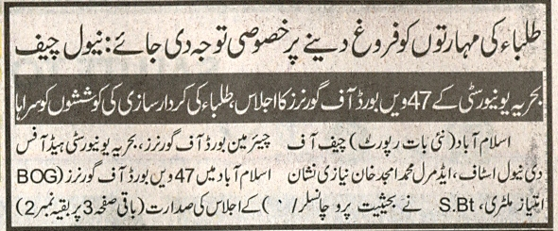
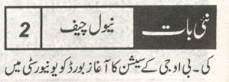
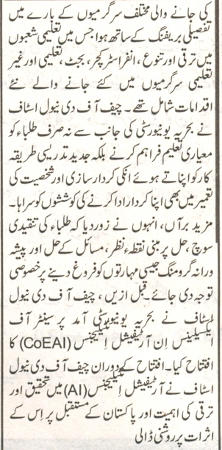

Bahria University Library Islamabad
Source: Express Tribune, Tuesday Sep 06, 2022

