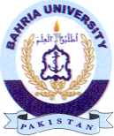
Bahria University Library Islamabad
Source: Express Tribune, Tuesday Aug 23, 2022

