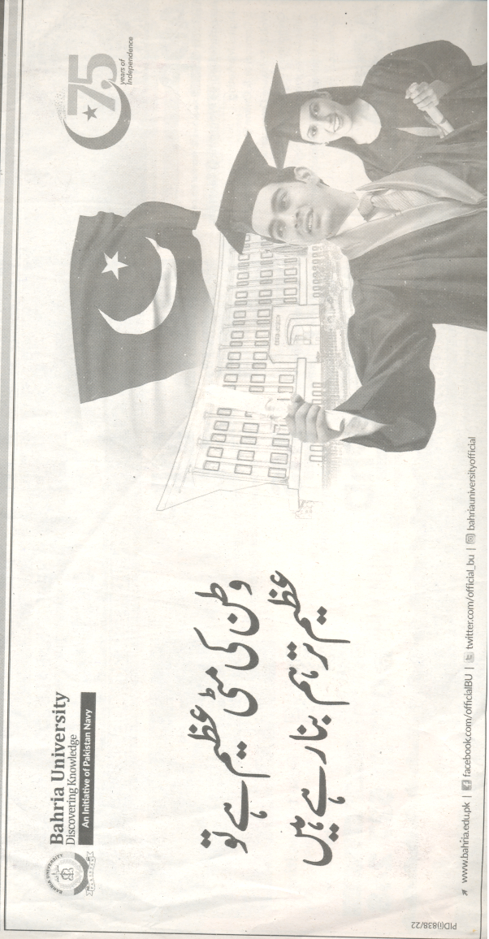
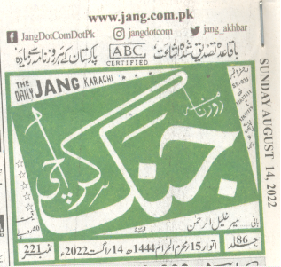
BAHRIA UNIVERSITY KARACHI CAMPUS LIBRARY
NEWS CLIPPING 75TH INDEPENDENCE DAY OF PAKISTAN
PAGE # 3

