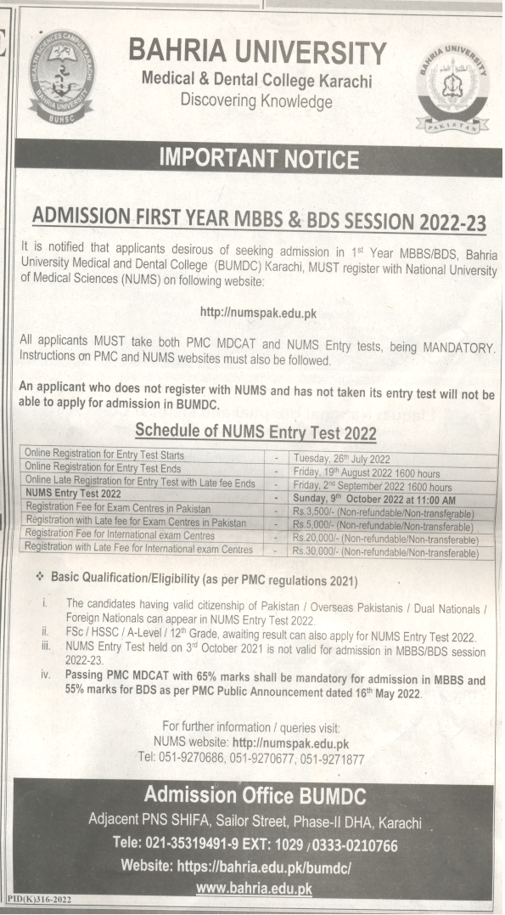
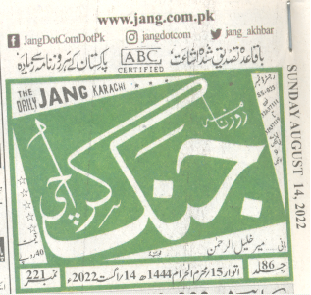
PAGE # 4
BAHRIA UNIVERSITY KARACHI CAMPUS LIBRARY
NEWS CLIPPING ADMISSION DIRST YEAR MBBS & BDS 2022-23

