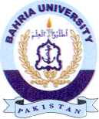
Bahria University Library Islamabad
Source: Dawn & Jang, Sunday Aug 14, 2022

