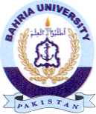
Bahria University Library Islamabad
Source: Dawn & Jang, Sunday Aug 07, 2022

