
Bahria University Library Islamabad
Source: The News, Saturday Jul 30, 2022



Bahria University Library Islamabad
Source: Pak Observer, Saturday Jul 30, 2022

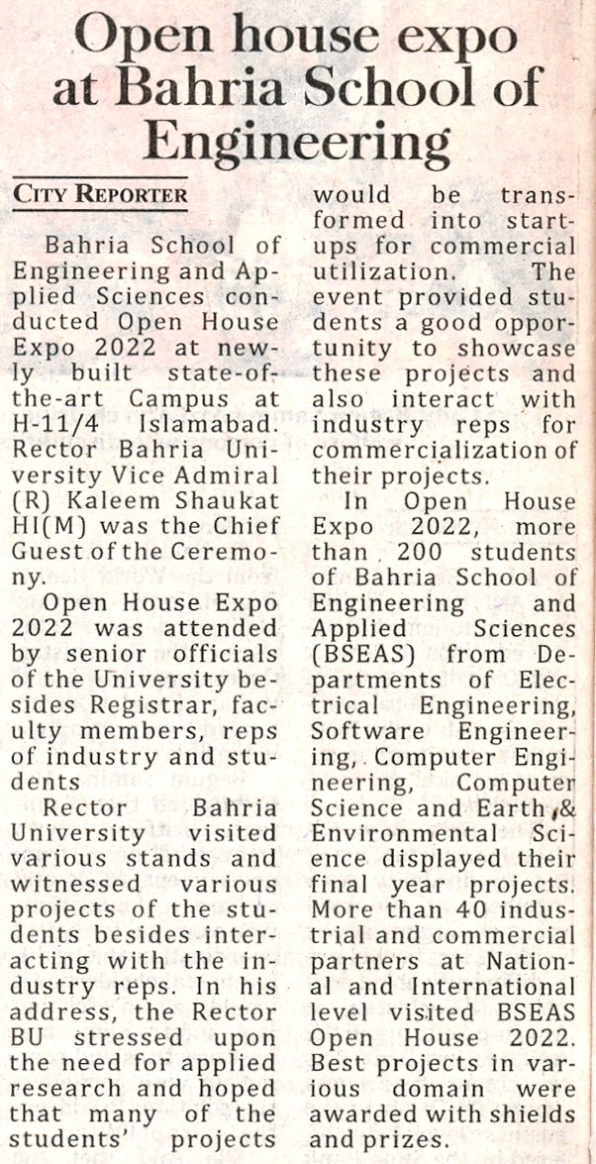

Bahria University Library Islamabad
Source: Express, Saturday Jul 30, 2022

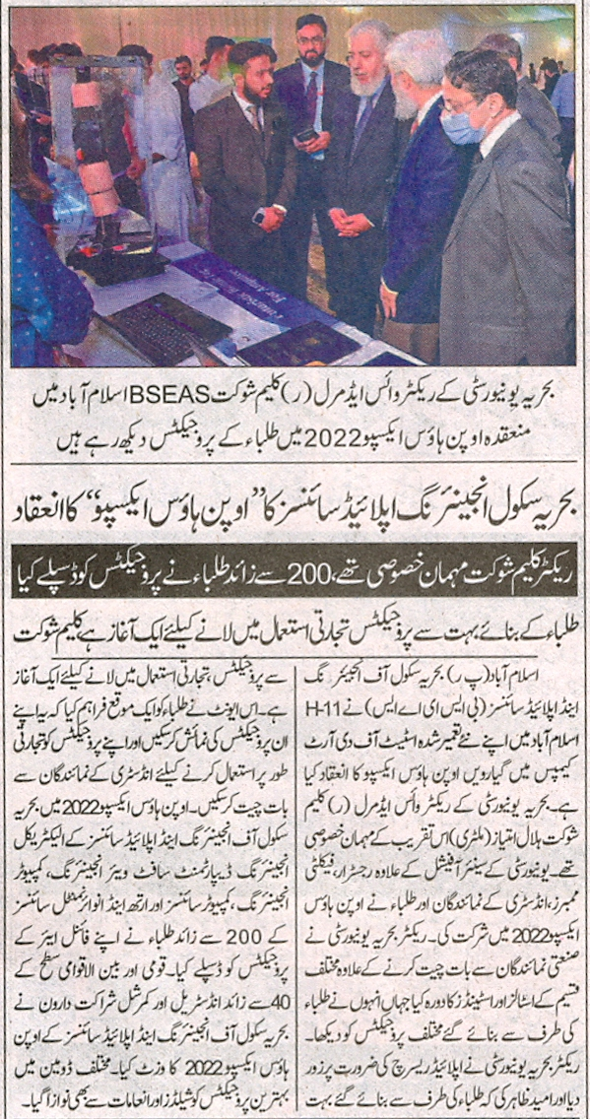

Bahria University Library Islamabad
Source: Dunya, Saturday Jul 30, 2022

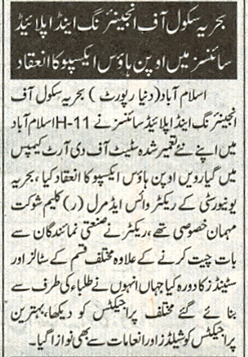

Bahria University Library Islamabad
Source: Nai Baat, Saturday Jul 30, 2022

