
Bahria University Library Islamabad
Source: The News, Thursday Jul 28, 2022

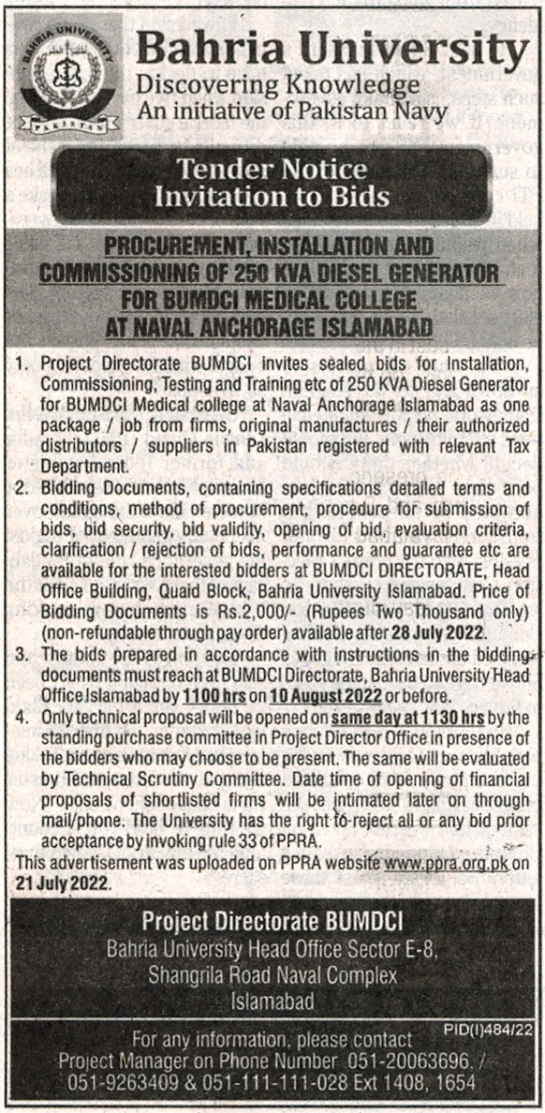

Bahria University Library Islamabad
Source: Jang, Thursday Jul 28, 2022

