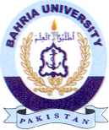
Bahria University Library Islamabad
Source: Express, Wednesday Jul 06, 2022

