
Bahria University Library Islamabad
Source: The News, Tuesday June 28, 2022

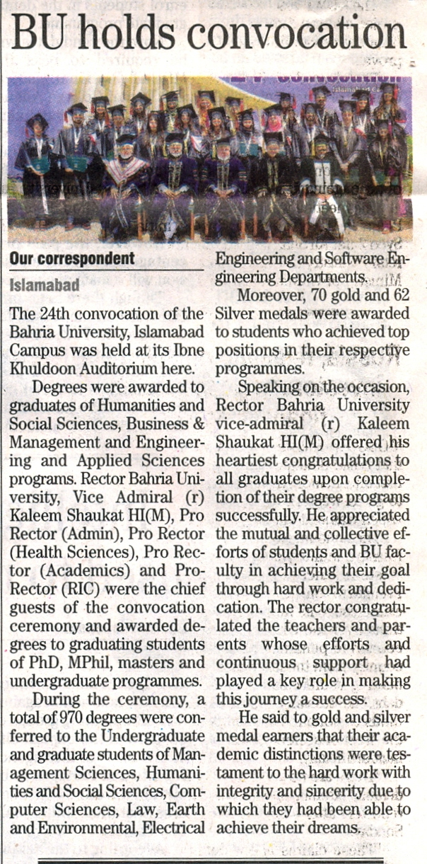

Bahria University Library Islamabad
Source: The Nation, Tuesday June 28, 2022

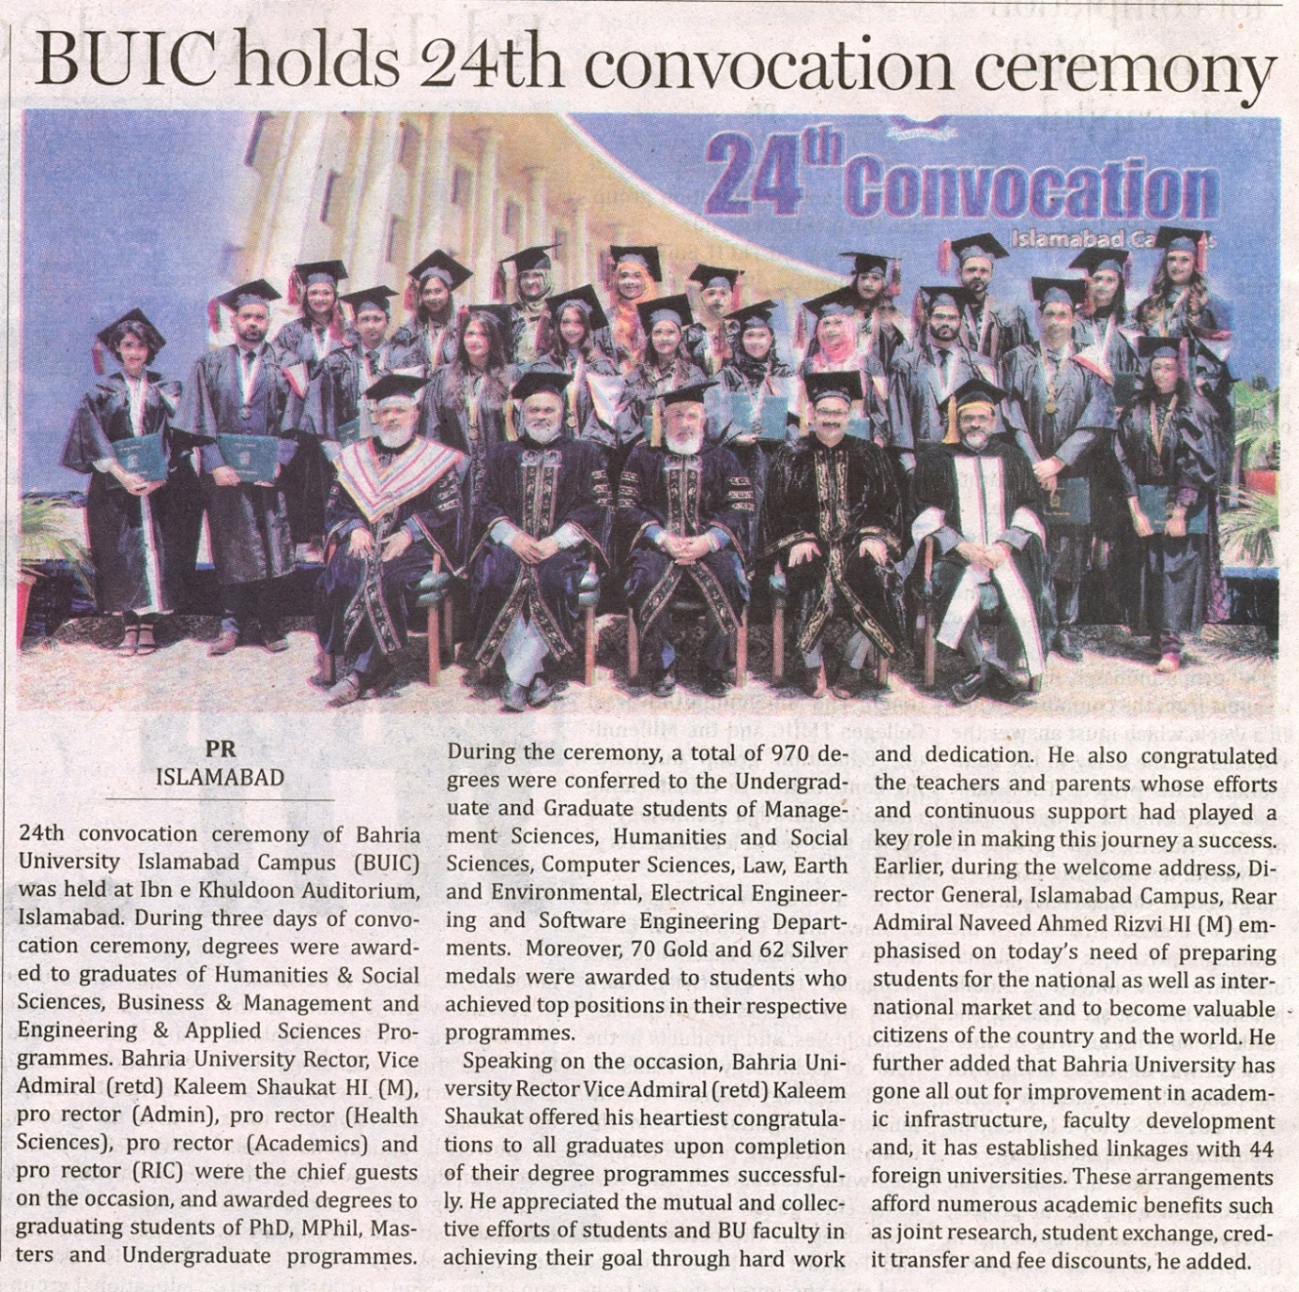

Bahria University Library Islamabad
Source: Dunya, Tuesday June 28, 2022

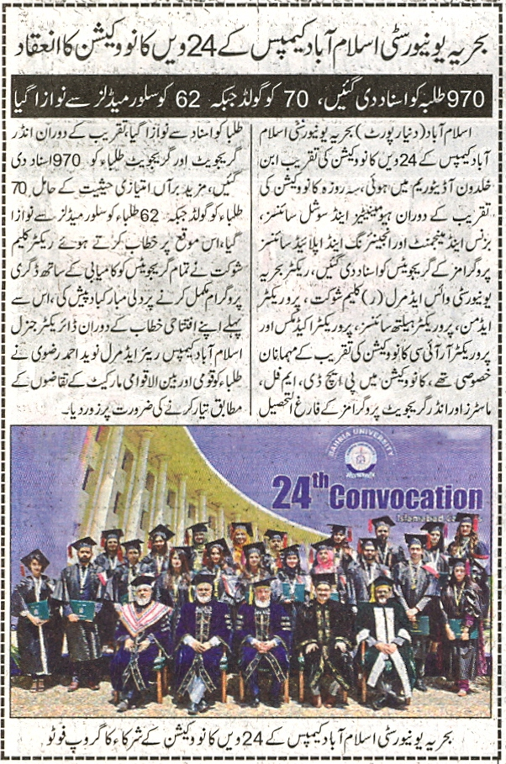

Bahria University Library Islamabad
Source: Nai Baat, Tuesday June 28, 2022

