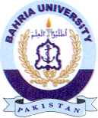
Bahria University Library Islamabad
Source: Dawn & Jang, Sunday June 26, 2022

