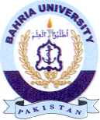
Bahria University Library Islamabad
Source: The Nation, Saturday June 25, 2022

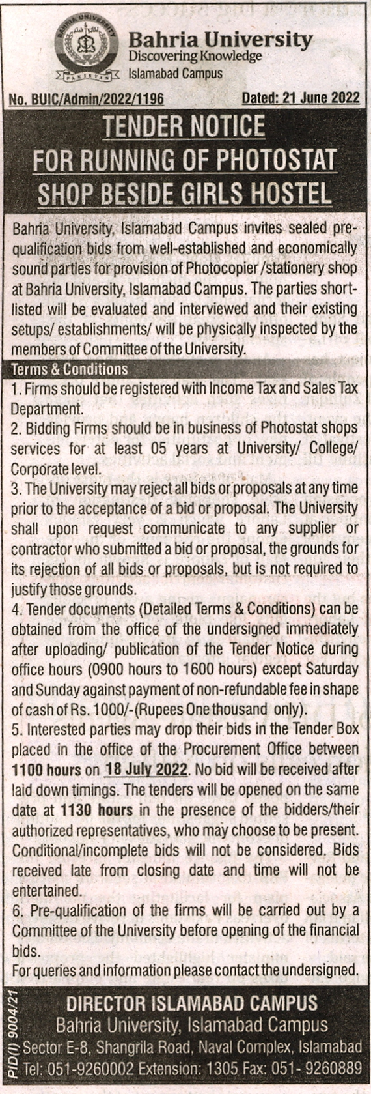

Bahria University Library Islamabad
Source: Jang, Saturday June 25, 2022

