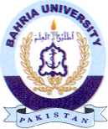
Bahria University Library Islamabad
Source: Pak Observer, Friday June 17, 2022

