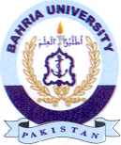
Bahria University Library Islamabad
Source: Dawn & Jang, Sunday June 12, 2022

