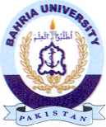
Bahria University Library Islamabad
Source: Dawn, Sunday June 12, 2022

