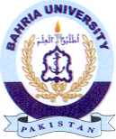
Bahria University Library Islamabad
Source: Express Tribune, Tuesday June 07, 2022

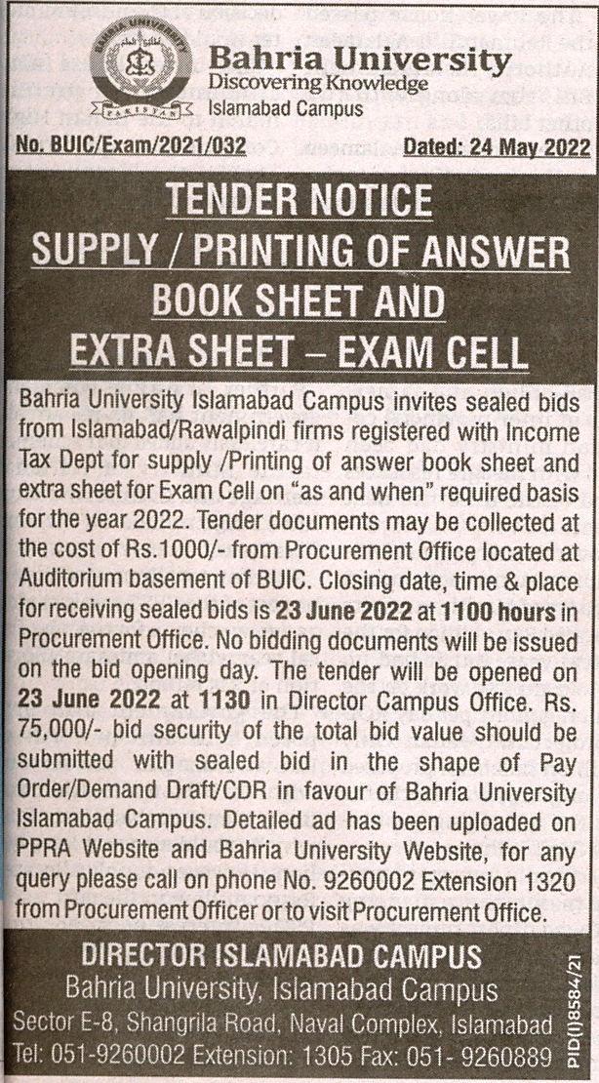

Bahria University Library Islamabad
Source: Jang, Tuesday June 07, 2022

