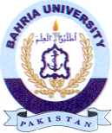
Bahria University Library Islamabad
Source: Express Tribune, Saturday June 04, 2022

